Title: Mono ocular adduction deficit; a novel syndrome.

Mohamed A. Eldesouky
Department of Ophthalmology, School of Medicine Tanta University, Tanta, Egypt
Keywords: Duane’s retraction syndrome, myositis, inter nuclear ophthalmoplegia, medial orbital wall fracture, lateral orbital wall fracture, medial rectus laceration.

- Abstract Body
In this study we describe mono ocular isolated medial rectus paresis or paralysis not associated with oculomotor nerve dysfunction or with other gaze deficiency. In this study I present a group of cases with monocular adduction deficit with diverse etiologies. Central causes; chronic progressive ophthalmoplegia and internuclear ophthalmoplegia, Duane’s retraction syndrome, traumatic and iatrogenic causes as medial rectus muscle contusions and lacerations, medial rectus inflammation and neoplasia as well as restrictive lesions affecting the antagonistic lateral rectus muscle. The clinical and radiological features and the differential diagnosis are thoroughly described . To my knowledge this is the first description of monocular adduction deficit as a novel syndrome.

- Image:
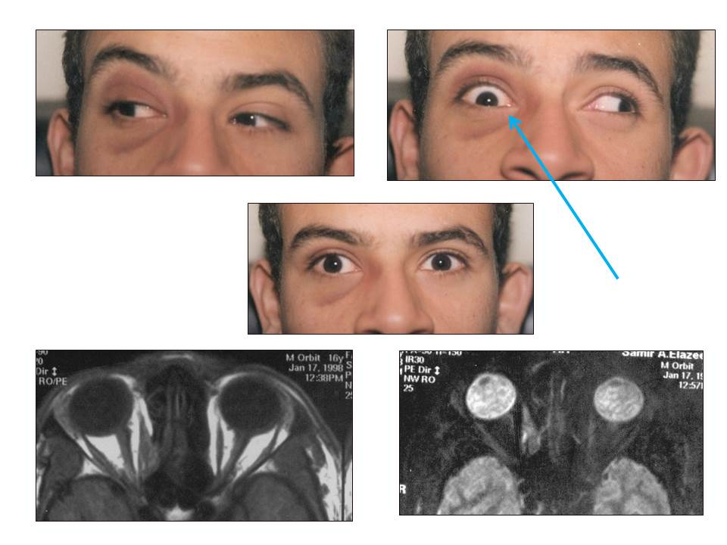

- Reference:
- Lueder GT. Orbital Causes of Incomitant Strabismus. Middle East African Journal of Ophthalmology. 2015;22(3):286-291
- Henson KJ. Diagnostic tools in the evaluation of strabismus secondary to trauma. Am Orthopt J 2004;54:2-6.
- Murray AD. An approach to some aspects of strabismus from ocular and orbital trauma. Middle East Afr J Ophthalmol 2015;22:312-9.
Biography:
Mohamed A. Eldesouky has completed his PhD at the age of 36 years from Tanta University and Postdoctoral Studies from School of Medicine, University of Tennessee, Memphis. He is the Director of oculoplasty, and ocular pathology service in Tanta University Eye Hospital. He has published more than 25 papers in reputed journals.
- Presenting author details

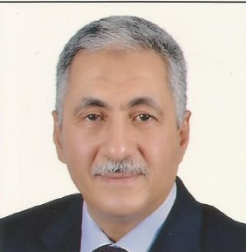
Full Name: Mohamed Ashraf Eldesouky
Contact number: 002 0123451082
E mail: ashrafdesouky@yahoo.com
Session name/ number: Medical and Clinical Microbiology
Category: (Oral presentation)
Passport Number: A08564927

