Title: Genome-wide analysis of NeuroD family of bHLH transcription factor

Shouhartha Choudhury¹ Prosenjit Paul² and, Supriyo Chakraborty^{3*}
¹Department of Biotechnology, Assam University, Silchar-788011
²School of Life Sciences, Assam University, Silchar-788011

Keywords: Type 2 diabetes, NEUROD1, NEUROD Family, bHLH transcription factor, Gene expression
Abstract
The present study investigated NeuroD (Beta2) family is a basic helix-loop-helix transcription factor widespread in genome. In NeuroD family particular gene express in certain parts in the neurons, beta-pancreatic cells and, enteroendocrine cells. It’s involved differentiation of nervous system and development of pancreas. NEUROD1 (Neurogenic differentiation 1) found to convert reactive glial cells into functional neurons in the brain.
The NEUROD1 induces differentiation of nervous system and regulate insulin gene expression by binding to the critical E-box motif on insulin promoter and mutation result type 2 diabetes mellitus. It is logically assumed NUEROD1 regulate insulin and found to Chromosome 2 in human. The NeuroD family and their bHLH domain is recorded in genomic data. The family-wise classification study is essential component for better understanding of the specific gene induces in the genome. We accumulate eukaryotes organism genome i.e. Homo sapiens and Mus musculus for comparative and functional analysis. The genome-wide analysis suggested NeuroD family and their bHLH domain, motifs, phylogeny, chromosome location and, gene expression. In this study, we performed bioinformatics and computational technique to the current knowledge of NeuroD family of bHLH transcription factor in eukaryotes

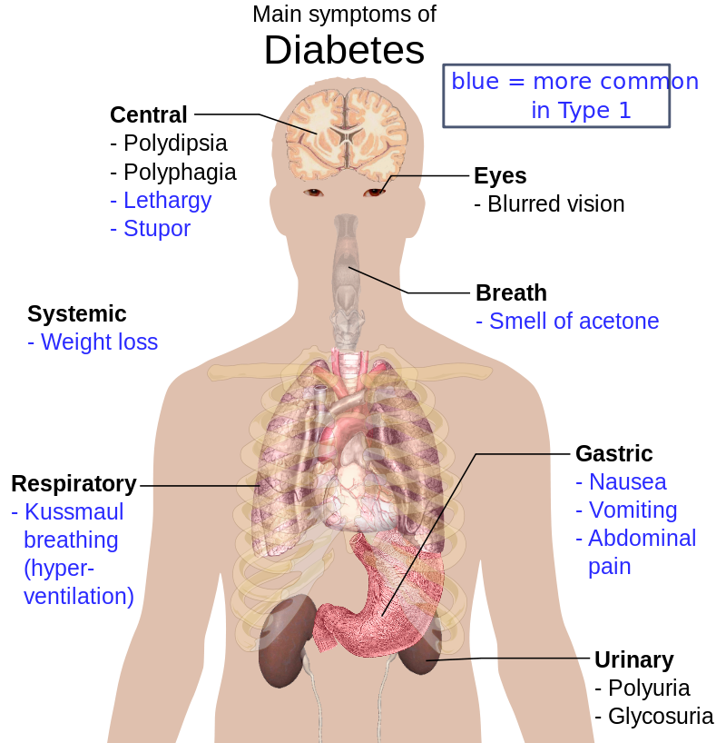

Reference
- Latchman, D.S., Transcription factors: an overview. The international journal of biochemistry & cell biology, 1997. 29(12): p. 1305-1312.
- Malecki, M.T., et al., Mutations in NEUROD1 are associated with the development of type 2 diabetes mellitus. Nature genetics, 1999. 23(3): p. 323.
- Liu, M., et al., Loss of BETA2/NeuroD leads to malformation of the dentate gyrus and epilepsy. Proceedings of the National Academy of Sciences, 2000. 97(2): p. 865-870.
Biography
Shouhartha Choudhury has completed his B.Tech and M.Tech in Bioinformatics from India and now pursuing integrated pre-Ph.D. research program in School of Life Sciences, Department of Biotechnology, Assam University, Silchar-788011. He submitted four research reports entitled (a) Computational Genomics: AP2/ERF Family in plants, (b) Comparative Genomics: Novel: BCL-2 Family, (c) Genomics of OLIG Family of bHLH transcription factor and, (d) Genome-wide analysis of NeuroD Family of bHLH transcription factor in Assam University, for short communication

Author details


Full Name: Shouhartha Choudhury
Contact number: +91-9954411181
Twitter account: Shouhartha Choudhury
Linked In account: Shouhartha Choudhury
Session name/ number: +91-93655860541
Category: (Oral and poster presentation)
Passport Number:

