OPHTHALMO-ACROMELIC SYNDROME IN A PALESTINIAN

INFANT: A CASE REPORT
Allam FM Abuhamda,consultant neonatologist,MOH,Gaza,palestine

Abstract

Ophthalmo-acromelic syndrome (OAS) is a rare congenital disorder that leads to malformations of the eyes and limbs. In this article, we have reported the case of a newborn girl with OAS. She was the fifth child in the family. The non-consanguineous parents were healthy. The newborn had bilateral true anophthalmia, macrodactyly and oligodactyly (two toes in both feet, three fingers in the lefthand, and four in the right hand). In addition, she had lumbar spina bifida and hydrocephalus. Thisw as not reported before in the same syndrome. The number of reported cases of this syndrome around the world is limited. These rare congenital anomalies had not been witnessed before in the Gaza Strip, raising an alarm about the relation between congenital birth defects and environment alfactors, especially over the last decade.

Keywords: Ophthalmo-acromelic syndrome, spina bifida, hydrocephalus, Gaza Strip
Image
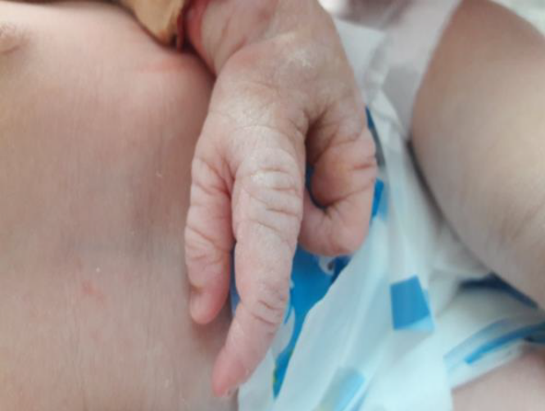
Figure 3. Her left hand had three fingers with
macrodactyly
Recent Publications
- Abuhamda AF. Ophthalmo-acromelic syndrome in a Palestinian infant: a case report. Gulf Medical Journal. 2017;6(1):42–44.

- Abuhamda AF. A case study of thanatophoric dysplasia type 2. Gulf Medical Journal. 2017;6(1):45–48.

- DOI: 10.5455/IJMRCR.amniotic-band-syndrome-holoprosencephaly

- DOI:10.5455/IJMRCR.apert-syndrome-lobar-holoprosencephaly-agenesis-corpuscallosum

- DOI:10.5455/IJMRCR.Klippel-Trenaunay-Weber-syndrome


Allam Fayez Abuhamda
Date of birth:4/5/1970
Arab Board of pediatrics/Qatar
Neonatal fellowship/Qatar
The senior consultant neonatologist and the head of Shifa NICU since 2013 till 2017
Ministry of health Senior consultant neonatologist for all neonatal intensive care units in Gaza Strip since 1/11/2017 till now.
Lecturer in the Islamic University in Gaza for Diploma of Child Health and Nutrition
Lecturer in the Al-Quds University for the master of nursing
Email: allam570@yahoo.com

