Title: Should vasopressin be used as a first line systemic vasoconstrictor in pulmonary hypertension patient - an in-vitro study
Full Name: Azat Hussain MBBS, MRCS (Ed), PG Cert (Ldshp & Mgmt), PG Dip (Rsch Meth), MSc (Trans Rsch), MD.
NIHR – Clinical Lecturer / NTN Cardiothoracic Registrar
Affiliation: Department of Cardiothoracic Surgery, Castle Hill Hospital, Cottingham, UK. HU165NW.

ABSTRACT
Background:
Acute pulmonary hypertension following cardiac surgery can have a significant effect on postoperative morbidity and mortality. However, limited data is available on the efficacy and potency of clinically used systemic vasopressors on the human pulmonary vasculature. The aim of this study was to use human pulmonary artery to characterize the pharmacological effects of clinically used vasopressors on the human pulmonary vasculature.
Methods:
Fifty-seven pulmonary artery rings of internal diameter 2-4 mm and 2 mm long, mounted in multiwire myograph system, were used for measuring changes in isometric tension. Concentration response curves were constructed to KCl, Noradrenaline (NA), Adrenaline (Ad), Vasopressin, Endothelin-1 (ET-1) and Prostaglandin F2a (PGF2a) by cumulative addition to the myograph chambers.
Results:
The Adrenaline, Noradrenaline, Endothelin-1, PGF2a and KCl caused dose-dependent vasoconstriction in the pulmonary artery (EC50 246nM, 150nM, 1.46nM, 6.35uM and 17.24mM respectively) while vasopressin had no significant effect. The order of efficacy was KCl = PGF2a > Ad > NA > ET-1 and the order of potency was ET-1 > Ad = NA > PGF2a > KCl.
Conclusion:
This study demonstrated the efficacy and potency of clinically used vasopressors and endogenous vasopressors on human pulmonary vascular reactivity with PGF2a and KCl equally causing maximal constriction while Endothelin 1 had less effect with Vasopressin having no effect. These effects may need to be taken into account in the clinical setting as they might result in the development of pulmonary hypertension.


Image

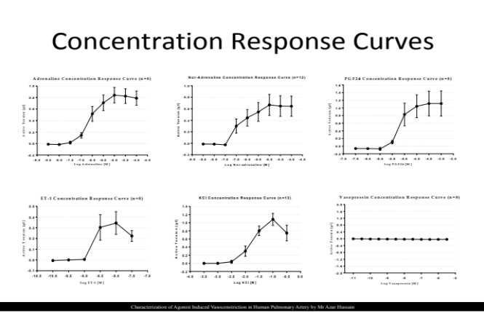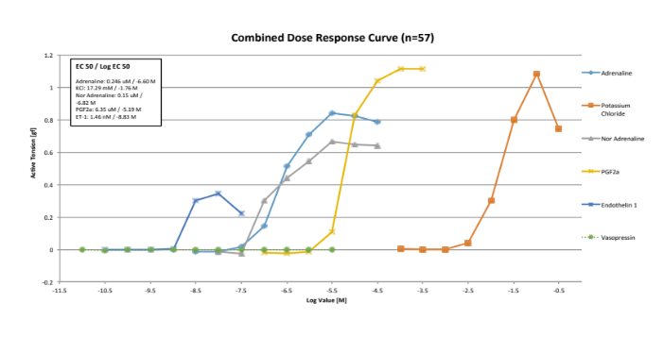

Recent Publications
1. The differential effect of systemic vasoconstrictors on human pulmonary artery tension. A Hussain, R Bennett, Y Haqzad, M Chaudhry, S Qadri, M Cowen, A Morice, M Loubani. Europeon Journal of Cardiothoracic Surgery (in press).
2. Characterization of optimal resting tension in human pulmonary arteries.
A Hussain, R Bennett, M Chaudhry, S Qadri, M Cowen, A Morice, M Loubani.
World Journal of Cardiology. 2016 Sep; 8(9): 547-552.
3. NICE thromboprophylaxis guidelines are not associated with increased pericardial effusion after surgery of the proximal thoracic aorta.
Rahman IA, Hussain A, Davies A, Bryan AJ. Ann R Coll Surg Engl. 2013 Sep; 95(6):433-6.
4. Human Cognitive and Neuro-Psychiatric Biomarkers in the Cardiac Peri-Operative Patient.
H.J. Reis, A.C.P. de Oliveira, M.A. Mukhamedyarov, A.L. Zefirov, A.A. Rizvanov, M.E. Yalvaç, A.L. Teixeira, Z. Janka, A. Hussain, L.B. Vieira and A. Palotás. Current Molecular Medicine 2014;14: 1-9
5. Pneumonectomy for lung cancer: long-term outcome of 15-year experience of a single center.
A.Hussain, S.Qadri, Y.Haqzad, M.Chaudhry, A.Cale, M.Cowen, M.Loubani.
Lung Cancer, 2016; 91(1): S63.
6. Follow up after lung cancer surgery: plain chest x-ray does not increase diagnostic accuracy
A. Hussain, M. Khatri, G. Casali, T. Batchelor, D. West.Lung Cancer, 2014; 83 (1): S194.

Biography (150 word limit)
Mr. Azar Hussain is a Cardiothoracic Surgeon with particular interest in pulmonary hypertension and heart failure. In view of his additional interest in vasoreactivity of small human pulmonary vessels he recently completed his MD and also completed his MSc in translational research from University of Bristol. Mr Azar Hussain, a HYMS clinical research fellow based in the Department of Cardiothoracic Surgery at Castle Hill Hospital, was awarded two prizes at the International Conference on Cardiovascular Medicine held in August. The Best Young Researchers Forum award and the Best Poster Presentation award were given in recognition of Azar’s research on pulmonary arteries, constrictors and dilators, which has been carried out under the supervision of Professor Alyn Morice and Professor Mahmoud Loubani. Azar’s researches on pulmonary arteries, constrictors and dilators have clinical implications for the treatment of patients with pulmonary hypertension in general but more specifically in patients undergoing complex heart surgery.

