Climate change impact on groundwater modeling using an integrated approach: A Moroccan’s case study
El Assaoui N, Professor, Mohammed V University Rabat Morocco
Sadok A, Professor, Mohammed V University Rabat Morocco

Abstract
Climate change forecasts from IPCC (Intergovernmental Panel on Climate Change) reports and different studies provided that by 2100, Morocco will face a decrease of average annual rainfall by 10 to 30% and an increase of average annual temperature by 1° to 2°C. Aquifer’s overexploitation due to the increase of water demand, for urban, agricultural and industrial development; and climate change, has negative impact on groundwater resources. Therefore, different consequences are predicted: natural recharge decrease, water quality decline, salinity intrusion. The scientific knowledge of processes related to climate change impact on groundwater resources remains insufficient both nationally and internationally. This is due particularly to: the inadequacy of databases both quantitatively and qualitatively; Insufficient accuracy of predictions by climate models especially rainfall and their sensitivity to the choice of climate scenarios; Insufficient accuracy of methods for estimating groundwater recharge; the difficulty of modelling surface water/groundwater interaction. The assessment of climate change impacts on groundwater resources requires reliable predictions of climate variables; a good estimation of groundwater recharge; and modeling of the aquifer’s hydrodynamic response to climate change scenarios. This research aims to improve assessment of climate change impacts on Moroccan’s groundwater resources, using a global methodology. The proposal approach was based on national and international benchmark, and outcomes derived from Berrechid aquifer’s studies which is among many vulnerable Moroccan’s aquifers to climate change and water scarcity. The results of simulations showed a decline of water table of this aquifer even for optimistic IPCC scenarios: SRES-B1 (Special Report on Emissions Scenarios) or RCP-2.6 (Representative Concentration Pathways). Berrechid aquifer was considered as case study to improve this global methodology based on a link of different aspects (climate, hydrologic, and flow groundwater), to assess future impacts of climate change on groundwater resources in Morocco.
Image
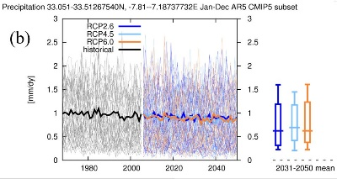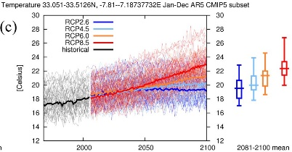
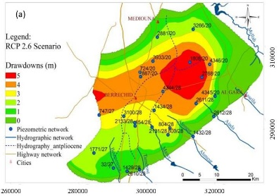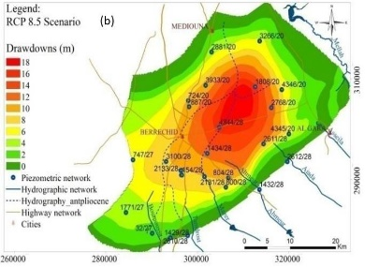
Recent Publications (minimum 5)
- Christiensen J H and al (2007) Regional Climate Projections the fourth assessment Report of the IPCC, Cambridge University Press, New York.
- Wilby R L (2007) Climate change scenarios for Morocco. Final technical Report, Department of Geography Lancaster University and Environment Agency of England and Wales on behalf of World Bank.
- Jaw T and al (2015) Journal of hydrology: regional studies 3:359-378.
- Pitz C F (2016) Predicted impacts climate change on groundwater resources of Washington state Ecology Department Publication 16-03-006, Washington.
- El Assaoui N (2017) Contribution à l’étude méthodologique de l’impact des changements climatiques sur les ressources en eau souterraines : cas de la nappe de Berrechid PhD Thesis. Hassan II University, Casablanca

 Biography
Dr. EL ASSAOUI Naïma is Professor of Geosciences, Water and Environment in Mohammed V University in Rabat, Morocco. She is Engineer in Hydrogeology, Master graduated in GIS and Land Management and PhD in Geosciences. She has focused her research in the management and planning of groundwater, computational modeling of groundwater flows, water erosion, remote sensing applied to water systems, as well as the impact study of climate change on surface and groundwater resources. she's author of several scientific publications (conference communications, scientific journals, technical documents).
Email: nelassaoui@gmail.com

Notes/Comments:

