Clean energy development – an alternative pathway to climate justice in India
Sharma S. Kumar, PhD, Greenwood Hills School, Dehradun, India

Abstract (300 word limit)
India's energy sector is a significant contributing factor of greenhouse gases mainly the carbon dioxide (CO2), when fossil fuels are burnt to meet the energy demands leading to climate change. The adverse effects of climate change is manifesting in the form of reductions in Himalayan snow, rising sea levels, extended droughts, as well as increased frequency of heavy and extreme rainfall events. The country is forced to look for ways to cut the nation's high carbon footprint while not jeopardizing its economic growth prospects. India is Asia's third-biggest economy which relies on coal for around 60 percent of its total electricity generation and the fossil fuel remains a vital element in the nation's long-term energy strategy. To effectively address the concerns of climate change and to follow the transition path away from fossil fuel extraction, the country on June 30, 2008 unveiled its National Action Plan on Climate Change (SDG’s climate action goal 13) with a view to lay down the priorities and future actions of the government for addressing climate change (SDG’s clean energy goal 7). To diversify its energy mix and reduce its reliance on coal, the Indian government has set ambitious renewable energy targets. Eight national missions (solar mission, energy efficiency, sustainable habitat, water, Himalayan eco-system, Green India, eco-green agriculture and knowledge) have been specifically outlined to simultaneously advance India’s development and climate change-related objectives of adaptation and greenhouse gas mitigation. The goal is to source 40 percent of India's electricity from renewable and other low-carbon sources by 2030. It also wants to reach 175 gigawatts (GW) of renewable energy capacity by 2022 - of which 100 GW will be from solar energy.
Image

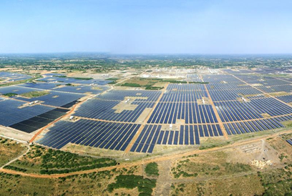
Fig 1 : This solar plant, and many others that are fast coming up in various parts of the country, signal the government's committed push to focus and shift to renewable energy. (Image by Adani Group)

Recent Publications (minimum 5)

- Kasturi Das and Kaushik Bandyopadhyay, 2015. “Climate Change Adaptation in the Framework of Regional Cooperation in South Asia” 1 CCLR, p. 40 – 50
2. Mittal, Radhika, 2012. "Climate Change Coverage in Indian Print
Media: A Discourse Analysis". The International Journal of Climate
Change: Impacts and Responses. 3 (2): 219–230.
- P.R. Shukla, ed. 2003. “Climate Change and India: Vulnerability Assessment and Adaptation”. Orient Blackswan. ISBN 8173714711, 9788173714719, Chapter 3.
4. Rupa K. Kumar, A.K. Sahai, K. Krishna Kumar, S.K. Patwardhan, P.K.
Mishra, J.V. Revadekar, K. Kamala and G.B. Pant, 2006. “High-
resolution climate change scenarios for India for the 21st century”
Current Science 90 no. 3 : Special Section : Climate Change and
India.
5. Sunjoy Joshi and Marlies Linke (eds), 2011. “Sustainable
Development and Climate Change”1st edn, Academic Foundation
,p.244.

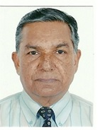 Biography (150 word limit)
S. K. Sharma is Head of the Geography and Environmental Science Department at the Greenwood Hills School at Dehradun in India where he has been teaching India’s perceptions, positions, policies and possibilities on climate Change to variety of students hailing from India, Nepal, Thailand and Korea. He has authored a text book “caring for environment” for students up to 12th class. Also, organized a training course on the “Harnessing of Alternate Sources of Energy” to increase awareness among general public and decision makers on the importance of environmental science for careful and efficient management of the environment and its natural resources. He is member of several national and international scientific bodies, and presented a paper entitled “Climate change impacts and mitigation processes” at the Global Climate Observation Conference (GCOS), Amsterdam, The Netherlands, 2-4 March 2016.
Email: sks105@rediffmail.com
Notes/Comments :
Dear Sir,
I being a teacher from India, I am unable to bear the conference expenses entirely on my own and, therefore, I would appreciate some funding support to ease my participation. Thanking you in anticipation.

