Biodiversity in Morocco: Importance, ecology and dynamic in climate and environmental change
Mohammed Sghir Taleb, PhD, Institut Scientifique, Mohammed V University, Morocco,

Abstract (300 word limit)
With its geographical situation (true crossroads between Europe and Africa and the Mediterranean and the Atlantic), with the diversity of its climate and its habitats, Morocco shelters a particularly varied natural vegetation, as well by its structure and its aspect, as by the diversity of the species. The floristic richness of the country is mainly related to the ecological heterogeneity of its biotopes. Indeed, of the desert to the high mountain and the littoral to the most continental borders, Morocco offers very varied ecological conditions which allowed the installation of species of various stocks.
The most important ecosystems of Moroccan are the forests and the matorrals which extend on approximately 5 million hectares. Then Stipa tenacissima ecosystem cover nearly 3 million hectares.
The vascular flora of Morocco has 3913 species and subspecies in 1298 (including 426 sub-species types), distributed among 155 families and 981 genera. The number of endemic species amounted to 640 (16%) and 280 subspecies (32%). The rare or endangered flora species is estimated to be 463 and 1284 subspecies.
The summary biogeographic analysis of the Moroccan flora shows that the latter is of indigenous stock, primarily Mediterranean, enriched by contributions by more or less of great importance, coming from north (elements holarctic), of the south (tropical or Saharan elements), of the east or the west.
However, this diversity is subjected to many natural pressures (climate change, parasitic attacks…) and antropic pressures (clearing, overgrazing etc.).
In this study, we will evaluate the impact of the climate changes and human pressure on the degradation and the dysfunction of ecosystems as well as the rarefaction and the disappearance of species in Morocco.

Image
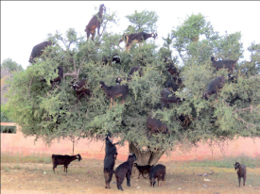
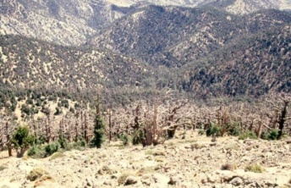

Figure 2: Example of ecosystem services
Figure 1 : Dryness

Recent Publications (minimum 5)
1. Taleb, M. S. & Fennane, M., 2019.- Forests and preforests. Geobotany studies pp.1-40. Springer.
2. Taleb, M. S. & Fennane, M., 2019.- Aquatic (fresh water) and hygrophile environments. Geobotany studies pp.79-88. Springer.
3. Taleb, M. S. & Fennane, M., 2019.- Lawns, pozzines and meadows of high mountains. Geobotany studies pp.63-69. Springer.
4. Taleb, M. S. & Fennane, M., 2019.- Saharan, steppic or pre-steppic vivace communities (Shrublets and/or Graminaceous Herbs) and annual or perennial vegetation (incl. Adventices, Messicoles, Ruderals. Geobotany studies pp.119-147. Springer.
5. Taleb, M. S. & Fennane, M., 2019.-. Coastal, lagoon, estuarian and marine ecosystems. Geobotany studies pp.107-117. Springer.
6. Taleb, M. S. & Fennane, M., 2019.-. Terrestrial (Inland and Coastal) halo-gypsophile vegetation. Geobotany studies pp.89-105. Springer. 12
7. Taleb, M. S. & Fennane, M., 2019.-. Rupicolous communities. Geobotany studies pp.71-78. Springer.
8. Taleb, M. S. & Fennane, M., 2019.-. Matorrals and spiny high-mountain xerophytes. Geobotany studies pp.41-62. Springer.

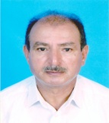
Biography (150 word limit)

Author and co-author of several scientific publications (Book in Springer and 45 publications in international revues: Acta Botanica Malacitana, Flora, Plant Ecology, Botanical Journal of the Linnean Society, Springer etc.) in ecology, flora, vegetation and biodiversity conservation. Expert followed many projects related to biodiversity assessment and conservation. Participated and presented oral papers and posters in many national and international scientific events (Conferences, Workshops and Congress etc.).
- Member of the Multidisciplinary Expert Panel (MEP) of Intergovernmental Science-Policy Platform on Biodiversity and Ecosystem Services (IPBES).
- Member of The Asahi Glass Foundation
- Member of the International Association of Botanical Gardens.
- Member of the CEM / EMP International IUCN program:
1- Ecosystem Red List
2- Dryland Ecosystem
3- Mountain Ecosystem
Email: talebmsg@yahoo.com

Notes/Comments: To attend the summit I will need a financial support

