Abstract Template

Distribution of extreme weather and its socio-economic losses in China

Zhao CL1, 2, 3, Chen JG1, 2, 3*, Yuan HY1, 2, 3
1Department of Engineering Physics, Tsinghua University, Beijing, China
2Institute of Public Safety Research, Tsinghua University, Beijing, China
3Beijing Key Laboratory of City Integrated Emergency Response Science, Beijing, China

Keywords: Natural Disaster Index; Climatic Disaster

- Abstract Body (up to 300 words)
Climate change and extreme weather have led to huge social and economic losses. This study aims at exploring the spatial relevancy of extreme climate and losses or impacts caused by climatic disaster. Percentile threshold method is used to evaluate the temporal and spatial distribution characteristics of extreme temperature and precipitation; the Natural Disaster Index is used to measure the socio-economic losses caused by meteorological disasters; and the relevance between extreme climate and socio-economic losses due to climatic disaster are discussed and analyzed. The results show, 1) For extreme temperature, the cold spell duration indicator leads to more losses on social economy than cool nights indicator, and low-temperature disasters are mainly distributed in northern and southern regions of China; 2) Extreme drought weather measured by consecutive wet days indicator is concentrated in northern and southwestern region, while the socio-economic losses focus on northern region rather than the southwest; 3) The distribution of extreme precipitation and losses caused by floods maintain a high consistency in the southeast of China; 4) Integrated Natural Disaster Indexes shows that the central and southwest region is suffering serious losses caused by climatic disaster, followed by northern region. Floods disasters account for 44.1% of frequency of natural disasters, ranking the first of climate disasters losses. We hope this study can provide theoretical and data reference for regional disaster prevention and climatic disaster emergency work.

Image:
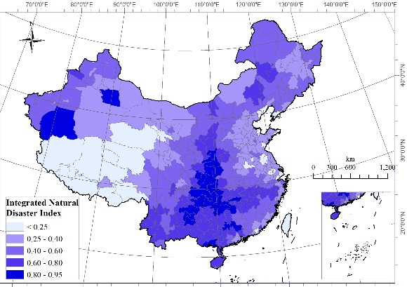
Figure: Distribution of Integrated Natural Disaster Indexes in China
- Reference:

1 Fischer, E.M.; Knutti, R. Anthropogenic contribution to global occurrence of heavy-precipitation and high-temperature extremes. Nat. Clim. Chang. 2015, 5, 560-564.

- Kantamaneni, K. Sponge Cities: A Perfect Solution for China’s Urban Flooding Problem! In proceedings of Urban Flooding and Sponge Cities Conference, Shenzhen, China, 3–5 July 2017, pp:2-19.

- Wang, Y.; Yan, Z.; Chandler, R.E. An analysis of mid-summer rainfall occurrence in eastern China and its relationship with large-scale warming using generalized linear models. Int. J. Climatol. 2010, 30, 1826-1834

Biography:
Zhao Chunli has completed his PhD at the age of 28 years from Research Center for Eco-Environmental Sciences, Chinese Academy of Sciences. She is taking her postdoctoral researches in Institute of Public Safety Research, Tsinghua University, China. She has published more than 10 papers in reputed journals.

Presenting author details


Full Name: Zhao Chunli
Contact number: +86-010-62792881
Twitter account:
Linked In account:
Session name/ number:
Category: Poster presentation
Passport Number: E62336159

