Title: Effects of air pollutants on the mortality of cardiovascular disease in Hefei, China, 2007-2016: a time-series study
Jinxia Zhai¹, Jixiang Xu¹, Changchun Xiao²
¹Department of Occupational and Environmental Health, School of Public Health, Anhui Medical University, 81 Meishan Road, Hefei, Anhui Province, 230000, China
²Hefei Center for Disease Control and Prevention, 86 Luan Road, Hefei, Anhui Province, 230000, China
Keywords: air pollution; cardiovascular disease; distribution lag nonlinear model; sensitive population
ⅠAbstract Body
Background: cardiovascular disease poses a huge economic and health burden worldwide. However, the sensitivity of people to air pollutants varies from region to region, and there are few studies on the relationship between air pollutants and cardiovascular disease death in specific areas.This study evaluated the impact on air pollutants on the number of cardiovascular deaths in Hefei, China. Daily data on cardiovascular death, daily air pollutant concentration and meteorological factors from 2007 to 2016 were included in this study. We established a time-series study design and applied a distributed lag nonlinear model to evaluate the association between every IQR increment of air pollutants and a percent increase of resident cardiovascular death. Subsequently, these associations were examined by gender, age group and sub-layer of cardiovascular disease to arrive at sensitive populations. There were 34,500 cases of CVD during the period 2007-2016, and the average number of daily CVD death was 9.44. PM₁₀, SO₂, NO₂, PM_{2.5}, CO, O₃ were observed to be strong and significantly associated with cardiovascular deaths at lag0-6 days, lag0-5 days, lag0-5 days, lag0-4 days, lag0-3 days and lag0-5 days, respectively. Females for cardiovascular deaths were more vulnerable to air pollution than males. In the age subgroup, residents ≥65 years old more sensitive to PM₁₀, CO and O₃, residents <65 years old were more sensitive to the effects of SO₂, NO_{2,} and PM_{2.5}. Therefore, effective measures should be taken to strengthen the management of air pollutants, especially SO₂ and NO₂, to enhance the protection of air pollutants among high-risk groups and to reduce the death of cardiovascular diseases caused by air pollution.

ⅡImage
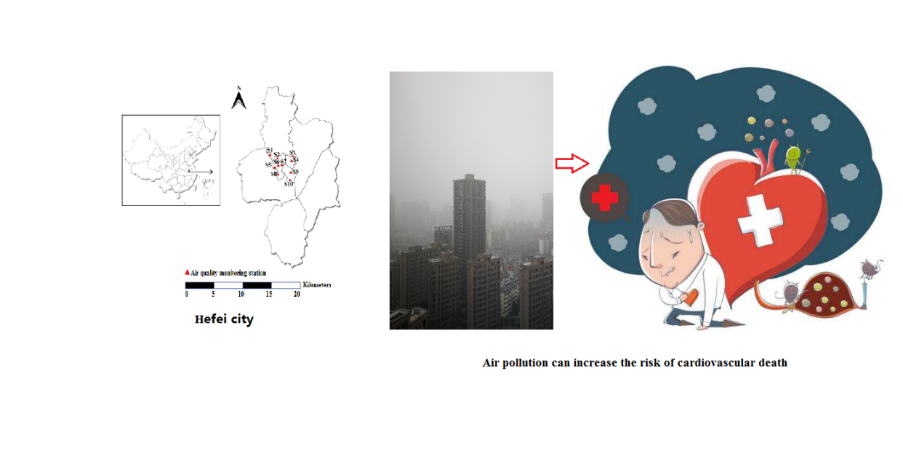

Ⅲ. Reference:
1.Dehbi HM, Blangiardo M, Gulliver J, Fecht D, de Hoogh K, Al-Kanaani Z, et al. Air pollution and cardiovascular mortality with over 25years follow-up: A combined analysis of two British cohorts. Environment international. 2017; 99:275-81.
2.Lu F, Zhou L, Xu Y, Zheng T, Guo Y, Wellenius GA, et al. Short-term effects of air pollution on daily mortality and years of life lost in Nanjing, China. The Science of the total environment. 2015; 536:123-9.
3. Dong G-H, Qian Z, Wang J, Chen W, Ma W, Trevathan E, et al. Associations between ambient air pollution and prevalence of stroke and cardiovascular diseases in 33 Chinese communities. Atmospheric Environment. 2013; 77:968-73.

Ⅳ Biography:
Jinxia Zhai, Ph.D., associate professor, graduated from Anhui Medical University, has been engaged in the study of environmental risk factors for chronic diseases, focusing on meteorological factors and the effects of air pollutants on diseases, and published dozens of SCIs. Member of the Youth Committee of the Public Health Professional Committee of the Chinese Medical Association, member of the Standing Committee of the Environmental Hygiene Committee of the Anhui Provincial Preventive Medicine Association, and member and secretary of the Health Branch of the Anhui Medical Association.

Ⅴ Presenting authordetails

Full Name: Jinxia Zhai
Contact number: +86 18156995788
Twitter account:none
Linked In account:none
Session name/ number:none
Category: (Oral presentation/ Poster presentation) Passport Number

