Abstract Template

Title: Evidence of Drought Events over Congo Basin since 1970
NONO NOUTCHIE Stève Yvan,
Ph.D student, Environmental Modeling and Atmospheric Physic Laboratory,
University of Yaounde I , Cameroon
Keywords: severe drought , extreme drought,
self-calibrated Palmer Drought Severity Index,
drought events, watershed

I- Abstract Body (up to 300words)

Since 1970, recurrent droughts have affected agriculture and ecosystems over Congo Basin (CB). The aim of this work is to capture hydro-climate events such as severe and extreme droughts and show its extent after 1970 over the domain. The method consists to apply self-calibrated Palmer Drought Severity Index and evalu ate its frequency and percentage of CB area in drought from the period 1905-2014 based on Climate Research Unit data. Results indicate that the increasing of severe and extreme droughts intensity after 1970 comes probably from little change in temper ature over the watershed with a negative average index of “-0.25” in 1990-1999 decade - 14:70% of CB area in drought. Before that date, high moisture remained homogeneously present over the entire basin marked by a positive average index of “1.13” in 1960-1969 decade corresponding to 2:60% of CB area in drought. 1970 is a break from the hydro-climatic regime on CB watershed.
- Image:
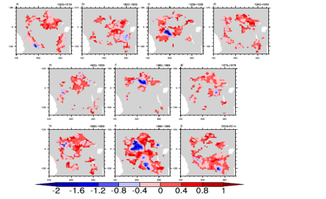

III.Reference :
- Chamani, R., Monkam, D., & Djomou, Z. Y. (2018). Analysis of return periods and return levels of Yearly July–September extreme droughts in the West Africa Sahel. Climate Dynamics, 1-13.

- Dai, A. (2016) Uncertainties in historical changes and future projection of drought. Part I, Climatic Change

- Biography
I am a Ph.D student at University of Yaounde I. My thesis project is based on « Analysis of multi scalar drought indice in Central Africa to adapt hydrological model : projection at Congo Basin scale. Iam also teached propagation w aves at private Institute in Y

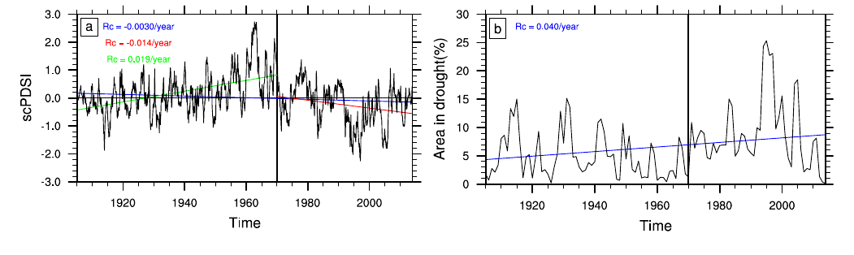V. Presenting author details
Full name: NONO NOUTCHIE STEVE YVAN
Contact number: 00237 675715158
E-mail: yvanono7@yahoo.fr/yvanono7@gmail.com

Session name/number: 4th world summit
Category: oral presentation
Passport number:

