Spatio-temporal Analysis of Lumpy Skin Disease Under Climate Change Scenarios

Fatemeh Alibaygi¹, Babak Mirbagheri1, Alireza Shakiba 1, Ali Akbar Matkan¹, Karim Amiri^{1.2}
1Department of Remote sensing & GIS, Shahid Beheshti University, Tehran, Iran
² Iran Veterinary Organization, Tehran, Iran

Keywords: Climate Change, Lumpy Skin, Maxent Model, Iran

- Abstract
In recent years, concerns about the impact of climate change on changing the pattern of spatial and temporal distribution of contagious diseases and the habitat of species are increasing. The main aim of this research is to model and predict the outbreaks probability of Lumpy skin disease virus (LSDV) in the cattle population in Iran for current the period 2012–2015 and future (2050) using presence-only maximum entropy ecological niche modeling (Maxent). To achieve the aim, independent bioclimatic variables (predictors) and 1778 LSDV outbreaks in cattle population were used. From 19 variables of bioclimatic, seven uncorrelated variables (four temperatures and three precipitation parameters) which are considered as the most important variables according to the Jackknife test were selected. In order to model future LSDV in the year 2050, the global climate model MPL-ESM-LR was used for two scenarios (RCP8.5, RCP4.5). The results show that the new areas of high outbreaks probabilities will be created by 2050 in northeast and west of Iran.

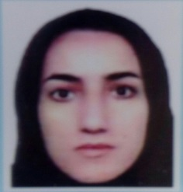
Image:
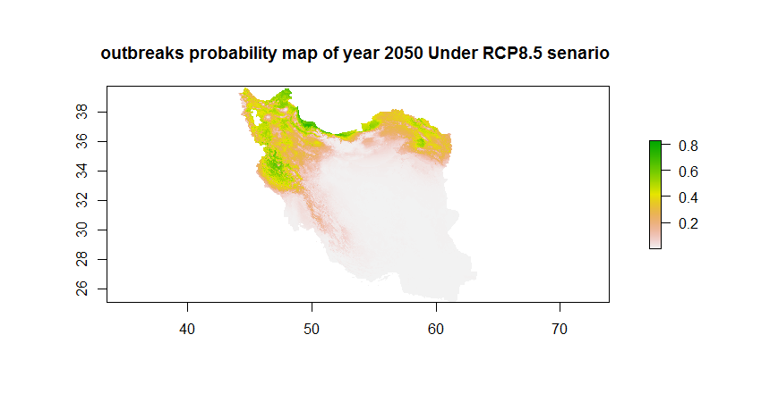

Reference:
- Phillips SJ, Andreson RP, Schapire RE. Maximum entropy modeling of species geographic distributions. Ecol Modell (2006) 190(3–4):231–59. doi:10.1016/j. ecolmodel.2005.03.026
- Hailu B, Tolosa T, Gari G, Teklue T, Beyene B. Estimated prevalence and risk factors associated with clinical Lumpy skin disease in north- eastern Ethiopia. Prev Vet Med (2014) 115(1–2):64–8. doi:10.1016/j. prevetmed.2014.03.013

Biography:
Fatemeh Alibeygi is Master Student of Remote sensing & GIS, at the age of 27 years from Shahid Beheshti University of Tehran , Iran.
Presenting author details

Full Name: Fatemeh Alibeygi Contact number: 989184195228
Session name/ number:
Category: (Oral presentation/ Poster presentation) Passport Number

