Assessment of Soil Organic Carbon Stocks Using Support Vector Regression Model
Under Climate Change Scenarios

Mohammadreza Geranmehr1, Alireza Shakiba1, Ali Akbar Matkan1, Babak Mirbagheri 1, Naser Davatgar 2,
1 Department of Remote Sensing and GIS, Faculty of Earth Science, University of Shahid Beheshti, Tehran, Iran.
2 Soil and Water Institute, Karaj, Iran

Keywords: Soil Organic Carbon, Climate Change, MLR, SVR

Soils are the biggest carbon store in the world (1500 Gt, e.g. 1.5×1021 g). Soil organic carbon (SOC) plays an important role in the carbon cycling of terrestrial ecosystems. The researches show that SOC contents increase with the increase in precipitations and decrease with a rise in temperature, however previous estimations of SOC variations in North West of Iran have not considered the direct effect of climate variables. The main aim of this research is estimation of the SOC variations in North West of Iran under climate change scenarios. In this study, at the first stage for current situation, SOC stocks were estimated using Multiple Linear Regression (MLR) and Support Vector Regression (SVR) models based on climate, land cover, elevation and soil data and Normalized Difference Vegetation Index (NDVI). The SVR had the lower root mean squared error (RMSE) and the higher $R^{2}$ values (14.87 Mg C ha⁻¹ and 0.62, respectively) than MLR. Then the selected model (SVR) was applied to predict SOC under climate changes scenarios for four representative concentration pathways (RCPs) and three times (2030, 2050 and 2070). The results indicate that in most land covers, SOC contents decrease in all mentioned times. The results also show that the methods used in this research can use for other parts of Iran where proper information on soil, land cover and climate are available.

Image:
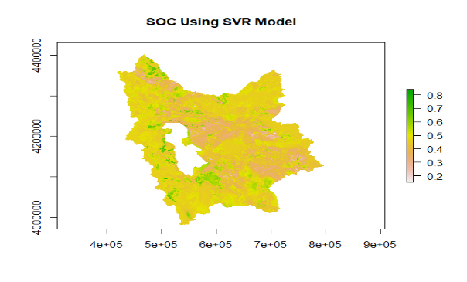
- Reference:

1 Fantappiè, M., G. L'Abate and E. Costantini (2011). "The influence of climate change on the soil organic carbon content in Italy from 1961 to 2008." Geomorphology 135(3-4): 343-352.

- Yigini, Yusuf, & Panagos, Panos. (2016). Assessment of soil organic carbon stocks under future climate and land cover changes in Europe. Science of the Total Environment, 557, 838-850.

Biography:
Mohammadreza Geranmehr is Master Student of Geography Information System and Remote Sensing at the age of 26 years old from Shahid Beheshti University of Tehran, Iran.

Presenting author details
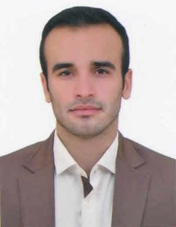
Full Name: Mohammadreza Geranmehr
Contact number: +989215746381
Twitter account: https://twitter.com/M_GeranmehrLinked In account:
Session name/ number:
Category: (Oral presentation/ Poster presentation) Passport Numbe

