Abstract

Title: Optimization of the Fuzzy Matter Element Method for Predicting Species Suitability Distribution Based on Environmental Data

Quanzhong Zhang^{1,2}, Haiyan Wei¹, Zefang Zhao^{1,2,3}, Jing Liu^{1,2}, Qiao Ran^{1,2,3}, Junhong Yu⁴ and Wei Gu^{2,3,5}
¹School of Geography and Tourism, Shaanxi Normal University, Xi’an, China
²National Engineering Laboratory for Resource Development of Endangered Crude Drugs in Northwest of China, Shaanxi Normal University,
Xi’an, China
³The Key Laboratory of Medicinal Resources and Natural Pharmaceutical Chemistry, the Ministry of Education, Shaanxi Normal University, Xi’an, China
⁴School of Mathematics and Information Science, Shaanxi Normal University, Xi’an, China
⁵College of Life Sciences, Shaanxi Normal University, Xi’an, China

Keywords: Species distribution modelling, Membership function, Suitability index, Climate change, GIS, Gynostemma pentaphyllum (Thunb.) Makino

- Abstract Body
Over the years, with the efforts of many researchers, the field of species distribution model (SDM) has been well explored. The model of fuzzy matter elements (FME), which, combined with GIS to predict species distribution, has received extensive attention since its emergence. Based on previous studies, this paper improved FME, extended the scope of the membership degree and habitat suitability index, and explored the unsuitable areas of species. We have enhanced the limitation effect of key variables on species habitats, making the operation of FME more consistent with biological laws. By optimizing the FME, it could avoid the accumulation of predicted errors with multi-variables, and make the predicted results more reasonable. In this study, Gynostemma pentaphyllum (Thunb.) Makino was used as an example. The experimental process used several major environmental variables (climate, soil, and terrain variables) to predict the habitat suitability distribution of G. pentaphyllum in China for its current and future period, which includes the period of 2050s (average for 2041–2060) and 2070s (average for 2061–2080) under representative concentration pathways 4.5 (RCP4.5). The results of the analysis showed that the model performed well with a high accuracy by reducing the redundancy of the environmental data. The study could relieve the reliance on a large database of environmental information and propose a new approach for protecting the G. pentaphyllum in unsuitable areas under climate change.

Image:

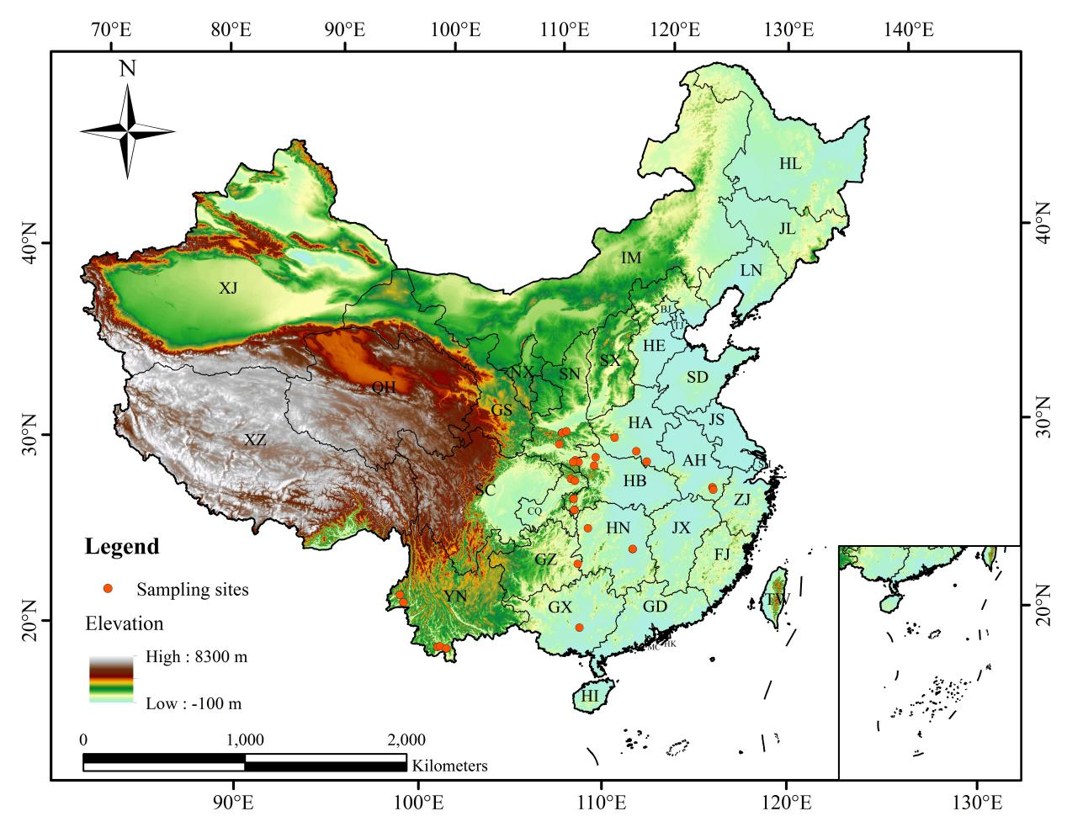
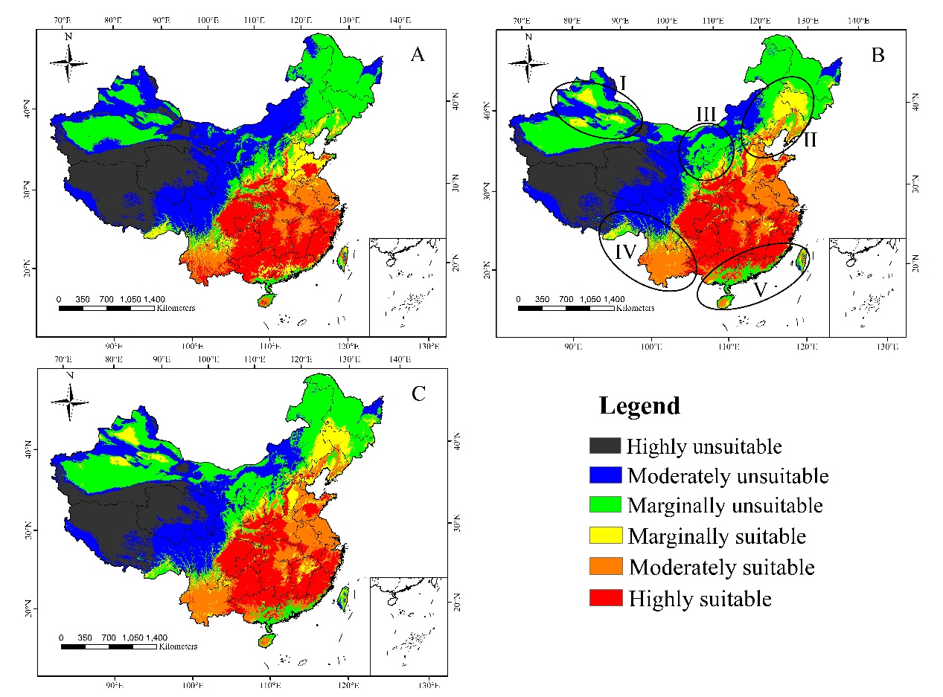
III. Reference:
1. Ottaviani, D., Lasinio, G.J. and Boitani, L. 2004. Two statistical methods to validate habitat suitability models using presence-only data. Ecol. Model., 179; 417–443
- Alexandreh, H. and Le, L.G. 2008. Habitat suitability modelling and niche theory. J. Appl. Ecol., 45; 1372–1381
- Cassini, M.H. 2011. Ecological principles of species distribution models: The habitat matching rule. J. Biogeogr., 38

IV. Biography:
Quanzhong Zhang will complete his Master’s degree next year from Shaanxi Normal University, China. He is majoring in SDMs and species biodiversity hotspot, especially, Bayesian network, Fuzzy matter element and R.

V. Presenting author details

Full Name: Quanzhong Zhang

Contact number: +86 13772432632
Email: Zhangqz@snnu.edu.cn

