Abstract

Title: Effects of climate change and multiple stresses on Sustainable development in Africa

Balgis Osman Elasha1,
1Climate Change and Green Growth Expert, African Development Bank, Tunis-Tunisia

Keywords: climate change, Multiple stresses, Africa, Sustainable development.

- Abstract Body (up to 300 words)
Based on the IPCC- AR5, Africa is one of the most vulnerable continents to climate change and climate variability. The vulnerability in Africa is exacerbated by the presence and interaction of multiple stresses such as, poor infrastructure particularly for water, health and energy, poverty and lack of stability. The climate change impacts are expected to be intensified by human-based activities driven by the continuous search for either the basic needs or a better quality life.
Addressing climate change concerns and other multiple factors highlighted above, needs a more comprehensive and integrated approach at different levels and scales. Meaning that, it should involve policy development and application of sustainability elements such as the broad participation (stressing the creation of awareness and education), addressing needs and providing necessary services on equal basis to all stakeholders, monitoring and evaluation of environmental, social and economic aspects including the quality of life indicators.
Drawing on desk reviews and case studies, this presentation will discuss the links between climate change and development with focus on Africa, the expected Impacts, and what policy measures and actions should be implemented to ensure sustainability.

Image:
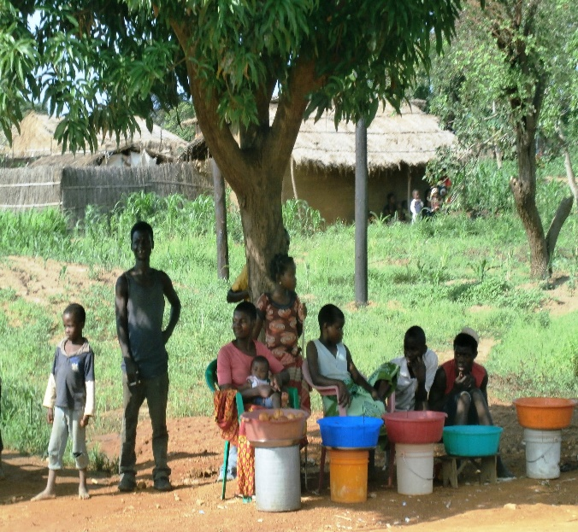
- Reference:
- United Nations. 2012. The Future We Want. Outcome document adopted at the United Nations Conference on Sustainable Development, Rio+20. Rio de Janeiro, Brazil: 20-22 June 2012. http:// www.uncsd2012.org/rio20/thefuturewewant.html
- Hardee, K and C Mutunga. 2009. “Strengthening the link between climate change adaptation and national development plans: lessons from the case of population in National Adaptation Programmemes of Action (NAPAs)”. Mitigation and Adaptation Strategies for Global Change.1. 15 (2).

Biography:
Holds a PhD in Forestry Science, Master in Environmental Science and a Bachelor of Science (B.Sc.) with Honour in Forestry and Agricultural Science – Currently working as a Climate Change Expert at the Climate Change and Green Growth Division at the African Development Bank (AfDB) since 2009. Have more than twenty years’ experience in climate change issues with special focus on vulnerability and adaptation assessment related to African countries. My work focuses on sustainable development, with special emphasis on human dimension of global environmental changes. Have served as a lead Author in the Inter-Governmental Panel on Climate Change (IPCC) and other global assessments.

Presenting author details

Full Name: Balgis Osman Elasha
Contact number: +21658851415
Twitter account: Linked In account: Balgis@yahoo.com
Session name/ number:
Category: (Oral presentation/
Passport Number:P02005983

