Abstract

Title: Projection of future streamflow of the Hunza River Basin, Karakoram Range (Pakistan) using HBV hydrological model

Ayaz Fateh Ali ^{1, 2}, Xiao Cunde^{3,}*, Zhang Xiaopeng ^{1, 2}, Muhammad Adnan^{1, 2}, Mudassar Iqbal^{2, 4},
Garee Khan⁵
1 State Key Laboratory of Cryospheric Science, Northwest Institute of Eco-Environment and Resources, Chinese Academy of Sciences, Lanzhou 730000, China
2 University of Chinese Academy of Sciences, Beijing 100049, China
3 State Key Laboratory of Land Surface and Resource Ecology, Beijing Normal University, Beijing 100875, China
4 Key Laboratory of land Surface Process and Climate Change in Cold and Arid Regions, Northwest Institute of Eco-Environment and Resources, Chinese Academy of Sciences, Lanzhou 730000, China
5 Department of Earth Sciences, Karakoram International University, Gilgit 15100, Pakistan

Keywords: HBV-Light; Hydrological modeling; Hunza River; Upper Indus Basin; Snow and glacier-melt

- Abstract Body (up to 300 words)
Hydrologiska Byrans Vattenbalansavdeling (HBV) Light model was used to evaluate the performance of the model in response to climate change in the snowy and glaciated catchment area of Hunza River Basin. The study aimed to understand the temporal variation of streamflow of Hunza River and its contribution to Indus River System (IRS). HBV model performed fairly well both during calibration (R2=0.87, Reff=0.85, PBIAS=-0.36) and validation (R2=0.86, Reff=0.83, PBIAS=-13.58) periods on daily time scale in the Hunza River Basin. Model performed better on monthly time scale with slightly underestimated low flows period during both calibration (R2=0.94, Reff=0.88, PBIAS=0.47) and validation (R2=0.92, Reff=0.85, PBIAS=15.83) periods. Simulated streamflow analysis from 1995-2010 unveiled that the average percentage contribution of snow, rain and glacier melt to the streamflow of Hunza River is about 16.5%, 19.4% and 64% respectively. In addition, the HBV-Light model performance was also evaluated for prediction of future streamflow in the Hunza River using future projected data of three General Circulation Model (GCMs) i.e. BCC-CSM1.1, CanESM2, and MIROCESM under RCP2.6, 4.5 and 8.5 and predictions were made over three time periods, 2010-2039, 2040-2069 and 2070-2099, using 1980-2010 as the control period. Overall projected climate results reveal that temperature and precipitation are the most sensitive parameters to the streamflow of Hunza River. MIROC-ESM predicted the highest increase in the future streamflow of the Hunza River due to increase in temperature and precipitation under RCP4.5 and 8.5 scenarios from 2010-2099 while predicted slight increase in the streamflow under RCP2.6 during the start and end of the 21th century. However, BCCCSM1.1 predicted decrease in the streamflow under RCP8.5 due to decrease in temperature and precipitation from 2010-2099. However, CanESM2 predicted 22%-88% increase in the streamflow under RCP4.5 from 2010-2099. The results of this study could be useful for decision making and effective future strategic plans for water management and their sustainability in the region.

Image: Study Area

- Reference:

- Adnan, M., N. Ghulam, K. Shichang, G. Zhang, R.M Adnan, M.N. Anjum, ,M. Iqbal and A.F Ali, 2017. Snowmelt runoff modelling under projected climate change patterns in the Gilgit River Basin of Northern Pakistan. Pol. J. Env. St., 26; 525-542

- Akhtar, M., N. Ahmad and M.J. Booij, 2008. The impact of climate change on the water resources of Hindukush–Karakorum–Himalaya region under different glacier coverage scenarios. J. hyd., 355; 148-163

- Ali., A.F, C. Xiao , M.N. Anjum, M. Adnan, Z. Nawaz, M.W. Ijaz, M. Sajid and H.U. Farid, 2017. Evaluation and Comparison of TRMM Multi-Satellite Precipitation Products With Reference to Rain Gauge Observations in Hunza River Basin, Karakoram Range, Northern Pakistan. Sus., 9(11)

Biography:
I was born in Lahore City of Punjab Province, Pakistan. I have successfully passed every academic milestone of my education by always ranking as good student in my class. After analyzing my past interests and final ambition I have decided to pursue my masters in Geography.
The graduate program at University of Punjab, Lahore provided me with strong foundations of Geography and exposed me to its various fields. My period in Punjab University have provided me with a strong foundation in my field, this postgraduate reputed program increased my knowledge and shaped me into a good researcher, along with this my working experience in Beacon House Schooling system paid a lot to me. Working experience at Beacon as Lecturer inclined my attention towards my higher education.
Based on the above aim and objective I found the PhD in “Northwest Institute of Eco-Environment and Resources, Lanzhou China” Chinese Academy of Sciences, China, very useful and it provides an excellent opportunity to pursue my PhD, this university suited for my goals and it will help me improve my credentials at theoretical and practical basis to learn more in-depth about GIS applications. The program will provide an enabling ground to enjoy an intellectual and international exposure as well as a lifetime opportunity to expand a professional network with its multiple impacts in post degree time frame.
My field of interest especially focuses on “Glaciers melting and its impacts on lives of downstream communities using GIS and Remote Sensing technology”.
I am confident that you will give me an opportunity; I will be proved useful and could make significant contribution to a going research.
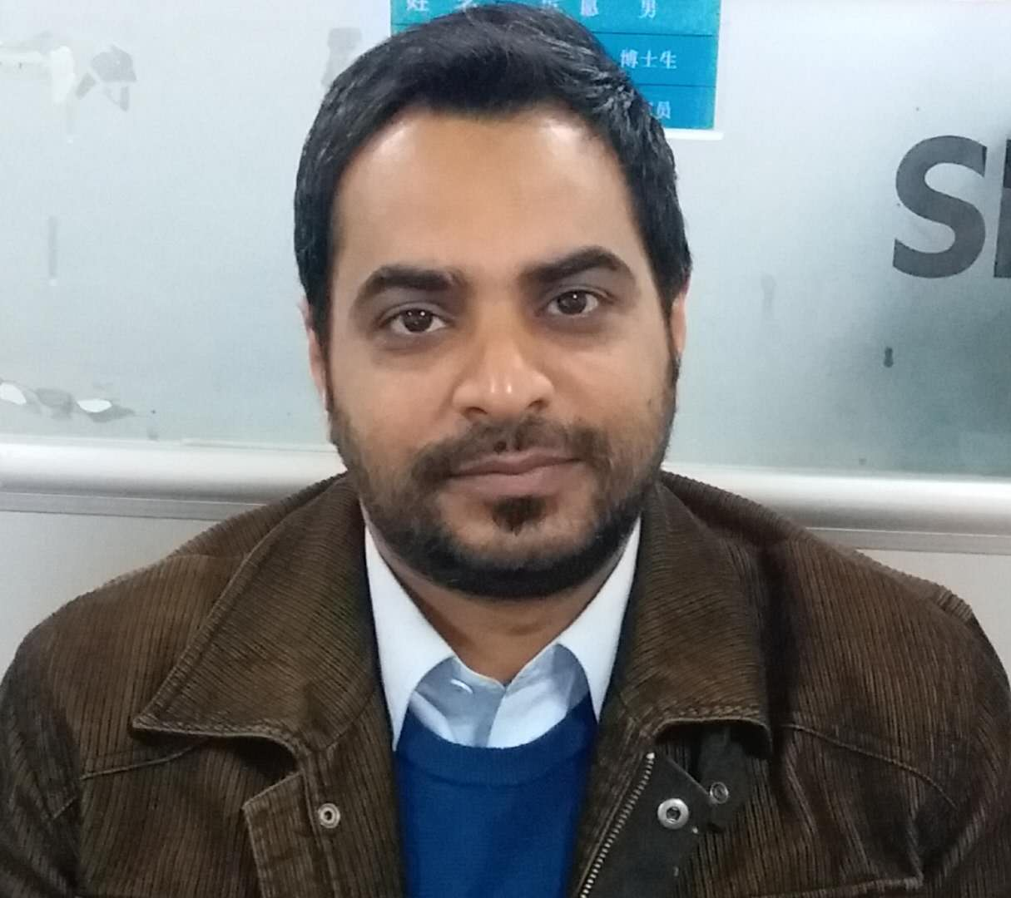

Presenting author details

Full Name: Ayaz Fateh Ali
Contact number: +8618609447913
Twitter account:
Linked In account:
Session name/ number:
Category: (Poster presentation)
Passport Number: ME1795673

