Abstract Template

Title: Estimation of SOM-stock after 35 years of critical land rehabilitation using Pinus mercusii in Aripan, West Sumatra, Indonesia

Yulnafatmawita Yulnafatmawita¹³, Fajrina Ulfa¹, Zainal A.Haris²

¹Soil Physical Laboratory Agriculture Faculty, Andalas University, Padang INDONESIA, 25164
2University Putra Indonesia, Kampus UPI YPTK Padang INDONESIA
³Corresponding author: yulna_fatmawita@yahoo.com

Keywords: Aripan, OC stock, pinus merkusii, rehabilation land, sloping land

- Abstract Body
Soil OM content can be used as an indicator of soil quality. Disappearance of OM from the top soil causes land degradation. Soil OM is mostly determined by the vegetation growing on it if the other environmental factors are homogeneous. A research on OM stock estimation was conducted on degradation land after being rehabilitated using pine (Pinuss mercusii) for approximately 35 years in Aripan, Solok Regency, West Sumatra Indonesia. Soil samples were taken from 3 different ranks of slope (15-25%, 25-45%, and >45%) and from secondary forest for comparison from the top 40 cm soil depth with 20 cm interval. The result showed that, generally SOM stock at the top 20 cm was higher than that at 20-40 cm soil depth. Total OM content at the top 40 cm soil depth linearly decreased (r=-0,97) by increasing slope grade from slightly steep (15-25%) to highly steep (>45%). The highest OM stock at rehabilitated land was 88.93 t/ha at 0-20 cm soil depth (for slope 15-25%). It was about 131% compared to the OM stock at slope grade > 45%. However, the value was still lower than the OM stock (115.63T/ha) under forest land use, it was still approximately 77% of that at forest land use. Soil OM stock at 0-40 cm depth was about 67%, 79%, and 97% of that at forest land use for slope >45%, 25-45%, and 15-25% respectively. Soil OM content in this rehabilitation land linearly affected soil bulk density (r=-0.74) but not soil aggregate stability.

Image:
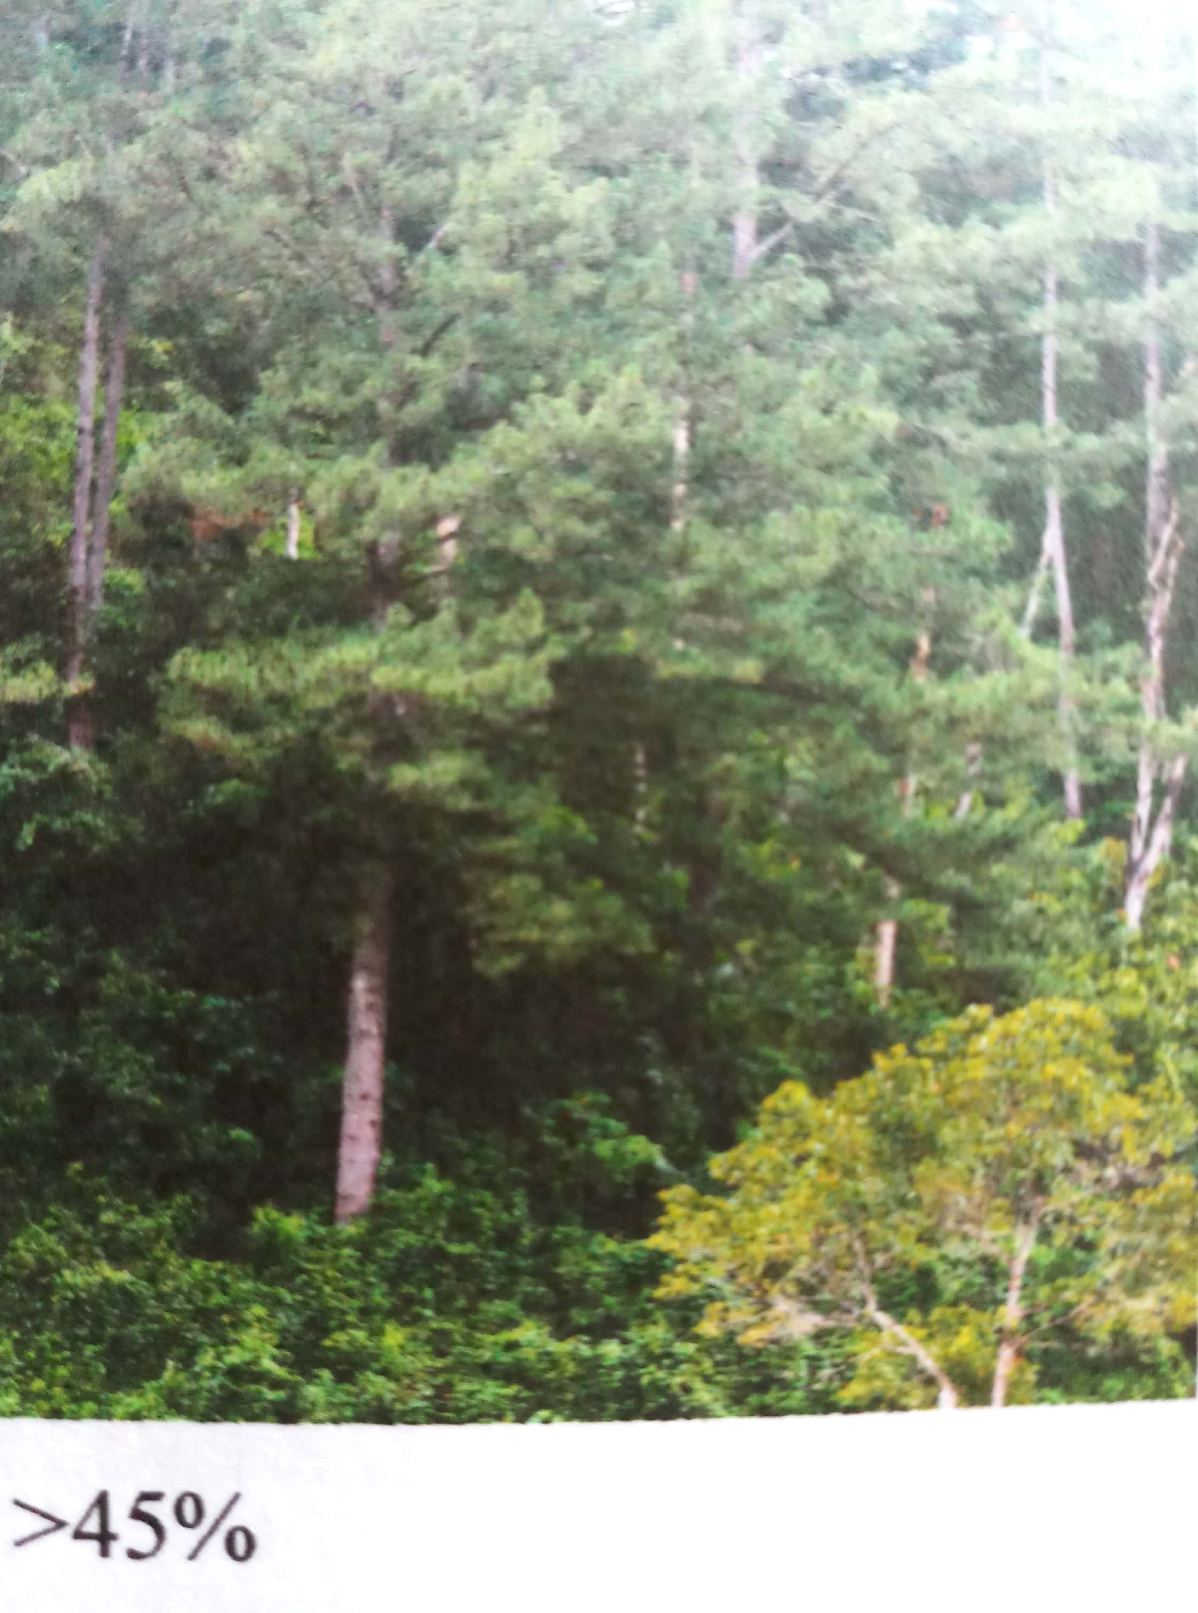
Pinus trees at Slope > 45%

- Reference:

1. Yulnafatmawita, Y. and S. Yasin, 2018. Organic carbon
sequestration under selected land use in Padang city. IOP Conf. Series: Earth and Environmental Science 129 (2018) 012021 doi :10.1088/1755-1315/129/1/012021
- Lorenz, K. and R. Lal. 2014. Soil organic carbon sequestration in agroforestry systems. A review. Agron. Sustain. Dev. Vol. 34(2): 43–454https://doi.org/10.1007/s13593-014-0212-y
- Yigini, Y. and P. Panagos. 2016. Assessment of soil organic carbon stocks under future climate and land cover changes in Europe. Sci. Tot. Environ. Vol 557-558:838-850. https://doi.org/10.1016/j.scitotenv.2016.03.085

Biography:
Yulnafatmawita has completed her PhD from The University of Queensland, Australia. Now she is a lecturer at Faculty of Agriculture, Andalas University, Indonesia. During her PhD, she joined CRC Greenhouse Gas Accounting (1999-2003). She did research for her PhD degree on CO2 emission from cultivation Black Earth and Ferrosol soils.

Presenting author details

Full Name: Yulnafatmawita Yulnafatmawita
ure
Contact number: +6281267148412
Twitter account: -
Linked In account: -
Session name/ number:
Category: (Oral presentation/
Poster presentation)
Passport Number: B9830880

