Title: Climate Change and Sustainability in Nigeria: The Developing Nations perspective, cause, effects and mitigations.

Greg Anyiador1, BSc Chemistry, MBA1, 2,
1Environment, Safety & Operations Department, OML 42 AMT, (NPDC/Neconde JV), Nigeria

Keywords: climate change, ocean swell, desertification, Perspective, Niger Delta, afforestation, savanna vegetation, gas flaring

- Abstract Body (up to 300 words)
This paper reviews one of the most urgent international topic of contemporary times; the challenges and Impacts of climate change as it affects developing and less developed nations using the Nigeria experience as case study and the opportunities sustainability presents for attaining green cities and economies of the future. Nigeria has been buffeted by desert encroachment from the north – southwards, ocean swells, soil erosions in the southern coast leading to coastal flooding and loss of lands, and their attendant socioeconomic effects such as herdsmen-farmer clashes over diminishing fertile land, low /poor agricultural yields , hunger, poverty , militancy and crime in a mutually reinforcing vicious circle is vital in the study of the impact and mitigation of climate change and its social-economic impact.. Nigeria with a population of over 180m, that is estimated to hit 259m by 2050, of which over 50% lives in the cities. Studies indicates that over 75% of greenhouse gases are generated in the cities, hence Nigeria and other developing nation, with large and growing population, coupled with high rural – urban migration is critically important in the global mitigation and adaptive strategy to tackle climate change. Nigeria in recognition of the consequences and adverse impact of climate change, is actively collaborating with the global community and has adopted treaties meant to tackle climate change. Such as the UNFCCC in 1992, ratified the Convention in 1994, the Kyoto Protocol of 2004. And ratified the Paris Agreement (PA) in March 2017.
The paper reviews the main culprits of greenhouse gases in Nigeria - gas flaring, low carbon electrification and unplanned mega city development following from population explosion and its concluded by looking at ongoing initiatives to mitigate the climate change impacts and opportunities available for sustainable development of green cities of the future.

Image:

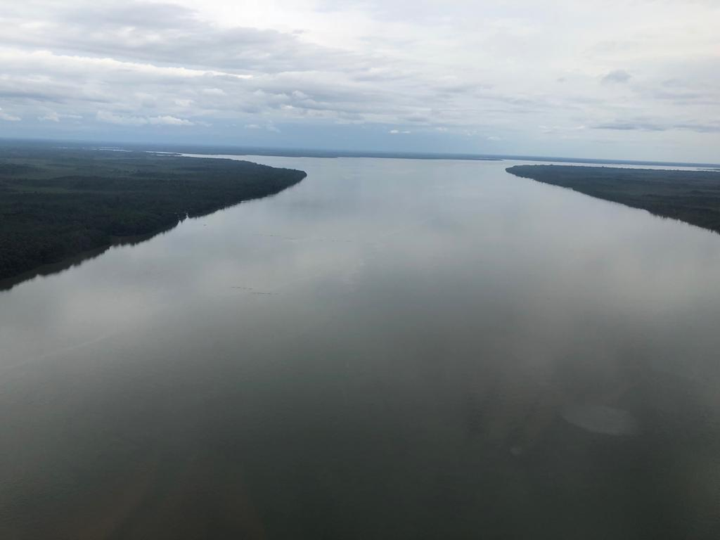
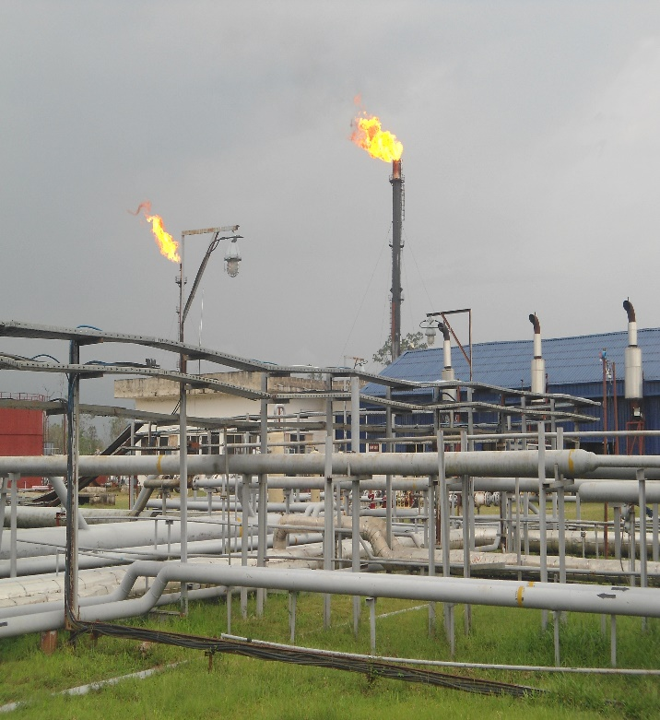
- Reference:

- World Bank Group Environmental Health and Safety Guidelines

- Impact of Climate Change in Nigeria
A.A. Idowu, S.O. Ayoola, A.I. Opele and N.B. Ikenweiwe

Department of Aquaculture and Fisheries, Management, University of Agriculture, Abeokuta, Ogun State. Department of Marine Sciences, University of Lagos, Akoka, Yaba, Lagos State, Niger

- IFC Performance standard on environmental and social sustainability Report. January 2012

- Awosika, L.F., G.T. French, R.T. Nicholls and loss C.E. Ibe, 1992. The impact of sea level rise on the coastline of Nigeria [O’ Callahan J. (E.d.)] In: Global climatic change and the rising challenge of the sea.
Proceedings of the IPCC workshop of Margarita
Island Venezuela, 9-13 March 1992. National
Oceanographic and Atmospheric administration,
Silver spring, M.D., U.S.A, pp: 690.

Biography:
Gregory Anyiador bagged a Bachelor of Science Degree in Chemistry from the University of Benin and an MBA from the Lagos Business School, both in Nigeria. and has attended many overseas training and conferences. He is the Head, Safety & Environment, on the OML 42 AMT JV (Nigerian Petroleum Development Co (NPDC)/Neconde JV). He has published more than 10 papers in reputed journals and has served on several boards including the Economist Intelligent Unit.

Presenting author details

Full Name: Anyiador Omolua Gregory
Contact number: +2348037133918Twitter account: omogrego
Session name/ number: Track 12: Climate Change and sustainability
Category: (Oral presentation)
Passport Number: A05966611

