In what circumstances seasonal runoff may be useful for recharge of an aquifer (Case study)

Tabatabaee Yazdi, J 1
1 Assist. Prof. (retired), Agricultural Research,Education and Extension Organization (AREEO), Secretary, Iranian Rainwater Catchment System Association (IRCSA), Iran.

Keywords: groundwater, recharge, rainfed, seasonal runoff, Runoff harvesting

- Abstract
Kohsorkh basin belongs to Kashmar district and is located in Khorasan-e-Razavi province (North-East of I.R.Iran). Around 16000 ha rainfed almond trees have been cultivated in this area which is the most important source for income of local farmers and villagers. It is about less than a decade that these trees have started to become dry. During a visit to the area it was realized that those trees located in the upstream part of the area has remained very productive where as those parts located in the downstream are being dry and non-productive. It is agreed by most specialists that the main reason for trees dryness has caused by seasonal run off variation which has happened because of climate change and drought condition. Therefore the only reason that could have survived the upstream part of the cultivated areas should be depended on the existent of subsurface soil moisture content. It was predictable that impervious layer is not so deep in the upper part of the basin so that in case of any possible recharge happening from the sub-catchments, it could have been reachable by trees’ root. Whereas the any possible subsurface flow could not be helpful for downstream part because of two simple reasons: firstly the current may not be enough to reach the lower region and secondly the impervious layers goes so deep in the lower part that trees’ root may not be able to make benefit of that. Above mentioned hypothesis have been approved during a systematic office and field investigation including meteorology, hydrology, geology and model study making use of several well logging and in situ tests. Lack of groundwater and deep impervious layer in was distinguished in three test pits which were dug in downstream parts. Hydraulic conductivity (double ring) and pumping tests has been carried out for quantifying the permeability of overburden material. The results was in agreement with abovementioned hypothesis as follows: overburden material deposited at the upstream were consist of silt and fine sand with high permeability so that most of the seasonal flow could have been infiltrated into the shallow stream bed and being used by trees root cultivated in the upper part. It is therefore recommended to try to slow down the seasonal runoff as much as possible in order to help more and more water being recharged into the upstream aquifer in order to maintain the water availability in the upper part of the basin. However, flood water in excess of upper part soil field capacity may flow down to be used by trees cultivated in the downstream.

Image:
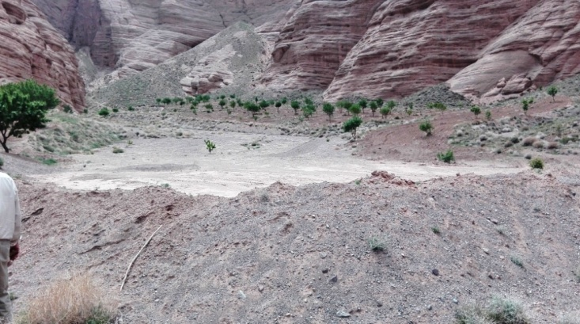

- Reference:

- Ngigi, N., H.G. Hubert and N. Josephine, 2005, Agro-hydrological evaluation of on-farm rainwater storage systems for supplemental irrigation in Laikipia district, Kenya, Agricultural Water Management 73, 21–41

- Tabatabaee, J., H. Tavakoli, A.A. Abbasi and M.Y. Han (2008). Rainwater Harvesting Potentials for drought mitigation in Iran, The 2nd International Conference on Rainwater Harvesting and Management, Tokyo, Japan

- Johnson, T., 2011, The Increasing Role of Storm Water for Groundwater Recharge in the Central Basin, Los Angeles Coastal Plain, Southern California Managed Aquifer Recharge Symposium, Irvine, California, 25-26

Biography:
Dr. Yazdi has completed his PhD in 1994 in the Dept. of Civil Eng., UNSW, Sydney, Australia and Postdoctoral Studies in 2009 in the Rainwater Lab., School of Civi Eng., SNU, Koera, He has retired in 2014 as Assist. Prof. from Dept. of Watershed Management in the Research, Education and Extension Organization, Ministry of Agri. Iran and is now secretary of Iranian Rainwater Catchment Systems Association where is founded by himself in 2010. He has published more than 50 papers in reputed journals and Int. seminars.

Presenting author details
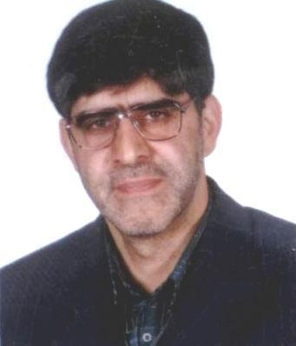
Full Name: Javad Tabatabaee Yazdi
Contact number: +98 915 5000 678
Linked In account: Javad Tabatabaee Yazdi
Session name/ number: Climate change and adaptability development
Category: Oral presentation
Passport Number: U 34202448

