Impact of climate change on the evolution of the pine processionary moth, Thaumetopoea pityocampa , at Aures, Algeria
TARAI Nacer¹, MIHI Ali ² ¹
1 Department of Agricultural Sciences, University of Biskra, Algeria, e-mail: tarainacer@yahoo.fr
2 Department of Biological Sciences, University of Setif, Algeria
Key words: pine processionary moth, male, forest, Mezbel, temperature, precipitation, altitude
I. Abstract
The pine processionary moth, Thaumetopoea pityocampa (Lepidoptera: Notodontidae) is a phytophagous insect reported in the region of Aures, Southern Algeria. This latter extends between parallels 34°45’ and 35°30’N and longitude 5°45’ and 7°E of the international meridian. During the last five years a study was conducted at five stations in the forest of Mezbel, to determine the effect of climatic factors, temperature and precipitation. Mean total precipitation for the year’s most humid months exceed 70 mm on axis oriented E-W, then fade in the center with 50 mm and finally decrease to the south with 20 mm. The population dynamics is related to the differences between the summit north and south and the other between the east and west either precipitation or thermal. Sex pheromone traps were installed according to the direction, south, east, west, north, during the period of the flight of males. The number of pine processionary moth males captured is important at a mean temperature higher than 20°C, and the relationship between the accumulated weekly precipitations is negative. The relation between altitude and the number of male moths captured was also analyzed.
II. Image
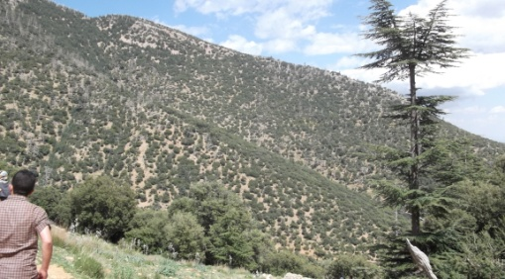

III. Reference:

- Pearson RG, Dawson TP, 2003. Predicting the impacts of climate change on the distribution of species: are bioclimate envelope models useful?Global Ecology and Biogeography, 27, 2, (245-256), (2017).
- Leitner M. and Kühn I., 2017. Dispersal in Plants and Animals, Diffusive Spreading in Nature, Technology and Society, 3, (29-47).
- Harrington R., Fleming R.A. and Woiwod I.P. Climate change impacts on insect management and conservation in temperate regions: can they be predicted? Agricultural and Forest Entomology, 3,233-240.

IV- Biography:

TARAI Nacer : Professor , Department of Agricultural Sciences, University of Biskra, Algeria , PhD in Agricultural Sciences since 2012, Project Manager, Bioaggressors and control methods , DEDSPAZA laboratory , Faculty of Exact Sciences , Natural and Life Sciences. . He has published more than 10 papers in reputed journals.
V-Presenting authordetails

Full Name:TARAI Nacer Contact number:
Twitter account:
Linked In account:
Session name/ number:
Category: (Oral presentation)
Passport Number: 153010777

