
World Summit on
Climate Change and Global Warming
November, 26-27, 2018 |Tokyo | Japan

Title: Footprints of Climate Change: Historical Sources and Evidence in Iran

Aliakbar Shamsipour1
1Department of Physical Geography, Faculty of Geography, University of Tehran, Tehran, Iran

Keywords: Climate change, Historical records, Central plateau of Iran, Natural Variance, Anthropogenic forcing

- Abstract
Climate change has been a “hot topic” of scientific discussion not only in recent times but equally as far back as the last centuries and even millennia. Main reasons for opposition to climate change occurrence are distrust of weather station data and predictions of climatic models at different scales. The objective of this research is to analyze the qualitative, descriptive and historical occurrence of climate changes on the central plateau of Iran in the past decades, centuries and millennia based on written sources obtained from travelogues, articles and historical books. The research was carried out using fundamental and historical methods based on documentary and natural evidence of land surface changes in lake and river water levels, morphology of surface features and related phenomena, vegetation covering and land use patterns.
The results of this historical research indicate that around the year 1000, as well as the fourteenth, seventeenth and early eighteenth centuries were wet times, while the sixth, nineteenth and twentieth centuries were times of drought in Iran. Such results are indicative of cyclical, or periodic, climatic variation in different regions of Iran. The conclusion of this paper argue that despite the occurrence of naturally-occurring humid and dry cycles, there is an overall lack of fundamental change in climatic conditions in recent centuries in Iran. This historical perspective provides an opportunity to put current climate change into a larger temporal context in order to better understand what may constitute natural variance and what may constitute anthropogenic forcing of climate change.

- Image:
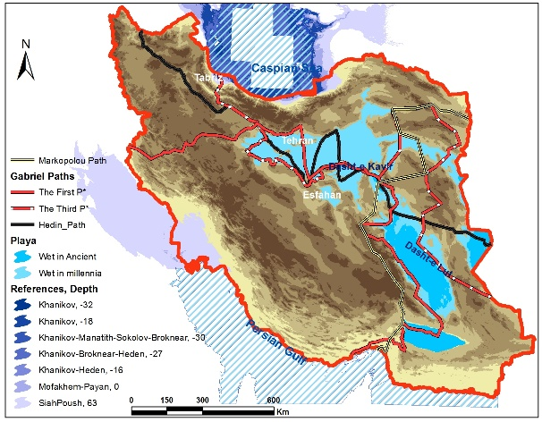

- Reference:

1 Hedin, S.A, 1910. Zu land nach indien: Durch Persien, Seistan, Belutschistan - Erster Band I. F.A. Brockhaus; Leipzig, ASIN: B00B513B0O.

- Gabriel, A., 1935. Duerch Persiens Wuesten, neue Wanderungen in den Trockenraumen Innerirans. Stuttgart, Strecker und Schroder Verlag, 272 P., ASIN: B003WUGK40.

- Sheil, L.Mary, 1856. Glimpses of life and Manners in Persia. London: John Murray, Albernarle street, Reprint edition: Arno Press: New York Times Company, 1973.

Biography:
Dr. Shamsipour has completed his PhD at the age of 30 years from University of Tehran and. He is the Head of Department. He has published more than 20 papers in reputed journals and has been serving as an editorial board member of repute.

Presenting author details
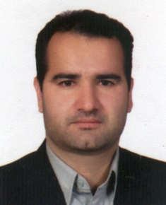
Full Name: Aliakbar Shamsiour Contact number: Twitter account: Linked In account: https://www.linkedin.com/in/dr-aliakbar-shamsipour-1a9818b1/
Session name/ number:
Category: (Oral presentation)
Passport Number: X33229083

Copyright © 2016-2018 Meetings Int PTE Ltd, All Rights Reserved.
Meetings Int. Pte Ltd

Company Registration No: 201524282R, 28 MAXWELL ROAD, #03-05 RED DOT TRAFFIC, SINGAPORE (069120)
Tel: +6531080483 | Toll Free no. +800-852-6126
Web: https://www.meetingsint.com/conferences/climatechange | E-mail: climatechange@meetingseries.com

