THE MULTIDISCIPLINARY APPROACH TO THE PATIENTS WITH ANTIPHOSPHOLIPID SYNDROME
LJUDMILA STOJANOVICH, Aleksandra Djokovic, Natasa Stanisavljevic, Gordana Bogdanovic, and Marija Zdravkovic.
Internal medicine, “Bezanijska Kosa”, University Medical Center, Belgrade, Serbia

Abstract (300 word limit)
OBJECTIVES: In the last three decades, a variety of clinical manifestations involving almost all organs and tissues (cardiac, pulmonary, neurological, renal, cutaneous, haematologic, and other), have been described associated with antiphospholipid antibodies (aPL) .
AIM: The aim of this study was to investigate multidisciplinary approach to the patients with antiphospholipid syndrome (APS). This is the report of Serbian cohort of APS patients.
PATIENTS AND METHODS: Our study comprises a total of 608 patients: 420 primary APS (PAPS) patients and 188 SLE patients with secondary APS (SAPS). aPL analysis included detection of aCL, aß2GPI, and LA. Pseudoinfective endocardits was observed in 12.8% secondary APS patients and 3.1% in primary APS patients (p=0.004). 30% of the patients with high levels of aCL IgG antibodies had valve thickening and dysfunction, as compared to 4.1% without valve abnormalities (p=0.002). We discovered significant connection between migraine and LA absence, livedo reticularis and aCL-IgG positively, skin ulcerations with aCL-IgG and anti-β₂GPI-IgM, pseudovasculitis lesions with aCL-IgG, aCL-IgM and anti-β₂GPI-IgM and thrombocytopenia with aCL-IgM, aCL-IgG and anti-β₂GPI-IgG. In PAPS, epilepsy correlated with ß₂GPI-IgM, migraine with aCL-IgM, thrombocytopenia with aCL-IgM, aCL-IgG, anti ß₂GPI-IgG and LA. Livedo reticularis was more prominent in PAPS with high levels of aCL-IgG. Epilepsy was related to high levels of anti ß₂GPI-IgM.Skin ulcerations were more prevalent in aCL-IgM positive SAPS patients and epilepsy more frequently had high levels of anti ß₂GPI-IgG in SAPS.
CONCLUSION: In this cross-section analysis of a large cohort of APS patients we analised that APS patients can be presented with a wide variety of nontrombotic manifestations. The key the success is multidisciplinary approach in all time of patients life.
Acknowledgement: This work was supported by research grant number 175041 for 2011 - 2020, issued by the Ministry of Science of the Republic of Serbia, and by research grant number TR 32040.

Image

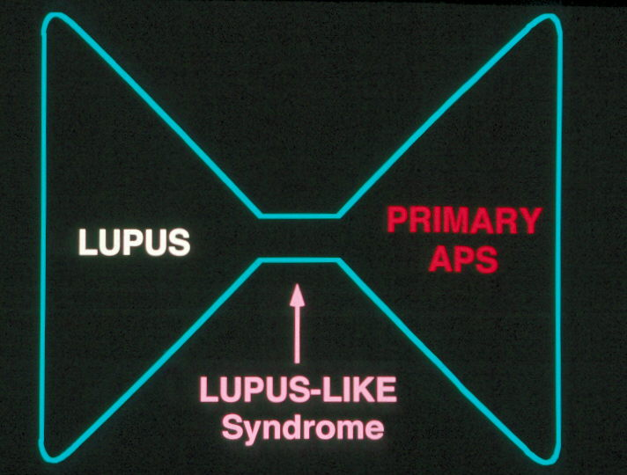

Recent Publications (minimum 5)
- Hughes GR. The antiphospholipid syndrome: ten years on. Lancet 1993; 342:341-4.
- Ardalan MR, Vahedi A. Antiphospholipid syndrome: A disease of protean face. J Nephropathology 2013; 2(1):81–4.
- Stojanovich L, Markovic O, Marisavljevic D, at all. Influence of antiphospholipid antibody levels and type on thrombotic manifestations: results from the Serbian National cohort study. Lupus 2011; 0: 1–8.
- Pérez D, Stojanovich L, Naranjo L,et all. (2018) Presence of Immune Complexes of IgG/IgM Bound to B2-glycoprotein I Is Associated With Non-criteria Clinical Manifestations in Patients With Antiphospholipid Syndrome. Front. Immunol. 9:2644. doi: 10.3389/fimmu.2018.02644.
- Stojanovich L, Kontic M, Djokovic A, et al. Association between systemic non-criteria APS manifestations and antibody type and level: results from the Serbian national cohort study. Clin Exp Rheumatol. 2013 Mar-Apr; 31(2):234-42.


Biography (150 word limit)
Ljudmila Stojanovich received her Ph.D. in Medicine in 1999. She is the scientific director in the Bezhanijska Kosa, University Medical Center of Belgrade University. She is an author of three monographs and of about 250 articles on various aspects of Autoimmune Rheumatic disorders. She is in Editorial Boards (LUPUS /LONDON). She is a member of number International Project, and member of the Steering Committee of the “EULAR recommendations for the prevention and management of adult antiphospholipid syndrome". Professor Stojanovich is EULAR Honorary Member, and the President of “12th meeting of the European Forum on APS”, in Belgrade, Serbia in April 2020.

Email: Ljudmila_Stojanovich@yahoo.com

Notes/Comments:

