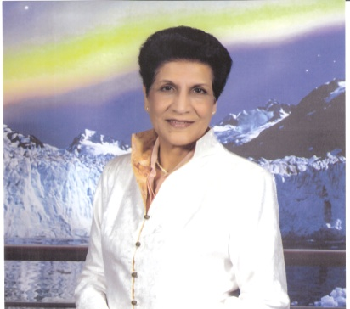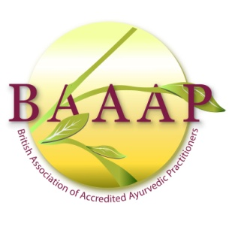

Energy Healing through some Esoteric Yogic Practices
Dr Indira Anand
Chair: British Association of Accredited Ayurvedic Practitioners, London, UK.
Energy vibrates in the body as a pranic flow and when the flow is increased by access to cosmic energy or by working directly on the dormant energy in the body it can be directed to the diseased parts of the body for healing. The direction of energy is done in different ways in different systems of healing. But intentionality is an important ingredient. By combining intentionality with faith and belief, we also access the valuable assistance of the subconscious mind. My presentation will cover ‘Tattwa Shuddhi’ – purification of the subtler elements the body is composed of- for general self–healing and as a preparation for healing others; ‘Prana Vidya’ – an Art & Science of Healing Oneself and Others; ‘Prana Nidra’ – which aims at expanding the awareness and the experience of prana in previously unconscious areas. It is useful both as a physical and mental therapy and also for changing one’s perspectives and lifestyle; ‘Yoga Nidra’ - the most effective way to relieve physical, emotional and mental tensions - the cause of most psycho-somatic diseases, which modern medical science is ill-equipped to tackle and finally, ‘Swara Yoga’ – which teaches us how using the right swara, by over-riding the natural rhythm of the breath through left or right nostril, one could help so many health conditions. The three swaras (through the left, right and both nostrils) correspond to the three major systems – Chitta, Prana and Atma - which control gyanendriyas, krmendriyas and the whole being, respectively. All these require some experience of Yoga.
Biography
As the Chair of BAAAP, Indira has been organising Ayurveda workshops and conferences in London for the past 10 years. She took up Ayurveda after early retirement from her main profession as an Investment Banker. She was a Director of Merrill Lynch for over 10 years and finished her Investment Banking career in 1998. She holds a Masters and a Ph.D. in Economics and has published several professional papers and 6 books. Indira trained as a teacher of Yoga from Bihar School of Yoga, Munger, and has been teaching Yoga and conducting Yoga retreats for the past 20 years.
Presenting Author Details
Full Name: Dr Indira Anand
Contact Number: +44 20 8429 0635/+44 7801 325 198
Session Name: Yoga & Energy Medicine (Track 16)
Category: Oral Presentation

