Jalauka (Medicinal Leeches), its related facts in Ayurveda and their effect in Raynaud’s disease- A single case report

Dr. TukaramDudhamal (Associate Professor)
Dr. Bijendra Shah, MS (Ayu)
Dept. of Shalay Tantra,IPGT&RA, GAU, Jamnagar, Gujarat, India

Abstract
In Ayurveda, Sushruta has been described the uses of Jalauka (medicinal leech) for the treatment of various medico-surgical disorders. About 700 leech species are identified and only 5 leeches are used in medicinal purpose. In Ayurveda, 2 varieties ofJalauka are found i.e. one poisonous group (Savisha) and another one non-poisonous group (Nirvisha) while in modern science, poisonous leech are known as stinging land leeches (Hemadipsapicta and Hemadipsa ornate). The species Hirudomedicinalis is commonly used for therapeutic purpose which is NirvishaJalauka. During the process of sucking, leeches secrete various biological enzymes in to the blood stream through its saliva.Hirudin is one important component which acts as anti-coagulant. In addition to that several other properties are found in leech saliva like anesthetic, antibiotic, analgesic etc. Therefore it is advised to use in ischemic, inflammatory conditions, skin grafting, chronic fatigue, pain, non-healing ulcers etc.
In this case report, female patient of 80 years was diagnosed as Raynaud’s disease with complaints of gangrenous changes in left digital phalanges (three fingers), swelling in forearms and pain in forearm since 20 days. Three leeches were applied in each digit of gangreneous part. Total three setting one in every week leeches were applied. After 1st sitting of Jalauka application pain and swelling was got reduced. After second sitting line of demarcation was developed and dried up the necrosed part. Lastly after third sitting all necrosed part was sloughed out without surgical debridement. This single case manifests that gangrenous digit due to Raynaud’s disease can be managed with Jalkauka application.
Images:

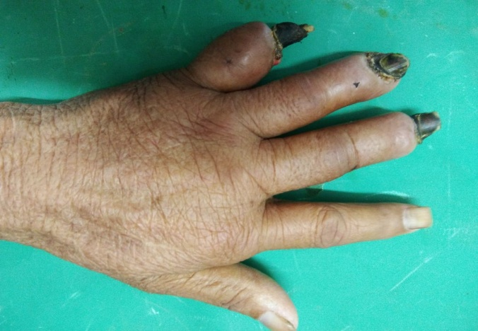
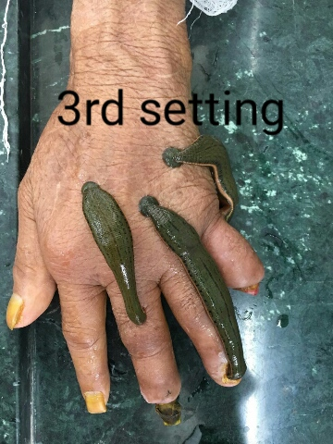
Key words: Ayurveda, Gangrene, Hirudo medicinalis, Jalauka, Leech, Raynaud’s disease.

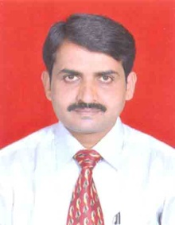

Biography:

Dr. Tukaram Dudhamal has completed his PhD from Institute for Post Graduate Teaching and Research in Ayurved (A WHO collaborating centre), Gujarat Ayurved University (NAAC-A accredited), Jamnagar, Gujarat, India. He is Associate Professor and I/C HOD of Dept. of Shalay Tantra, IPGT&RA Gujarat Ayurved University, Jamnagar, Gujarat, India He has 17 years teaching and research experience in Ayurveda and published more than 100 research papers in reputed journals. He guided 20 PG scholars as guide and 16 scholars as co-guide also under guidance 8 PhD scholars He has been serving as an editorial board member in journals, ie. AYU, Ayurlog, IJHM, IJMPNP, Ayurline, etc.

Email: drtsdudhamal@gmail.com
_______________________________________________________________________________

