Influence of Amorphophallus paeoniifolius tuber on normal and constipated rats
Dey YN¹, Wanjari MM², Srivastava B², Kumar D³, Sharma D², Sharma J⁴, Gaidhani S⁵
¹School of Pharmaceutical Technology, Adamas University, Barasat, Kolkata, West Bengal, India.
²Regional Ayurveda Research Institute for Drug Development, Gwalior, Madhya Pradesh, India.
³Faculty of Pharmaceutical Sciences, UCSI University, Kuala Lumpur, Malaysia.
⁴Centre for Advanced Research in Pharmaceutical Sciences, Shobhit University, Meerut, Uttar Pradesh, India.
⁵Central Council for Research in Ayurvedic Sciences, New Delhi, India

Keywords: Loperamide, rats, constipation, glucomannan, betulinic acid

I. Abstract
Tuber of Amorphophallus paeoniifolius is used in ethno-medicinal practices in mitigation of constipation. Hence, present study evaluated its effect on normal and experimentally-induced constipated rats. Normal rats were orally administered with methanolic (APME) or aqueous (APAE) extract (125, 250 and 500 mg/kg, each) of tuber for 7 days and fecal parameters were evaluated. Metoclopramide (MET) (3 mg/kg, orally) was used a reference prokinetic drug. The isolated tissue preparations were used to check the effect of the extracts on fundus and intestinal contractility. Functional constipation was induced in rats by oral administration of loperamide (3 mg/kg) for first 3 consecutive days. The rats were orally treated APME or APAE, glucomannan (300 mg/kg) and betulinic acid (1.5 mg/kg) for 7 days and the fecal parameters were evaluated. Results of normal rats indicated that the pre-treatment of APME and APAE significantly (p<0.05) increased the number, wet and dry weight and moisture content of stools, and gastric emptying and intestinal transit which were comparable to MET. APME and APAE showed a contraction of fundus and ileum in isolated preparations. Further, in loperamide induced constipation model, results indicated that treatment with tuber extracts, glucomannan and betulinic acid showed significant (p < 0.05) increase in fecal parameters and intestinal transit in constipated rats. The effects were comparable to standard laxative drug, sodium picosulfate (5 mg/kg, orally). Results indicated that tuber extracts and its active constituents showed laxative effect and relieved constipation. The study validates the ethno-medicinal use of Amorphophallus paeoniifolius in correction of constipation.

II. Image
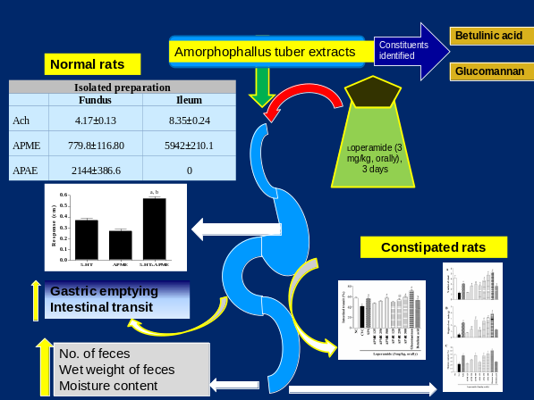
III. References
• Devi Prasad, A.G., Shyma, T.B. and Raghavendra, M.P., 2013. Plants used by the tribes for the treatment of digestive system disorders in Wayanad district, Kerala. J. Appl. Pharm. Sci., 3; 171-175.
• Yesodharan, K., Sujana, K.A., 2007. Wild edible plants traditionally used by the tribes in the Parambikulam Wildlife Sanctuary, Kerala, India. Nat. Prod. Rad., 6, 74-80.
• Dey, Y.N., Sharma, G., Wanjari, M.M., Kumar, D., Lomash, V., Jadhav, A.D., 2017. Beneficial effect of Amorphophallus paeoniifolius tuber on experimental ulcerative colitis in rats. Pharmaceut. Biol., 55, 53–62.

IV. Biography:
Dr. Yadu Nandan Dey is working as an Assistant Professor in the School of Pharmaceutical Technology, Adamas University, Kolkata, West Bengal, India. He completed his B. Pharm. and M. Pharm. from West Bengal University of Technology. He worked as a Senior Research Fellow at CCRAS-RARIDD, Gwalior where he completed his Ph.D. studies. He has acquired more than 10 years of research experience and 1 year teaching experience. He was awarded with ICMR Centenary Post Doctoral Fellowship in 2017 and carried out his Post Doctoral research work at ICMR-National Institute of Traditional Medicine, Belagavi. He was also awarded with “Young Scientist” Award by Madhya Pradesh Council of Science and Technology, Bhopal in 2016. He has undergone various training programs and workshops in reputed organizations and presented more than 15 research papers in various national and international conferences. He contributed in 3 book chapters and has 35 research papers in various national and international journals which got more than 600 citations. He is also member of the Editorial Board and reviewer of various reputed journals. His area of research is safety and efficacy of herbal drugs in various animal models of inflammatory and metabolic diseases.

V. Presenting Author Details

Full Name: Dr. Yadu Nandan Dey
Contact number: +91-7566232359
Session name/ number:5
Category: Speaker

