Development of Atropisomeric Azo-binaphthyl Polymers for Light-driven Molecular Switches
Fathy Hassan, Chemistry Department, Faculty of Science, Tanta University, 31527, Egypt

Abstract (300 word limit)
Light-driven atropisomeric polymers containing azobenzene moiety as a photorsponsive segment and binaphthyl as an axially chiral segment were designed and synthesized. The polymers were obtained by radical polymerization, and the number-average molecular weight and polydispersity were around 7,000 and 2.0, respectively. The chiral polymer exhibited the glass transition temperature over 75 ºC with good thermal stability above 280 ºC. Solution-processed amorphous films could be obtained by spin-coating or drop-casting technique. The films show good uniformity without grain boundary, which are advantageous for fabrication of the thin-film devices. The chiral polymers in the film showed trans-cis photoisomerization upon irradiation at 365 nm for 180 s. The ratio of the trans:cis isomers in the photostationary state was determined to be 60:40. After photo-irradiation of visible light at 436 nm, cis-trans backisomerization occurred clearly. cis-trans thermal backisomerization also took place at 25 ºC with a half-life of 13 h. Photoisomerization of the chiral polymer gave rise to photo-induced change in optical rotation. Photochemical modulation of the optical rotation reached to 700 º, and these values were switched by alternating irradiation between 365 nm and 436 nm. Interestingly, the polymers show fluorescence properties, which is a unique behavior compare to simple azobenzene polymers. Normally, azobenzene compounds are non-fluorescent because of the nonradiative relaxation process of the azo-benzene group caused by the highly efficient trans-cis isomerization. In terms of molecular design, binaphthyl moiety act as fluorescent segment leading to the overall molecule become has fluorescent. Further, a photoswitchable fluorescence behavior was obtained; an increase in the fluorescence intensity after irradiation at 365 nm and recovery to the initial state after irradiation at 436 nm.Additionally, photo-control of molecular orientation of the polymer was explored in the film. After photoirradiation of linearly polarized light at 532 nm, change in refractive index was observed owing to anisotropic molecular orientation. Maximum change in a value of birefringence after irradiation was 6 x 10⁻³. These results suggested the chiral polymers are expected to be photoresponsive chiroptical materials for light-driven molecular devices.

Image
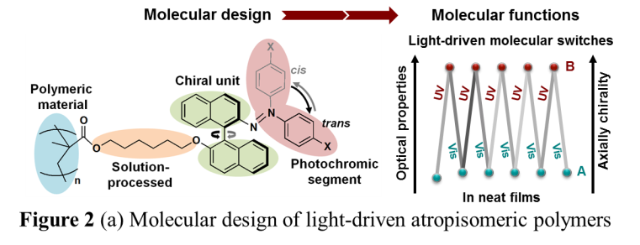
Recent Publications (minimum 5)
- Hassan, F., Sassa, T., Hirose, T., Ito, Y., & Kawamoto, M. Light-Driven Molecular Switching of Atropisomeric Polymers Containing Azo-Binaphthyl Groups in their Side Chains. Polymer J. 50, 455–465 (2018).
- Feringa, B., Delden, R. & Wiel, M. in Handbook of Molecular Switches (ed. Feringa, B.) Ch. 5, 123–163 (Wiley-VCH, Verlag GmbH, Weinheim, Germany, 2001).
- Koumura, N., Zijlstra, R., Delden, R., Harada, N. & Feringa, B. Light-driven monodirectional molecular rotor. Nature 401, 152–155 (1999).
- Browne, W. & Feringa, B. Making molecular machines work. Nat. Nanotechnol. 1, 25–35 (2006).
- Bandara D. & Burdette, S. Photoisomerization in different classes of azobenzene. Chem. Soc. Rev. 41, 1809–1825 (2012).
- Yu Y. & Ikeda, T. Alignment modulation of azobenzene-containing liquid crystal systems by photochemical reactions. J. Photochem. Photobiol. C: Photochem. Rev. 5, 247–265 (2004).

 Biography
Fathy Hassan has granted the Doctor of Science degree from Graduate School of Science and Engineering, Saitama University, Japan in March 2018. He previously worked as a Junior Research Associate at Emergent Bioengineering Materials Research Team, RIKEN CEMS, Japan. Now, he is working as an Assistant Professor of Physical Chemistry at Chemistry Department, Faculty of Science, Tanta University, Egypt. His research interest is development of advanced functional materials for photonic and electronic applications.
Email: fathy.hassan32@yahoo.com

Notes/Comments:

