NAIL VARNISH AS AN ALTERNATIVE MOUNTANT IN WOOD HISTOLOGY
Adeniyi, I.M., Adejoba, A.L., Akinlabi, F.M. and Alao O.J.
Department of Forest Products Development and Utilization, Forestry Research Institute of Nigeria P.M.B 5054, Forest Hill, Jericho Estate, Ibadan, Oyo-State Nigeria
ABSTRACT
Most of the mountants used in wood histology are costly and could be toxic, therefore clear nail narvish (CNV) was investigated for its mounting ability in this study as an alternative to conventional mounting media with a view to making use of the enamel in wood histology. Sections of about 20 microns from Nauclea diderichii wood were used for this study; the choice of wood species was informed on its density which is of medium to high density. Three set of wood sections were used: sections mounted directly using a clear nail polish without clearing; sections cleared in a clove oil before mounting in nail varnish; and sections cleared in clove oil and mounted using in Canadan balsam. Sections prepared in clear nail varnish (CNV) without clearing, and sections mounted in CNV after clearing in clove oil did not manifest a notable difference between specimens prepared or mounted using canadan balsam. Sample distortions namely shrinkage or other dimensional changes were not observed throughout the procedure, Photographs illustrating the micrographs of sections prepared from nail polish and Canadan balsam were obtained using a digital camera on the Zeiss light microscope. The study showed that specimens could be transferred from alcohol and covered directly with CNV during mounting procedures, whereas transferring specimens directly from alcohol to Canada balsam won’t work, because alcohol won’t dissolve in Canada balsam; moreover, nail polish is readily available, and its use can avoid the use of toxic organic solvents such as xylene in treating specimens in wood histology.
Keywords: Mountants, CNV, Clove oil, histology, sections, micrographs.

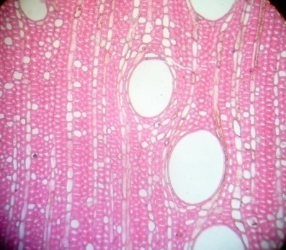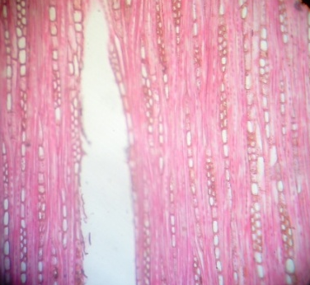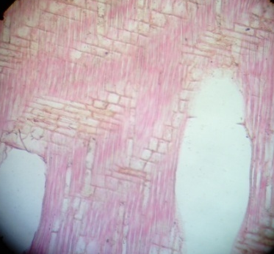
Fig. 1: Sections mounted in Canadan balsam

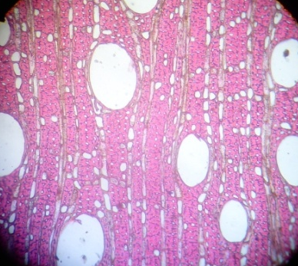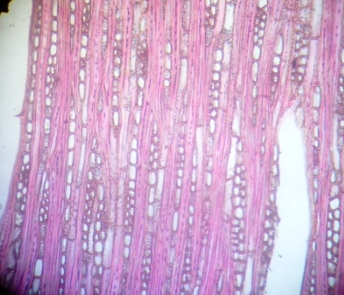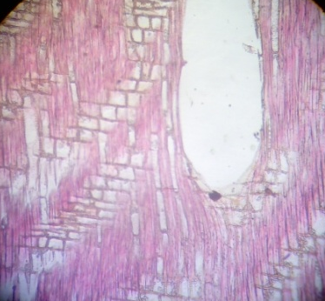
Fig. 2: Sections mounted in CNV after clearing in clove oil

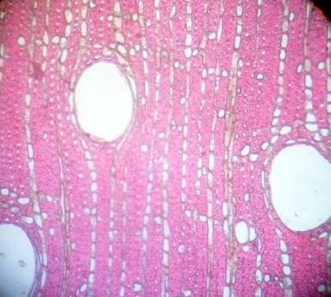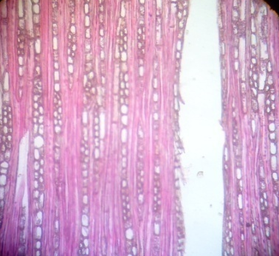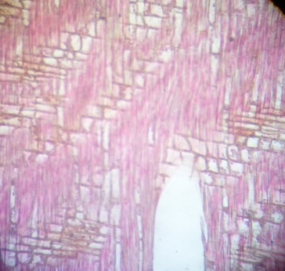
Fig. 3: Sections mounted in CNV without clearing

REFERENCES
Dioni W. 2002. About microscopy and chemistry of nail polish. Micscape Magazine.
Microscopy UK front page Article library August 2002 Edition.
Renshaw S. 2007. Immunochemical staining techniques. Immunochemistry: methods
Express. Bloxham: Scion Publishers. p. 46-95
Lee G. Luna. 1960. Manual of Histologic and Special Staining Techniques. 2 ^{nd} ed. New
York: The Blakiston Division McGraw Hill Book Co. Mountants-© Woods and Ellis
2000-Connecting SA for 25 Years. [Last accessed on 2012 Aug
Ochei, J. and Kolhatkar, A. 2000. Medical Laboratory: Theory and Practice.Tata McGraw
-Hill Publishing Company Limited. Pp 446
Toedt, J.; Koza, D. and Van Cleef-Toedt, K. 2005. Chemical Composition of Everyday
Products; Greenwood Press: Westport, CT, 2005; pp 49–50. See http://books.google.com/books?id=UnjD4aBm9ZcC
Microbe Hunter, 2016. An over view of mounting media for microscopy. Found in Labwork. MicrobeHunter. www.microbehunter.com
Shahrazad Abdul Satar Al-Janaby, 2005. Evaluation of colourless clear fingernail polish
material as a permanent mounting medium.Medical Technical Institute, Baghdad. http://www.iasj.net/iasj?func=fulltext&aId=41812
Pickard, G. E. ; Smeraski, C. A. ; Tomlinson, C. C., and Banfield, B. W. 2002. Intravitreal
Injection of the Attenuated Pseudorabies Virus, Barth Results Infection of the Hamster Suprachiasmatic Nucleus only by Retrograde Transynaptic Transport Via Automatic Circuits. The journal of neuroscience .Vol. 22, No.7, pp. 2701.
Sturbaum, G, D; Reed, C.; Hoover, P. J. and Jost, B. H. 2001. Species-specific, Nested
PCRResraction Fragmentength Polymorphisim Detection of Single, Cryptosporidium Parvum Oocysts. Applied enviromental microbiology, , Vol. 6, No. 3, pp. 2665.
Schrader, M; Bahlmann, K; Giese,G., Hell,S. W. 1998. “4Pi-Confocal Imaging in Fixed
Biological Speciemens” Biophysical Journal, Vol.7, No.54, pp. 1659-1668.
Gillespie, S. H and Hawkey, P. M. 1995. Medical Parasitology a Practical Approach Oxford
University Press. pp. 17, 1995.
Davidson, I. and Henery. J., Todd. 1974. Sanford Clinical Diagnosis by Laboratory Methods
15th ed. Saunders Company pp. 1367.
Internet-5, http://w3.nsn.cu.edu/copepod/ Huys,R. and Boxshall, G.A.,Copepod Evolution.
The Ray Socity, London., pp. 468, 2004.

Biography


Adeniyi Ifedayo Michael obtained his first degree from the Federal University of Technology, Akure, Nigeria in Forestry and Wood Technology in 2001. He later bagged his Master’s degrees from the same university in Wood Science in 2011. Adeniyi is a senior research officer in the Department of Forest Products Development and Utilization in Forestry Research Institute of Nigeria, Ibadan as the Head of Wood Anatomy and Timber Quality Section. He has published numerous refereed articles in professional journals and conference proceedings. Adeniyi’s field of expertise includes wood histology, wood identification and investigation into wood qualities for various aspects of wood utilization. He is currently on his PhD in the area of anatomy of some indigenous wood species in Nigeria.

Full Name: Adeniyi Ifedayo Michael
Contact number: 2348060255041
Poster presentation
Passport No.: A00655023

