Study of photocatalytic hydrogels & ozonation as combination method on water purification
Seyyed Masud Naserzade, MSc of Chemical Engineering, Tehran University

Abstract
Statement of the Problem: Following the global water issues, advanced countries as China, the USA have different methods to solve this crisis. If the pollutant is crucially harmful and causes cancer among humans, this substance should be degraded by an advanced material. Meanwhile, innovation in the photocatalyst is significant by the advanced material. Photocatalytic polymeric networks are proposed since they are sustainable, reusable, and have degradation properties for water treatment and wastewater. Laboratory results are a discrepancy from industrial results because on a larger scale other factors such as scaling and increasing the volume of the treatment plant and unstable environmental conditions are involved in the industry. For instance, if the laboratory results indicate up to 90% removal of pollutants, is cut down to 80-50% in the industry. Therefore, finding a solution to improve water purification on a larger scale is essential. Water treatment methods include membrane filtration (reverse or forward osmosis), adsorption, flocculation, advanced oxidation, degradation, and ozonation. Due to the effectiveness of photocatalytic adsorbents and photocatalytic ozonation methods, they can be complementary methods considerably. It is appraised that this method will take a constructive step to reduce pollutants in the environment and industry. The approach has many factors, including optimization amounts of monomer, photocatalytic nanoparticles, cross-linker, and gum, likewise obtaining the lifespan of ozone under UV irradiation conditions and estimation the degradation substances. One of the questions is, which method of producing ozone should be more profitable? The reply is that with the advancement of technology, the response may modify, but now the electrical discharge method (Corona) is markedly affordable. It is anticipated that desirable results obtain by considering the interactions of all factors.

Image
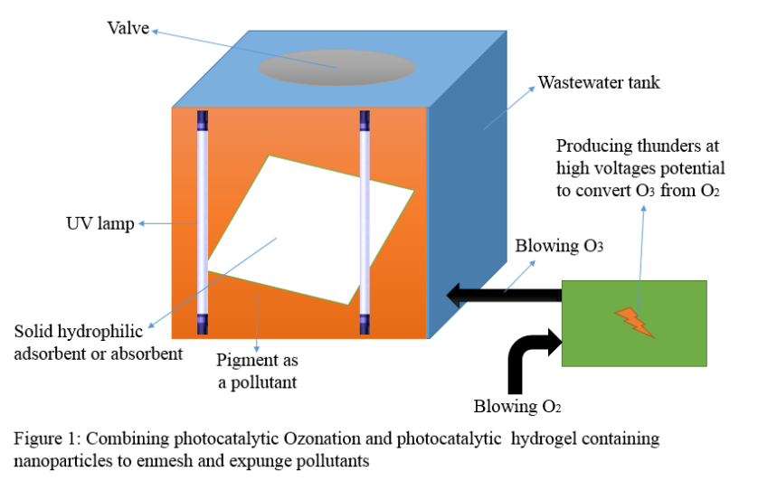
Recent Publications (minimum 5)
- Gan, Lu, Songmin Shang, Enling Hu, Chun Wah Marcus Yuen, and Shou-xiang Jiang. "Konjac glucomannan/graphene oxide hydrogel with enhanced dyes adsorption capability for methyl blue and methyl orange." Applied Surface Science 357 (2015): 866-872.
- Yang, Tangtao, Junmin Peng, Yun Zheng, Xuan He, Yidong Hou, Ling Wu, and Xianzhi Fu. "Enhanced photocatalytic ozonation degradation of organic pollutants by ZnO modified TiO2 nanocomposites." Applied Catalysis B: Environmental 221 (2018): 223-234.
- Mecha, Achisa C., and Martha N. Chollom. "Photocatalytic ozonation of wastewater: a review." Environmental Chemistry Letters 18 (2020): 1491-1507.
- Hosseini, Hadi, Abbas Zirakjou, David Julian McClements, Vahabodin Goodarzi, and Wei-Hsin Chen. "Removal of methylene blue from wastewater using ternary nanocomposite aerogel systems: Carboxymethyl cellulose grafted by polyacrylic acid and decorated with graphene oxide." Journal of Hazardous Materials 421 (2022): 126752.
- Zheng, Alvin Lim Teik, Sarah Sabidi, Teruhisa Ohno, Toshinari Maeda, and Yoshito Andou. "Cu2O/TiO2 decorated on cellulose nanofiber/reduced graphene hydrogel for enhanced photocatalytic activity and its antibacterial applications." Chemosphere 286 (2022): 131731.
- Orge, Carla A., M. Fernando R. Pereira, and Joaquim L. Faria. "Bezafibrate removal by coupling ozonation and photocatalysis: Effect of experimental conditions." Environmental Nanotechnology, Monitoring & Management 17 (2022): 100610.

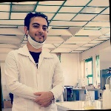Biography
Seyyed Masud Naserzade has a master's degree from the University of Tehran. His expertise and research have been the removal of pigments by photocatalytic hydrogels in water treatment. He confirms that isothermal and kinetic models indicated favorable results by photocatalytic hydrogels. He tends to expand his work in the discipline of water treatment and is apt in various sections of the membrane, oxidation, and ozonation.
Email: Masud.naserzade@ut.ac.ir

Notes/Comments:

