Ecofriendly Microwave Synthesis of Diamino-Pyrrolo-Dipyrimidines with their Antifungal Efficacy
DR. RAVINDRA DHIVARE¹, DR. SHANKARSING RAJPUT²
¹Department of Chemistry, Sangola College Sangola, Maharashtra, India
²Department of Chemistry SVS’s Dadasaheb Rawal College, Dondaicha, India

Keywords: microwave synthesis, diamino-pyrrolo-dipyrimidines, antifungal activities

I. Abstract:
Heterocyclic compounds prominently incorporate in the development of chemical, pharmaceutical, medicinal and agriculture sectors. Nowadays, it is the most requirements for the fundamental development of all sectors. Mostly the preparation of the organic compounds by using several synthetic methods with conventional routes but at the present time there is a strong recommendation and preferences should drive for eco-friendly methods should adopt for the chemical syntheses. To achieve the goal of the green method, here the researchers have been developed the simple and clean green method and implemented to accomplish the pyrimidine derivatives. The diamino-pyrrolo-dipyrimidines derivatives were synthesized and demonstrated by the simple and clean one-pot system using formerly prepared bis-chalcone derivatives from different substituted phenyl succinimides and guanidine nitrate with neutral corundum irradiated under the microwave supported solvent free conditions. All the synthesized diamino-pyrrolo-dipyrimidines derivatives were examined their antifungal activities and revealed the synergistic and significant activities along with Candida albicans and Aspergillus niger fungal strains.
II. Scheme:
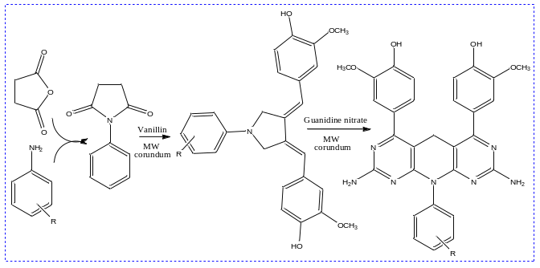

III. References:
- Kartrizky A.R., Yang B., Qiu G and Zhang Z.A., (1998), A convenient Trifluoroacetylation Reagent:N-(Trifluoroacetyl) succinimide, Center of Heterocyclic compounds, University of Florida, Gainesville, 55-57
- Rajput S.S., (2012), Synthesis and Characterization of Bis-heteroyclic Derivatives of 1-(3-Chlorophenyl)-Pyrrolidine-2,5-Dione,
International Journal of Advances in Pharmacy, Biology and Chemistry, 1(2): 242-246.
- Chang S, Yin S, Wang J, Jing Y and Dong J., (2009), Design and synthesis of novel 2-phenylaminopyrimidine derivatives and their antiproliferative effects in human chronic myeloid leukemia cells, Molecules,
14(10): 4166-4179
- Dhivare R. S. and Rajput S. S., (2015), Synthesis and antimicrobial evaluation of some novel bis-heterocyclic chalcones from cyclic imides under microwave irradiation, Chem Sci Rev Lett., 4(15), 937-944

IV. Biography:
Dr. Ravindra Dhivare (M.Sc. Chem, M.Ed., and Ph.D. Chemistry, TEFL & TESOL-Canada) has been acknowledged as one of the prominent researcher in the field of chemistry. He possesses 13years teaching experience and published 22research papers in the journals of international repute, 02Books and 10Patents. He has been serving as reviewer committee member in various journals and engrossed in a variety of academic as well as research activities.

V. Presenting author details:

Full Name: Dr. Ravdindra S. Dhivare
Contact number: +919766775522
Twitter account: NA
Linked In account: 14588540
Session name/ number: NA
Category: Oral presentation
Passport Number: N8922276
:

