The effect of Eutrophication on Drinking Water

R. K. Mishra¹ and A.K.Tripathi²
¹Department of Physics, A.P.S. University, Rewa (M.P.) India.
Department of physics Govt H.S.S. Kandel,disst.dhamtari State C.G. pin -493773
E-mail ~ rakesh_response@rediffmail.com
²Department of Physics, S.G.S. Govt. P.G. College, Sidhi (M.P.) Pin-486661, India.

ABSTRACT

The effects of eutrophication on the environment may have deteriorate consequences of health of exposed animal and human populations through various path way’s. when fresh water, extracted from eutrophic areas, is used for the production of drinking water severe impacts can also occur during watering in eutrophic waters. eutrophication is complex processes which occurs both in fresh and marine waters, where certain types of algae disturbs the aquatic ecosystem and become a threat for animals and human health the primary cause of eutrophication is an excessive concentration of plant nutrient’s originating from agriculture of sewage treatment. The main cause of eutrophication is the large input of nutrient mixed to water body and the main effect is imbalance in the food web that results in the high levels of phytoplankton, zooplankton, algae biomass in stratified water bodies. This can lead algal blooms. The direct consequences is in an excess of oxygen consumption near bottom of the water body .eutrophication processes can be divided in to two categories depending on weather they are linked to the nutrients dispersion and phytoplankaton growth to oxygen cycle near the bottom of the water body. Various effects can be observed depending upon the severity of the eutrophication. Treatment of eutrophic water for producing drinking water. algae disturbs the aquatic ecosystems a threat for animal and human health..eutrophication concern the availability of oxygens. Some species of algae may also contain toxins but incidents where fresh water algae or the origin of cause human or animal illness. Some cynobacteria have capacity to produces toxins dangerous to human beings. A variety of symptoms depending on toxins implicated our observed such as fatigues, headache, diarrhoea, vomiting, and some throat fever skin irritations. Good practices to inform people about risks of bathing or sporting activity in normally colored or turbid waters. Allergic bathers of people walking along shore of water body affected by algae blooms. Any allergies releasing not only toxin but also allergic compounds.
In some specific case; local authorities must rely on eutrophic water for producing drinking water.
Key words:-eutropic water,phytoplankaton.alage. drinking water

Introduction
"Eutrophication" is the enrichment of surface waters with plant nutrients. While eutrophication occurs naturally, it is normally associated with anthropogenic sources of nutrients. The "trophic status" of lakes is the central concept in lake management. It describes the relationship between nutrient status of a lake and the growth of organic matter in the lake. Eutrophication is the process of change from one trophic state to a higher trophic state by the addition of nutrient. Agriculture is a major factor in eutrophication of surface waters. Municipal solid waste (MSW) disposal is a major global concern particularly in developing countries across the world. Rapid population growth, higher urbanization and cites have efficient waste management policies and infrastructure place land filling is the waste in lowing areas. Ground water under flow trough waste or rainwater infiltration picks’up a variety of inorganic and organic compounds in organic compound such as Al,Ca, magnesium, sodium, iron, sulphate, cholorides and Heavy metal likes Cadinium, Chromium, Copper etc. toxic metal leatches from the solid vaste dump’s is major environmental problem in the towns and cities and pose serious contamination risk both ground water surface water.
The most complete global study of eutrophication was the Organization for Economic Cooperation and Development (OECD) Cooperative Programme on Eutrophication carried out in the 1970s in eighteen countries (Vollenweider et al., 1980). The sequence of trophic state, from oligotrophic (nutrient poor) to hypertrophic (= hypereutrophic [nutrient rich]) is shown in table 2.
Although both nitrogen and phosphorus contribute to eutrophication, classification of trophic status usually focuses on that nutrient which is limiting. In the majority of cases, phosphorus is the limiting nutrient. While the effects of eutrophication such as algal blooms are readily visible, the process of eutrophication is complex and its measurement difficult. This is not the place for a major discussion on the science of eutrophication, however the factors noted in
Because of the complex interaction amongst the many variables that play a part in eutrophication, Janus and Vollenweider (1981) concluded that it is impossible to develop strict boundaries between trophic classes. They calculated, for example, the probability (as %) of classifying a lake with total phosphorus and chlorophyll-aconcentrations of 10 and 2.5 mg/m³ respectively, as:
Table 1
 | Phosphorus | Chlorophyll
Ultra-oligotrophic | 10% | 6%
Oligotrophic | 63% | 49%
Mesotrophic | 26% | 42%
Eutrophic | 1% | 3%
Hypertrophic | 0% | 0%

The symptoms and impacts of eutrophication are:
- Increase in production and biomass of phytoplankton, attached algae, and macrophytes.
- Shift in habitat characteristics due to change in assemblage of aquatic plants.
- Replacement of desirable fish (e.g. salmonids in western countries) by less desirable species.
- Production of toxins by certain algae.
- Increasing operating expenses of public water supplies, including taste and odour problems, especially during periods of algal blooms.
- Deoxygenation of water, especially after collapse of algal blooms, usually resulting in fish kills.
- Infilling and clogging of irrigation canals with aquatic weeds (water hyacinth is a problem of introduction, not necessarily of eutrophication).
- Loss of recreational use of water due to slime, weed infestation, and noxious odour from decaying algae.
- Impediments to navigation due to dense weed growth.
- Economic loss due to change in fish species, fish kills, etc.

Algal and cyanobacterial blooms
Cultural eutrophication causes excessive algal bloom in water bodies, with consequent algal overload. Under certain conditions of darkness and warm temperatures these blooms may die, decompose and produce offensive sewage-like odor. If the receiving water is used as a raw water supply for some public or private agency, algae may be difficult to remove and hence add certain objectionable tastes to the delivered water. Algae also have the tendency to absorb and concentrate mineral nutrients in their cells. When they die, at the end of the growing season, they settle to the stream or lake bottom, from which they release these mineral and organic nutrients at the beginning of the next growing season. In this way they serve as a form of secondary pollution.
One of the most common symptoms of lake eutrophycation is the development of blue-green algal (Cyanobacteria) blooms. They can be generated by human activity: for example, sediment runoff from construction sites may greatly diminish water clarity and therefore decrease the amount of light available for phytoplankton. Cyanobacteria are able to maintain themselves near the surface of the water by means of special gas-filled vacuoles that give the plants slight positive buoyancy. Once cyanobacteria or more generally algal blooms reach high concentrations, problems can occur: they have a negative impact on water quality, creating taste and odorous problems and interfering with certain water treatment processes. When certain bacteria populations reach very high proportions, they can also produce toxins that can render water unsafe for consumption.
Excessive aguaticmacrophyte growth
Increased nutrient levels can stimulate other forms of primary production, in addition to algae and cyanobacteria. The littoral zones of many nutrient-enriched water bodies are often chocked with excessive growths of aguaticmacrophytes, which can influence recreational and industrial activity and alter the structure of the food web. Excessive growth of phytoplankton and macroscopic plants in the water create aesthetic problem and reduce the value of the body water as a recreational resource. From a purely aesthetic point of view, crystal clear water characteristic of oligotrophic systems is most attractive for swimming and boating. High phytoplankton concentrations cause the water to appear turbid and aesthetically unappealing. Macroscopic plants can completely cover the entire surface of eutrophic lakes making the water almost totally unfit for swimming and boating.

Deepwater oxygen depletion
Oxygen is required for all life forms on this planet, with the exception of some bacteria. For this reason oxygen depletion is considered to be a serious lake management problem often associate with eutrophycation: this causes an increased organic matter production, so more material is sedimenting down into the profundal waters, consuming oxygen. Since it is impossible for some organisms to function efficiently unless the oxygen concentration in the water is near saturation, such organisms are often absent from eutrophic environments. This problem can preclude fish or other biota from inhabiting deepwater regions of anoxic lakes. It may be a seasonal or nocturnal phenomenon.

The cause; the impact and management of eutrophication
the word ‘eutrophic’ comes from the greek word eutrophics meaning well fed. Eutrophication is the processes of nutrients enrichment of waters which results in the stimulation of an array of sympotomatic changes, amongst which increased production of algae and aquatic macrophytes deterioration of water quality and other symptomatic changes are found to undesirable and interfere with water uses “(OECD;1982)”.
Eutrophication management strategies:-
control of major eutrophication sources. In order to control eutrophication and restore water quantity, it is necessary to check and restrict phosphrous inputs, reduce soil erosion, and develop new technologies to limit phosphorus content of over- riched soil (Carpenter and Lathrop 2008). Fresh water algal blooms are the results of an excess of nutrients particularly phosphorus (Diersing 2009). Industrial agricultural, with it’s reliance on phosphate –rich fertilizers, is the primary source of excess phosphorus responsible for degrading lake (carpenter 2008). The routine application of chemical fertilizer and phosphorus-laden manure has resulted in the gradual accumulation of phosphorus in soil, which wahes in to lakes of the watershed where it is applied on a global basis; researcher have demonstrated a strong correlation between total correlation between total phosphorus input and algal bimass in takes ( Anderson et al, 2002). According to an estimate 400 grams of phosphates could potentially induce an algal blooms to the extent of 350 tons (Sharma 1999).Eutrophication is the processes of excessive nutrients enrichment of waters that typically result in problems associated with macrophyte,algal or cynobacterial growth. The cause and effect of eutrophication are complex. The current state of knowledge, much research work is progress that aims at furthering our knowledge of the intricate interrelationship involved in eutrophication of water resources. (Rast and thorton 1996). Eutrophication causes in natural lakes a distinction is sometimes made between ‘natrual’ and ‘cultural’ (anthropagenic) eutrophication processes (e.g. Rast and throrhton (1996). Natural eutrophication is associated with human activites which accelerate the eutrophication processes beyond the rate associated with natural processes (e.g. by increasing nutrients loads in to aquatic ecosystems ). Increased nutrients enrichment can arise from both point and non-point sources external to the impoundment as wellas internal sources like the impoudment’s own sediments (that release phosphate). Impact’s eutrophication eutrophication is concern because it has numerious negative impacts increased productivity in an aquatic system can sometimes be beneficial Fish and other desireable animals. However determental ecological impacts can in turn have other adverse impact’s which vary from aesthetic ecological impacts can turn have other adverse impacts which vary from aesthetic and recreational to human health and economic impacts.
Impacts of eutrophication are complex and interrelated. The excessive growth of aquatic plants and cynobacterial have multitude of impacts on an ecosystem .the specific impacts depends on plants are stimulated to grow.
Ecological impact’s macrophyte invasions and algal and cynobacterial (blue-green) blooms are themselves. Direct impacts on an ecosystem. Howeveral; their presence cause a number by other ecological impacts. Of critical concern is the impact of eutrophication on biodiversity macrophytes invasions impede or prevent the growth of other aquatic plants.
Cynobacterial can maintain a relatively higher growth rate compared to other phytoplankatonorganisims when light intensities are low. They will therefore have a comparative adavantage in waters that are turbid due todense growths of other phytoplankton maximum growth rates are attained by most cynobacteria at temperature above 25⁰C.growth rates days per doubling.
These optimum temperature are higher than for green algae and diatom’s (Chorus and Bartam1999).Cynobacterial can form sums (like microcytis), be disturbuted homogeneously throughout eppilimnion (like oscillatoria) or grow on submerged surfaces. Cynobacteria are particularly problematic because when their cells are- ruptured 9e.g. by decay or by aligicides) they release toxic substances (cyano toxins) water, through passive release can also occur. Thsecynotoxins falls into three broadgroups of cyclic peptides, alkaloids and lipopolysaccharides.Cynotoxins are recognized to have caused the deaths of Wilds animals, farm livestock pets, fish and birds in many countries (Holdsworth,1991). The primary target organ of most cynotoxin in mammals in liver (i.e. they are hepatoxic). Some cynotoxins are neurotoxic (target the nerves system) and others determatotoxic (target the skin). Ecological impacts include various waters quality impacts like increased cynotoxin levels and lowering of oxygens levels (due to decay of algae and cynobacteria). Decreased oxygens levels can have a number of other secondary water quality impacts. Anerobic conditions allow reduced chemical species (like ammonia and sulphide) to exisits. These chemical can be particularly toxic to animals and plant.
Human health impacts aninfectation of water hyacinth (eichhoniacrassipes) can be a health hazards. It can provides an ideal breeding habitat for mosquito larvae and it can protect the snall vector of biliharzia(Scott et al., 1979). A number of adverse consequences have been documented for swimmers exposed to cyanobacterial blooms.
Chronic exposoure to low doeses may promote the growth of liver and other tumours. Nevertheless many cynobacterial blooms are apparently not Hazardous to animals (Carmichael 1992).It also possible exposed to odours from waterways contaminated with decaying algae of cynobacterial may suffer chronic ill-health effects economic impacts. Human and domestic and wild animals health impacts due to cyanotoxins in water have obvious direct economic impacts. A drinking water supply safe from cynotoxins should be free of cynotoxins , or have treatment in place that will remove cynobacterial cell ( without rupturing cell ( without rupturing them) and released cynotoxins(chorus and Bartram,1999).The impacts of cultural eutrophication on lakes :review of damage and nutrients control measures:-
The assignment was to expolore a significant issue relating to water bodies, to study the extent to which it has an impact on or alters the ecosystem, and to analyze the future implication for clean water and society in general. Excess of nutrients in water can cause widespread detroration of water quality; severely harming the environment. The numerious actions take prevent eutrophication through human activites., aquatic plants need two essential nutrients for growth phoporous and nitrozen.
For growth phoporous and nitrozen. They receive these nutrients through process known as eutrophication, in which water bodies accumulate plant nutrients; typically from nutrients-rich land drainage (smith 2003).In healthy lake , both nutrients occur in limiting amounts; anthropgenic (human) factors can dramatically increase the concentration of plant. Nutrients in water bodies, a phenomenon known as “cultural eutrophication” (Haseler 1947). Human – induced pollution through the impacts of excessive fertilizers use, untreated waste water effluents, and detergents significantly increase nutrients loading in to lakes, accelerating eutrophication beyond natural levels and generating deleterious changes to natural ecosystems (litke 1999). Over past 50 years, a large body literature has been developed to identify the principal impacts and sources of increased nutrients levels on the quality of receiving waters (Smith 2003).
It is now generally accepted that cultural eutrophication can stimulate the rapid growth of plant and alage ,clogging water ways and potentially creating toxic alage blooms. Hypoxic (very low oxygen) conditions may result when these plants and alage die and decompose stripping water of dissolved oxygen; leading to kills fish and degrading the aesthetic and recreational value of the lake (ESA 2008). Cultural eutrophication is in an increasingly global problem as the detriration of water quality and excessive biological productivity in lake inflicits significant environmental and societal damage. In identifying sources a strong relationship between algal biomass and nutrients loading with phosphorous being the primeship between algal bimass and nutrients loading with phosphorous being primarily limiting nutrients in freshwater bodies. Therefore, most efforts to control algal biomass in lakes concentrate on reducing phosphorous levels in water (smith 1999).The strategies developed to reducing phosphorous levels in water the strategies developed to mitigate eutrophication, integrated approaches focusing on nutrients loading restriction’s should be essential cornerstone of effective. This approach would incorporate nutrients loading restrictions with biomanipulation to limit. The levels of phosphorous and nitrogen in lakes aswell as to alter the food web to control phytoplankaton population; the major contributor to eutrophication. Run off especially from urban and agricultural areas, carries fertilizers, pesticides, sediments, and/or industrial effluents that accelerate eutrophication when discharged into water body (Smith et al .1999).with severe eutrophication; hypoxic conditions often result, disrupting normal food web and ecosystem processes foodweb and ecosystem processes by creating “deadzone” where no animal life can be sustained (Smaya 2008). In 1960’slake Washington (Seatels , USA)., was one of the most publicized example of antropogenic eutrophication. At the maximum eutrophication lakes Washington recived 20 million gallons of waste water effluent each day (Edmondson 1991)., from developed agricultural and water lands sweage the lake; stimulating plant and alage growth that choked out most other species (Edmondson 1970). Lakes and reservoirs deteriorates through excessive additions of plants nutrients; organic matters and slit, which combine to produced increased algae and rooted plant biomass,reduced water claring and usually decreased water volumes (Harper 1992).if lake serves as a drinking water sources excessive algal growth clog intake increases corrosion of pipes, make filteration more expensive and often causes taste and odur problems (Vollenweiders 1968). Algal removal also increase filteration costs for industries using eutropic waters. People generally find clear waters enter aesthetically pleasing then turbed cloudy waters both Social impacts and economic are important and eutrophication control necessary.When phosphates are introduced into water systems, higher concentration cause increased growth of algae and plants.As the nutrients sources higher levels persist and conditions remains favourable ,algal blooms can become long-terms events that have an impact on ecosystem.
Algae tend to grow very quickly underhigh nutrients availability, but each algae is short lived, and the result is high concentration of dead organic matter that start decay. The decay process consumes dissolved oxygen in water, animals, and plants die off in large numbers. Additionally; sustained blooms reduce or block out sunlight penetrating the water, stressing or killing aquatic plants.in severe eutrophic conditions harmful algal blooms (HAB) are blooms that can have negative impact on the otherorganisims due to the production of natural toxins, the infliction of mechanical damage or other means.
The main effects caused by eutrophication can be summarized as follows
- Species diversity decreases and the dominant biota changes
- Plant and animal biomass increase
- turbidity increase
- Rate of sedimentation increases, shortening the lifespan of the lake
- Anoxic conditions may develop

Eutrophication can give rise undesireable Aesthetic impacts in the form of increased turbidity, discolouration, unpleasant odours, slimes and Foam formation. Eutrophication ultimately destroys from biodiversity, through profliferation and dominance of Nutrients – tolerant plants ansalgeal species. These tend to displace more sensitive species of higher conservation value, changing the structure of ecological communication .eutrophication can also adversely affect a wide variety of water uses such as water supply (e.g. alage, clogging filters in treatment works). Some bacteria harmful to under ground water pipeline.

Role of agriculture in eutrophication
In their summary of water quality impacts of fertilizers, FAO/ECE (1991) cited the following problems:
Fertilization of surface waters (eutrophication) results in, for example, explosive growth of algae which causes disruptive changes to the biological equilibrium [including fish kills]. This is true both for inland waters (ditches, river, lakes) and coastal watersGroundwater is being polluted mainly by nitrates. In all countries groundwater is an important source of drinking water. In several areas the groundwater is polluted to an extent that it is no longer fit to be used as drinking water according to present standards.While these problems were primarily attributed to mineral fertilizers by FAO/ECE (1991), in some areas the problem is particularly associated with extensive and intensive application of organic fertilizers (manure).The precise role of agriculture in eutrophication of surface water and contamination of groundwater is difficult to quantify. Where it is warranted, the use of environmental isotopes can aid in the diagnosis of pollutant pathways to and within groundwater (IAEA, pers. comm. 1996). RIVM (1992), citing Isermann (1990), calculated that European agriculture is responsible for 60% of the total riverine flux of nitrogen to the North Sea, and 25% of the total phosphorus loading. Agriculture also makes a substantial contribution to the total atmospheric nitrogen loading to the North and the Baltic Seas. This amounts to 65% and 55% respectively. Czechoslovakia reported that agriculture contributes 48% of the pollution of surface water; Norway and Finland reported locally significant eutrophication of surface waters arising from agriculture; high levels of usage of N and P are considered to be responsible for proliferation of algae in the Adriatic; similar observations are made in Danish coastal waters; substantial contamination of groundwater by nitrate in the Netherlands was also reported (FAO/ECE, 1991). Lake Erie (one of the North American Great Lakes) was declared "dead" by the press due to the high levels of nutrients accompanied by excessive growth of algae, fish kills, and anaerobic bottom sediments. The situation for nitrogen, as for phosphorus, was quite variable from country to country. Danish statistics indicated that manure contributes at least 50% of the leaching of inorganic N (Joly, 1993). Nitrogen from agricultural non-point sources in the Netherlands amounted to 71% of the total N load generated from within the Netherlands (ECE, 1992).A study by Ryding (1986) in Sweden demonstrated how lakes which were unaffected by industrial or municipal point sources, underwent long-term change in nutrient status as a result of agricultural activities in the watershed. Over the period 1973-1981 the nutrient status of Lake Oren increased from 780 to 1000 mg/m3 for Total-N, and from 10 to 45 mg/m3 for Total-P. Lake transparency declined from 6.2 to 2.6 m and suffered periodic (heavy) algal blooms.the US-EPA regards agriculture as the leading source of impairment of that nation's rivers and lakes with nutrients ranking second only to siltation as the pollutant most affecting rivers and lakes.Agricultural uses associated with poor land management practices that lead to erosion also produce significant nutrient losses. Wastes, manures and sludges, through biological concentration processes, can supply soils with 100 times more hazardous products than fertilizers for the equivalent plant nutrient content (Joly, 1993). This is considered a major environmental (and water quality) problem in periurban areas of many developing countries.

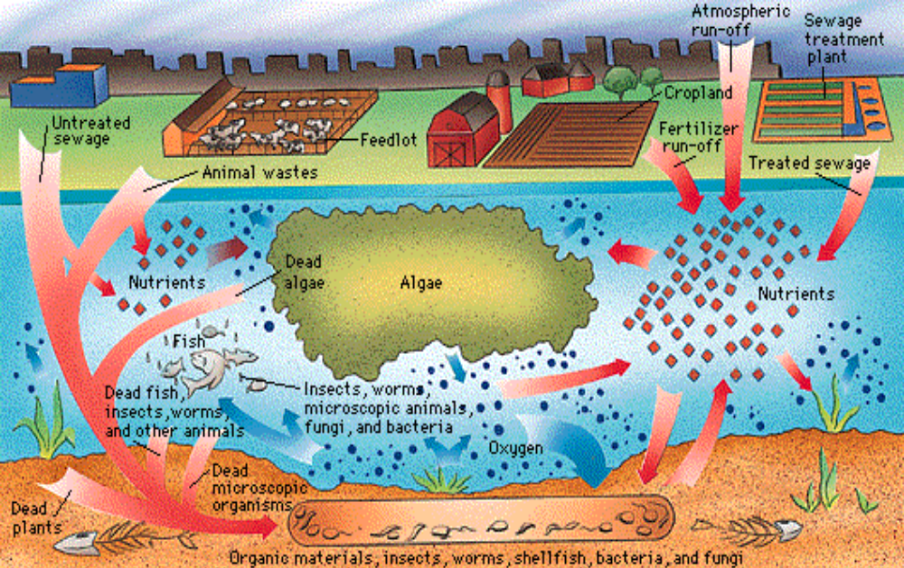
Figure 2 eutrophication on river or Lake

Organic fertilizers
Chemical fertilizers has been adversely affecting the flora, fauna as well as soil quality more ever every plant pathogens are causing loss of 10 to 20% of agricultural production world wide. Verimicompositing is natural process by micro-organisim that turn organic/ biodegrable material in to a dark. Earthy , smelling substances called composet or humus.
The importance and, in some cases, the major problems associated with organic fertilizers, deserve special mention. Manure produced by cattle, pigs and poultry are used as organic fertilizer the world over. To this is added human excreta, especially in some Asian countries where animal and human excreta are traditionally used in fish culture as well as on soils. However, intensive livestock production has produced major problems of environmental degradation, In addition to problems associated with excessive application of manure on the land, is the problem of direct runoff from intensive cattle, pig and poultry farms. Although this is controlled in many western countries, it constitutes a serious problem for water quality in much of the rest of the world.
• Fertilization of surface waters, both as a result of direct discharges of manure and as a consequence of nitrate, phosphate and potassium being leached from the soil.
• Contamination of the groundwater as a result of leaching, especially by nitrate. Phosphates are less readily leached out, but in areas where the soil is saturated with phosphate this substance is found in the groundwater more and more often.
• Surface waters and the groundwater are being contaminated by heavy metals. High concentrations of these substances pose a threat to the health of man and animals. To a certain extent these heavy metals accumulate in the soil, from which they are taken up by crops. For example, pig manure contains significant quantities of copper.
• Acidification as a result of ammonia emission (volatilization) from livestock accommodation, manure storage facilities, and manure being spread on the land. Ammonia constitutes a major contribution to the acidification of the environment, especially in areas with considerable intensive livestock farming.
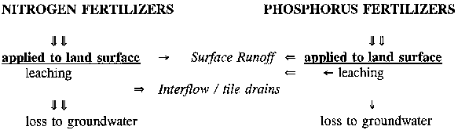

FIGURE 3 The N cycle in soil (from Stevenson, 1965)
FIGURE 3Schematic diagram of nitrogen and phosphorus losses. Arrows are proportional to loss

Problems of restoration of eutrophic lakes
Eutrophic and hypertrophic lakes tend to be shallow and suffer from high rates of nutrient loadings from point and non-point sources. In areas of rich soils such as the Canadian prairies, lake bottom sediments are comprised of nutrient-enriched soil particles eroded from surrounding soils. The association of phosphorus with sediment is a serious problem in the restoration of shallow, enriched lakes. P-enriched particles settle to the bottom of the lake and form a large pool of nutrient in the bottom sediments that is readily available to rooted plants and which is released from bottom sediments under conditions of anoxia into the overlying water column and which is quickly utilized by algae. This phosphorus pool, known as the "internal load" of phosphorus, can greatly offset any measures taken by river basin managers to control lake eutrophication by control of external phosphorus sources from agriculture and from point sources. Historically, dredging of bottom sediments was considered the only means of remediating nutrient-rich lake sediments, however, modern technology now provides alternative and more cost-effective methods of controlling internal loads of phosphorus by oxygenation and by chemically treating sediments in situ to immobilize the phosphorus. Nevertheless, lake restoration is expensive and must be part of a comprehensive river basin management programme

Conclusions
Human reduced eutrophication have heavily degraded fresh water system world wide reducing water quality and altering ecosystem ecosystem structure and function, population growth rapid industrialization and excessive use of fertilizers have resulted in disproportionate amounts of phosphorous in lake stimulating plant and algae over growth. With the demand for fresh water resources expected to increase substantially (Jorgenson et al 2001). These anthropegenic influences have severe environmental and economic repercussions. Ultimately , it is imperative to increase public awareness and the environmental education of citizen and also developed an integrated strategy to abate eutrophication (Jorgenson 2001). Only collective community effort can more effectively reduce nutrient input to lake (e.g. by reduction in detergent use) and bring cultural eutrophication under control. Double food Yield in latter require a ten fold increase in fuel, fertilizers and pesticides (E.P.Odum 1971.).the blue – green algae , some of which have gelatinous capsules and thrives on organic pollution , thus clogging public water supplies and creating nuisance in recreational lakes. Ecology is concerned not only with organisim but with energy flows and material cycles on the land, in the oceans, into air, and in fresh waters, ecology.
Water pollution control specialist have, in the past failed to understand these relationship and have attempted to single out one factor as the cause of undesirable but unstable algal blooms resulting from pollution.( one problem one solution syndrome) the strategy of water pollution control must involve reducing the input of all enriching and toxic materials , not just one or two item banned.as geographer M.G. Wolmann 1971. Has concluded that; demand on water resources are increase a rate that exceeds the rate of installation of waste treatment facilities.Change in freshwater availabliy will consequences of global climate change. Water management must adopt to effect of climate change by adopting a hostalic approach to management ecosystems on a regional basis. Inorganic fertilizers in sewage treatment effluent entering lakes increase their primary production rates and changes the composition of the aquatic community .Eutrophic water requires cool clear oxygen rrich water may disappear; growth algae and aquatic plantmay become so great as to interfere with swimming or undecomposed dissolved organic may impact a bad taste to water even after it has passed trough water purification systems.Effort to divert municipal wastes from certain lakes has demonstrated that cultural eutrophication can be reserved in the sense that some lakes will return to less fertile condition with improved water quality in terms of human use. ( Edmondson,1968).

Sources of phosphorous – Agriculture =62%, major town=-9%, industry=1%, Septic Tank=14%
Water pollution
1.Change in water quality that can harm organisims or make unfit for Human uses
2.Contamination with Chemicals
3.Excessive Heat.

Water Treatment Plant
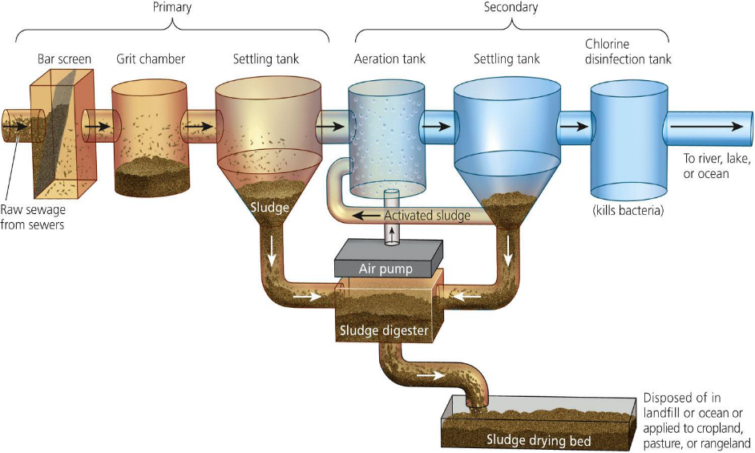

Figurer 4 Waste Water treatment plant facilities

References
- Anderson DM, Gilbert PM and Burkholder JM. 2002. Harmful Algal Blooms and Eutrophication: Nutrient sources, composition, and consequences sources.
- Carpenter SR, 2008. Phosphorous contol is critical to mitigating eutrophication. Proceedings of the National Academy of Science 105:11039-11040.
- Carpenter SR, Christensen DL, Cole JJ et al, 1995, biological control of eutrophication in lakes .,Environmental sciences and Technology 29:784-786.
- E.P.Odum 1971.
- Edmonson WT. 1970. Phosphorous Nitrogen , and Algae in Lake Washington after diversion of Sewage. Science169:690-691.
- ESA ( ecological Society of America) 2008, Hypoxia Washington DC: Ecological Society of America; 1p.
- Harper D. 1992 Eutrophication of freshwaters: Principal; and restoration Newyork: Chapman & Hall.
- Hasler AD,1947. Eutrophication of lakes by domestic drainage ecology 28:383-395.
- Jorgensen SE. 2001. Water quality : The impact of eutrophication lakes and Reservoirs 3:15-18.
- Kund- Hansen C, 1994 ., Histrocal Perspective of the phosphate detergents conflicts, 1993.natural Resources and environmental policy seminor of the University of Colorodo Boulder CO. University of Colorodo.
- Lathrop RC., Carpentar SR, Panuska JC, Soranno PA, and stow CA.1998. Phosphorous loading reduction needed to contolcriceses blue – green algal blooms intake Mendota. Candian Journal of fisheries and aquatic science 55:1169-1178.
- Litke DW.1999. Review of Phosphorous control measure in the US and their effects on water Quality AssesmentProgramm : Water- Resources Investigation Reportnr99-4007.
- NOAA (National Oceanic and Atmospheric Administration) .2009.Phytoplankton Blooms: The Basics. 27 sept. 2009.
- Schildler DW. 2006. Recent in the understanding and management of eutrophication, liminology and oceanography 5:356-363.
- Sharma P.D. 2009, ecology and environment; 10th ed. Merrut India; Rastogi Publication.
- Smaya JJ. 2008. Complexity in the eutrophication- harmful algal bloom relationship, with comment on the importance of grazing Harmful algae 8:140-151.
- Smith V.H. Tilman GD and Nekola J.C. , 1999. Eutrophication: impacts of excess nutrients inputs on fresh Water; Marine and terrestrial ecosystems. Environmental pollution 100:179-196.
- Smith V.H., 2003. Eutrophication of fresh Water and coastal Marine ecosystems : a global problem Environmental Science and pollution Research 10: 126-139.
- Vollenweider R.A. 1968. Scientific foundamentals of the eutrophication of lakes and flowing Waters, with refrences to nitrogen and phosphorous as factors in eutrophication., DAS/ CSE?68.27,
- WHO ( World Health Organization issues in Water and Infectious Disease. World health organization report nr.2.
- Wolmann M.G. 1971.

