Title: Conditioning of radioactive/nuclear wastes: An overview
Abdel Rahman RO¹,
¹Hot Lab. Center , Atomic Energy Authority of Egypt ,P.O. No. 13759, Cairo, Egypt

Keywords: Radioactive waste, classification, immobilization, glass, cement, ceramic
- Abstract Body
Safe management of nuclear wastes is a critical aspect in ensuring the sustainability of the nuclear industry in some countries and/or to end legacy practices in other countries. Currently, these wastes are managed according to the containment and confinement option, where their radiological hazards are contained by isolating the wastes for a sufficient period to allow the decay of short-lived radioanuclides and limit the release of long-lived radionuclides. Conditioning is a predisposal activity that aims to produce an optimized waste package. Conditioning includes producing optimized waste form and encloses it in a suitable package. This work aims at summarizing the technical and academic efforts toward the optimization of the conditioning process and identifying the gaps in this area. Within this context, radioactive/nuclear waste classification and different activities in integrated radioactive waste management schemes will be introduced. Conventional and innovative conditioning technologies will be overviewed. Methods to assess the optimized performance of these wastes will be summarized. Finally, methods to address the conditioning of problematic wastes and the required research efforts in this field will be identified.
- Image
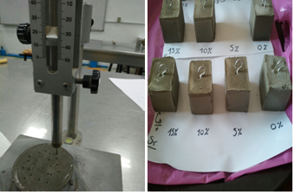
- References
- IAEA, (2003) Radioactive waste management glossary, IAEA, Vienna.
- Rehab O. Abdel Rahman, Ravil Z. Rakhimov, Nailya R. Rakhimova, Michael I. Ojovan, (2014) Cementitious materials for nuclear waste immobilisation, Wiley, New York, ISBN 9781118512005.
- R.O. Abdel Rahman, H.M. Saleh, Introductory chapter: Safety aspects in nuclear engineering, Accepted in publication in, In: R.O. Abdel Rahman& H.M. Saleh (Eds) nuclear engineering, Intech, ISBN: 978-953-51-5411-2
IV. Biography
Dr. Abdel Rahman is an associate professor of Chemical Nuclear Engineering at Atomic Energy Authority of Egypt. She received her Ph.D. degree in Nuclear Engineering from Alexandria University, Egypt. Her research interests cover different aspects in radioactive waste management. She co-authored more than 30 peer-reviewed scientific papers, 10 book chapters, and 1 book, and edited 6 books. She serves as a verified reviewer in several international journals, member of organizing committees of international conferences, managing editor in IJEWM, and IJEE (Inderscience). She is an honored scientist of ASRT and of Publons sentinel of science 2016 and peer-review awards in 2017.
V. Presenting author details
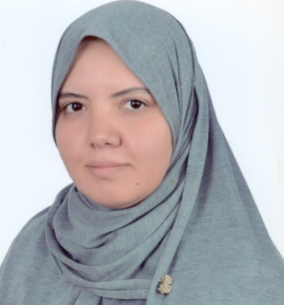
Full Name: Rehab O Abdel Rahman
Contact number: +201061404462
Twitter account: @RehabOAbdelrahm
LinkedIn account: http://www.linkedin.com/pub/rehab-o-abdel-rahman/15/3a4/aa3
Session name/ number: Waste Management and Chemical Engineering /14
Category: (Oral presentation/ Poster presentation)
Passport Number:A16031608

