Development of an Apparatus for Observation of Fundamental Biomass Reaction Behavior
Dr. Moe Thanda Kyi, Professor and Head
Department of Fuel and Propellant Engineering
Myanmar Aerospace Engineering University
Meiktila Township, Myanmar
Dr. Reiji Noda, Associate Professor
Graduate School of Science and Technology
Division of Environmental Engineering Science
Gunma University, Kiryu City, Japan

Abstract
Depletion of fossil energy is the reason for the exploration of the possibility of the use of renewable energy resources. This research paper presents the concept, design and construction of the device to thermogravimetric measurements and the results of tests carried out on wood pellets. The purpose of this paper is to study the characteristics and thermal degradation behavior of wood pellet for biofuel production via gasification technology. The elemental properties of the feedstock were characterized by an elemental analyzer while thermal properties were investigated using thermogravimetric analyzer (TGA). The gasification processes were being carried out at room temperature up to 900°C in the presence of nitrogen and air as gasification agent, gas flowing at 500 ml/min. The investigated parameters are particle sizes and heating rate. The particle size used in the range of 425 to 500 um. The heating rates applied was 10°C/min. Sample weight varied from 0.5 to 1 gram, and stainless steel tray was used for the test. The further part of the paper contains the results of the tests carried out on wood pellet in the form of a thermogravimetric curves. These studies are conducted by looking at opportunities to improve the energy efficiency of the gasification process of biomass.

Image
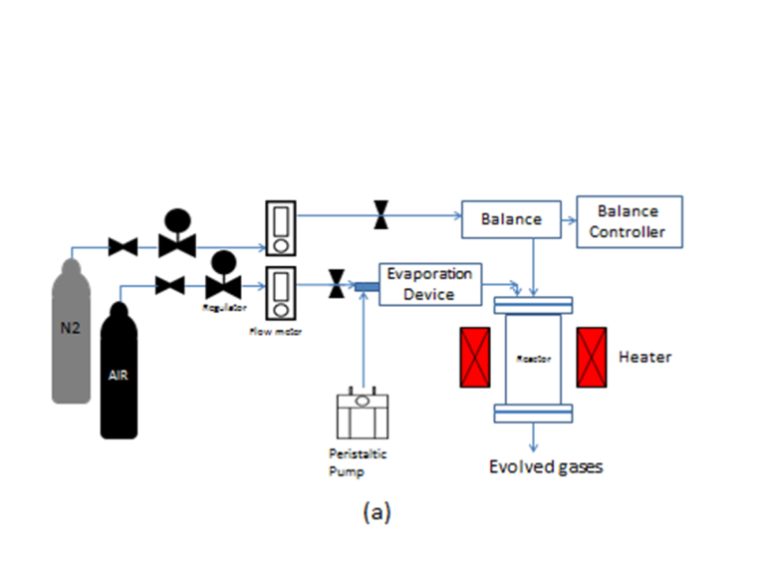
Figure1. (a) Schematic diagram of experimental apparatus

Publications
Study on the Anhydrous Ethanol Production by using Zeolite Molecular Sieve.
8th ASTW Technical and Scientific Conferences, 2008, Philippines.
Production of Synthetic Gasoline by Bergius process using Coal.
The 1st International Conference on Energy, Environment and Human Engineering (ICEEHE), 2013, Myanmar.
Preparation of Zeolite Molecular Sieve for Ethanol Dehydration.
5th Annual Seminar on Research and Engineering (Myanmar Engineering Society, MES), 2010, Myanmar.
Liquid Fuel Production from Biomass Tar by Hydrogenation
The 4th AUN/SEED-Net Regional Conference on Energy Engineering, 24-25th November 2016, Phnom Penh, Cambodia.
Liquid Fuel Production from Biomass Tar by Hydrogenation
International Journal of Scientific and Research Publications, ISSN 2250-3153, March 2017, Volume 7, Issue 3.
1. Noorhaza Binti Aliasa, Norazana Ibrahima, Mohd. Kamaruddin Abd. Hamidb (2014) Pyrolysis of empty fruit bunch by thermogravimetric analysis, UTM-MPRC Institute for Oil and Gas, Faculty of Petroleum and Renewable Energy Engineering, Universiti Teknologi Malaysia, 83130 UTM Johor Bahru, Johor, Malaysia.
2. Md.Ahiduzzaman and A.K.M.Sadrul Islam (2014) Thermo-gravimetric and Kinetic Analysis of Different Varieties of Rice Husk, Bangabandhu Sheikh Mujibur Rahman Agricultural University, Gazipur-1706, Bangladesh.
3. Sanjay Kumar Meher, KINETIC STUDY OF RICE BRAN BY THERMOGRAVIMETRIC ANALYSIS, Department of Chemical Engineering, National Institute of Technology, Rourkela Rourkela-769008, Odisha, India (2015) Sullivan EV, Zahr NM (2008) Neuroinflammation as a neurotoxic mechanism in alcoholism: Commentary on “Increased MCP- 1 and microglia in various regions of human alcoholic brain”. Experimental neurology 213:10-17.

 Biography
I am Dr. Moe Thanda Kyi, Professor and Head of Fuel and Propellant Engineering Department at Myanmar Aerospace Engineering University, Meiktila Township, Mandalay Region, Myanmar. I got Bachelor Degree (Chemical Engineering) in 2002 from Mandalay Technological University. With that experience, I tried to improve myself as a Master of Engineering student at Yangon Technological University. My research was "Biogas Production from Wet Market Waste". I was awarded Ph.D (Chemical Engineering) in 2009 from Mandalay Technological University. My research was "Preparation of Zeolite Molecular Sieve for Ethanol Dehydration".
Now, I am a Professor and Head of Fuel and Propellant Engineering Department at Myanmar Aerospace Engineering University (MAEU). I have been a Government servant under the Ministry of Science and Technology for eighteen years. Fortunately, my career participates in three functions: Management, Teaching and Research. I have to train my university students to be clever and outstanding in their learning. And I am also interested in research work. So, this year, I am working fuel research in Japan. My research is developments of appropriate conversion process for Myanmar biomass. In last year, I have focused in my laboratory work on production of liquid fuel from biomass tar by hydrogenation. This work led in the collaborative research activities with Gunma University, Japan.
I admit that I need to some extent to get improvements in my career. So, I apply this program to fulfill my needs and I promise to do my best. I apply for under the rules of the program if I am chosen as a winner.
Email: moethandakyi@gmail.com

Notes/Comments:

