Liquid Fuel Production from Biomass Tar by Hydrogenation
Dr. Moe Thanda Kyi, Professor and Head
Department of Fuel and Propellant Engineering
Myanmar Aerospace Engineering University
Meiktila Township, Myanmar .
Dr. Reiji Noda, Associate Professor
Graduate School of Science and Technology
Division of Environmental Engineering Science
Gunma University, Kiryu City, Japan

Abstract
Bio - oils production studied from heavy tar which is organic phase of pyrolysis oil using CoMo/Al₂O₃ catalyst in the bench scale hydrogenation process. In this experiments, hydrogenation of biomass tar were carried out in varied reaction conditions to elucidate influence of operation factors. The effect of reaction temperature, retention time, feed rate, space velocity (SV), hydrogen concentration, and catalyst loading factor on bio-oil yield, carbon content, and carbon recovery of heavy tar by catalytic conversion was investigated. The six variables ranged from 300 to 500 °C for temperature,0-140 min for retention time, 1,2, and 3.3 g-tar/min for feed rate,0.1,0.2,and 0.4 s⁻¹ for SV, 25,50, and 75 v% for hydrogen concentration, and 1.3,2.7 and 4.4 mg-tar /min/g-cat for catalyst loading factor. The product oils and gaseous species were analyzed by Karl Fischer moisture titrating analyzer, Total organic carbon (TOC) analyzer, GC – 14A gas chromatography, Agilent 3000 micro gas chromatography and elemental analysis. It was found that maximum bio-oil yield of 29wt% was obtained at 400°C,60-140 min,2 g-tar/min feed rate,0.2 s⁻¹ SV,50 v% hydrogen concentration and 2.7 mg-tar /min/g-cat catalyst loading. In this study, it was able to produce a high quality liquid fuel with minimum water content 0.3wt% in oil phase and maximum level of HHV (39.8MJ/kg). The oil was also observed to have an abundant amount of aromatic compounds. It was possible to produce multi-component fuels through the hydrogenation of bio-oils from heavy tar.

Image

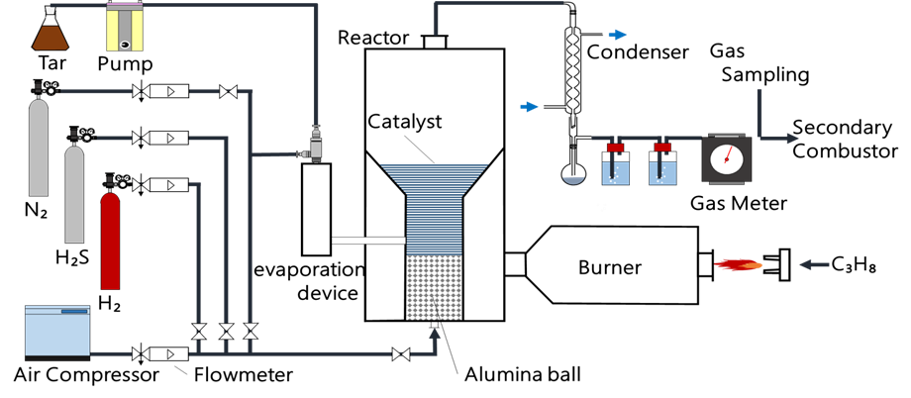
Figure1. Schematic diagram of experimental apparatus

Publications
Study on the Anhydrous Ethanol Production by using Zeolite Molecular Sieve.
8th ASTW Technical and Scientific Conferences, 2008, Philippines.
Production of Synthetic Gasoline by Bergius process using Coal.
The 1st International Conference on Energy, Environment and Human Engineering (ICEEHE), 2013, Myanmar.
Preparation of Zeolite Molecular Sieve for Ethanol Dehydration.
5th Annual Seminar on Research and Engineering (Myanmar Engineering Society, MES), 2010, Myanmar.
Liquid Fuel Production from Biomass Tar by Hydrogenation
The 4th AUN/SEED-Net Regional Conference on Energy Engineering, 24-25th November 2016, Phnom Penh, Cambodia.
Liquid Fuel Production from Biomass Tar by Hydrogenation
International Journal of Scientific and Research Publications, ISSN 2250-3153, March 2017, Volume 7, Issue 3.
- G. W. Huber, S. Iborra and A. Corma, Chem. Rev (2006) 106, 4044–4098.
- Faisal Abnisa, W. M. A. Wan Daud, Arash Arami-Niya, Brahim Si Ali, and J. N. Sahu, Energy Fuels (2014) 28, 3074−3085..
- Juan Carlos Serrano-Ruiz and James A. Dumesic (2012) Catalytic Production of Liquid Hydrocarbon Transportation Fuels, Department of Chemical and Biological Engineering, University of Wisconsin—Madison, Madison, WI 53706, USA.
- Elliott DC (2007) Historical developments in hydro processing bio-oils. Energy Fuel 21:1792–1815 63.Furimsky E (2000) Catalytic hydrodeoxygenation. Appl Catal A Gen 199: 147–190.
- Czernik S, French R, Feik C, Chornet E (2002) Hydrogen by catalytic steam reforming of liquid byproducts from biomass thermo conversion processes. Ind Eng Chem Res 41:4209–4215.
- Cortright RD, Davda RR, Dumesic JA (2002) Hydrogen from catalytic reforming of biomass derived hydrocarbons in liquid water. Nature, 418:964–967.
- Davda RR, Dumesic JA (2004) Renewable hydrogen by aqueous-phase reforming of glucose. Chem Commun 36–37.

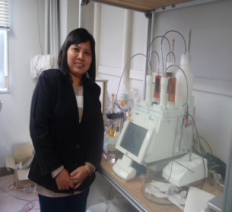Biography
I am Dr. Moe Thanda Kyi, Professor and Head of Fuel and Propellant Engineering Department at Myanmar Aerospace Engineering University, Meiktila Township, Mandalay Region, Myanmar. I got Bachelor Degree (Chemical Engineering) in 2002 from Mandalay Technological University. With that experience, I tried to improve myself as a Master of Engineering student at Yangon Technological University. My research was "Biogas Production from Wet Market Waste". I was awarded Ph.D (Chemical Engineering) in 2009 from Mandalay Technological University. My research was "Preparation of Zeolite Molecular Sieve for Ethanol Dehydration".
Now, I am a Professor and Head of Fuel and Propellant Engineering Department at Myanmar Aerospace Engineering University (MAEU). I have been a Government servant under the Ministry of Science and Technology for eighteen years. Fortunately, my career participates in three functions: Management, Teaching and Research. I have to train my university students to be clever and outstanding in their learning. And I am also interested in research work. So, this year, I am working fuel research in Japan. My research is developments of appropriate conversion process for Myanmar biomass.
In last year, I have focused in my laboratory work on production of liquid fuel from biomass tar by hydrogenation. This work led in the collaborative research activities with Gunma University, Japan.
I admit that I need to some extent to get improvements in my career. So, I apply this program to fulfill my needs and I promise to do my best. I apply for under the rules of the program if I am chosen as a winner.

Email: moethandakyi@gmail.com

Notes/Comments:

