Overexpression of miR-183 cluster induces neuronal cell fate in Human Retinal Pigment Epithelial (hRPE) Cells
Maliheh Davari¹, Zahra-Soheila Soheili^{1*}, Shahram Samiei², Zohreh Sharifi², Ehsan Ranaei Pirmardan³
¹ National Institute of Genetic Engineering and Biotechnology, Tehran, Iran
² Blood Transfusion Research Center High Institute for Research and Education in Transfusion Medicine,Tehran, Iran
³ Department of Molecular Genetic, Faculty of Biological Sciences, Tarbiat Modares University, Tehran, Iran
Abstract
Statement of the Problem: miR-183 cluster, composed of miR-183, miR-96 and miR-182, is highly expressed in the adult retina particularly photoreceptors. As a key miRNA cluster in differentiation of photoreceptors, miR-183 cluster was overexpressed in multipotent hRPE cells to evaluate its potential to induce hRPE reprogramming toward neuron fate in vitro. Methodology & Theoretical Orientation: hRPE cells were transfected with the construct carrying miR-18/-96/-182 genes and subjected to measure the expression levels of miR-183 cluster members and that of retina-specific neuronal genes such as OTX2, NRL, PDC, DCT, POU4F2, RCV, CRX, NR2E3 and NGN1. The hRPE cells expressing miR-183 cluster were also immunocytochemically examined for retina-specific neuronal markers including Rhodopsin, red opsin, CRX, Thy1, CD73, recoverin and PKC to identify the developing neuron-like cells. Findings: Data showed that hRPE cells overexpressing miR-183, miR-96 and miR-182 (78-, 158- and 64-fold, respectively) also demonstrated the upregulation of neuronal genes such as OTX2, NRL, PDC and DCT (2-, 2-, 7-, 2-fold, respectively) (Figure 1). Furthermore, some cells immunoreactive for neuronal markers including Rhodopsin, red opsin, CRX and Thy1 were found in miR-183 cluster-treated hRPE cultures. Conclusion & Significance: Both transcriptional and translational upregulation of neuronal genes in miR-183 cluster-treated hRPE cells suggests that in vitro overexpression of miR-183 cluster members could pave the reprogramming way of cultured hRPE cells to retinal neuron-like fate.
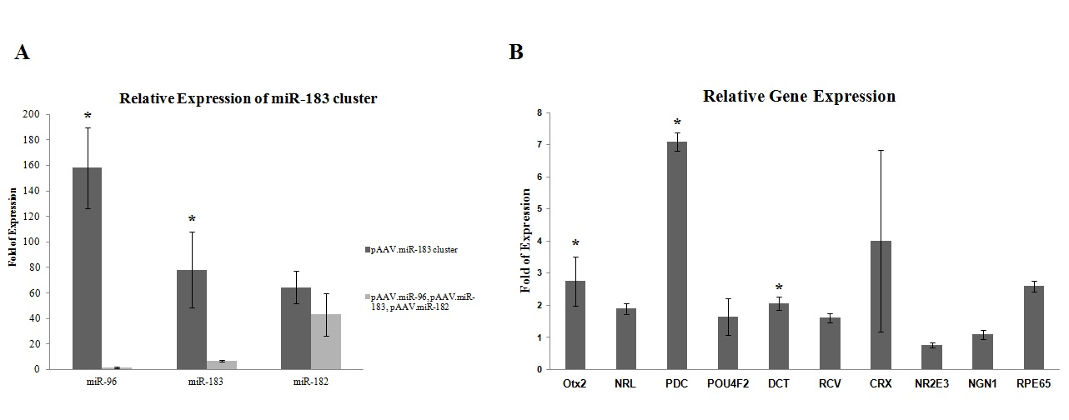
Images
Figure 1. Relative expression of miR-183 cluster and retina-specific neuronal genes in transfected hRPE cells. (A) miR-96/-183/-182 genes were overexpressed 158-, 78- and 64-fold, respectively, in hRPE cells transfected with miR-183 cluster (B) hRPE cells overexpressing miR-183 cluster showed upregulation of several retina-specific neuronal genes including OTX2, NRL, PDC and DCT.

Recent Publications
- Xu, S. (2009) microRNA expression in the eyes and their significance in relation to functions. Progress in Retinal and Eye Research, 28(2): p. 87-116.
- Andreeva, K. and N.G.F. Cooper (2014) MicroRNAs in the Neural Retina. International Journal of Genomics, p. 14.
- Xu, S., et al. (2007) MicroRNA (miRNA) Transcriptome of Mouse Retina and Identification of a Sensory Organ-specific miRNA Cluster. Journal of Biological Chemistry, 282(34): p. 25053-25066.
- ZHU, Q., et al. (2011) Sponge Transgenic Mouse Model Reveals Important Roles for the MicroRNA-183 (miR-183)/96/182 Cluster in Postmitotic Photoreceptors of the Retina. ETATS-UNIS: American Society for Biochemistry and Molecular Biology. 286 (12).
- Swaroop, A., D. Kim, and D. Forrest (2010) Transcriptional regulation of photoreceptor development and homeostasis in the mammalian retina. Nat Rev Neurosci, 11(8): p. 563-576.



Biography
Zahra-Soheila Soheili Ph.D. is an associate professor of cell and molecular biology at National Institute of Genetic Engineering and Biotechnology (NIGEB).She graduated from the Institute of Biochemistry and Biophysics, University of Tehran, Iran in 2002. In 2003 she was recruited to NIGEB and became an instructor and junior investigator at the “medical biotechnology department”, where she studied on human retinal pigment epithelium cells’ biology, in vitro. Recently, her lab discovered two types of RPE cell lines and wrote a license agreement for hRPE cell line trademark. She established herself within the NIGEB community and rapidly risen through the ranks to become a senior investigator, currently at the associate professor level.
In the past five years, she pursued novel therapies for important eye diseases, such as age-related macular degeneration (AMD) and retinitis pigmentosa. She is working on designing and synthesis of chimeric protein molecules for molecular therapy of ocular diseases.

Email: soheili@nigeb.ac.ir

