Characterization of in vitro inhibitory effects of consensus siRNAs against NS5B protein of hepatitis C virus 1a genotype
Imran Shahid, Ph.D, Umm Al-Qura University, Makkah, Saudi Arabia
Muhammad Hassan Hafeez, MBBS, FMHCM, Lahore, Pakistan
Waleed Hassan Al-Malki, Ph.D, Umm Al-Qura University, Makkah, Saudi Arabia
Sajida Hassan, Ph.D, University of Washington, Seattle, USA

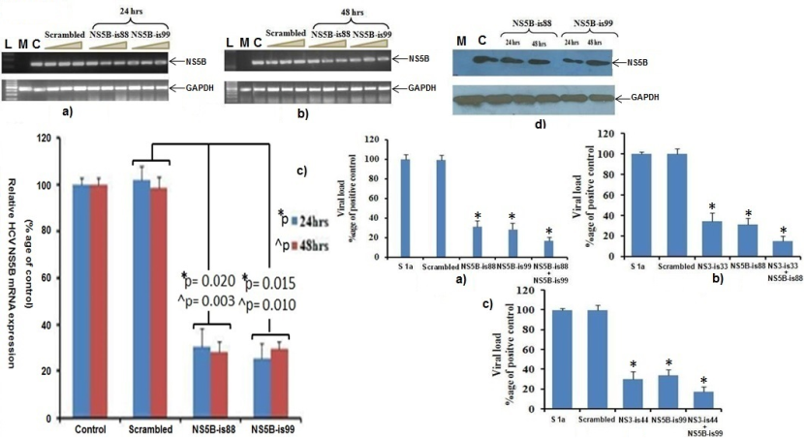
Abstract (300 word limit)
Statement of the Problem: This study was aimed to establish an in vitro stable human hepatoma (Huh-7) cell culture system with consistent expression of the NS5B protein of hepatitis C virus (HCV) 1a genotype and to explore inhibitory effects of sequence specific short interference RNA (siRNA) targeting NS5B in stable cell clones, and against viral replication in HCV genotype 1a serum - inoculated Huh-7 cells. Methodology & Theoretical Orientation: In vitro stable Huh-7 cells with persistent expression of NS5B protein was produced under gentamycin (G418) selection. siRNA inhibitory effects were determined by analyzing NS5B expression at mRNA and protein level through reverse transcription-polymerase chain reaction (RT-PCR), quantitative real-time PCR (qPCR), and Western blot respectively. Statistical significance of data (i.e., NS5B inhibition) was performed by using SPSS software (version 16.0, SPSS Inc). Findings: NS5B stable cell expression at mRNA and protein level was confirmed by RT-PCR and Western blot analysis on day 10, 20 and 30 post transfection. Cell proliferation remained unaffected at most concentrated dose of siRNAs (50 nmol/L) as revealed by MTT cell proliferation assay. Time-dependent siRNA inhibitory analysis demonstrated significantly decreased NS5B expression at mRNA and protein levels in stable Huh-7 cells. siRNA NS5B-is99 elucidated maximum inhibition of NS5B mRNA expression in stable Huh-7 cells at 24 (74%, P= 0.015) and 48 h (71%, P= 0.010) post transfection as determined by qPCR. The virus replication inhibition in serum inoculated Huh-7 cells was also shown by siRNA NS5B-is99 (71%, P< 0.05) and NS5B-is88 (68%, P< 0.05) at day 3 postinfection. The combinatorial silencing impact of siRNAs (NS5B-is88 + NS5B-is99) on viral copy number was much significant (82%, P< 0.05) as compared to individual inhibition. siRNA combinations (NS3-is44 + NS5B-is99) targeting different HCV genome regions also significantly decreased viral copy numbers (84%, P< 0.05) as compared to siRNA inhibitory effects alone (70% & 68% respectively, P< 0.05). Conclusion & Significance: Stable Huh-7 cell culture system with persistent expression of NS5B protein could be helpful for viral replication studies and development of anti-HCV drug screening assays. The siRNAs silencing impact against virus replication could be further evaluated and tested as an adjuvant therapy with other anti-hepatitis C regimens.

Image

Recent Publications (minimum 5)
- Shahid I, AlMalki WH, AlRabia MW, Mukhtar MH, Almalki SSR, Alkahtani SA, Ashgar SS, Faidah HS, Hafeez MH. In vitro inhibitory analysis of consensus siRNAs against NS3 gene of hepatitis C virus 1a genotype. Asian Pac J Trop Med. 2017 Jul;10(7):701-709. doi:10.1016/j.apjtm.2017.07.011. Epub 2017 Aug 8.
- Shahid I, AlMalki WH, Hassan S, Hafeez MH. Real-world challenges for hepatitis C virus medications: a critical overview. Critical reviews in microbiology. 2017:1-18.
- Imran Shahid, Waleed H. AlMalki, Mohammed W. AlRabia, Muhammad Ahmed, Mohammad T. Imam, Muhammed K. Saifullah and Muhammad H. Hafeez (2017). Recent Advances in Angiogenesis Assessment Methods and their Clinical Applications, Physiologic and Pathologic Angiogenesis - Signaling Mechanisms and Targeted Therapy, Dr. Dan Simionescu (Ed.), InTech, DOI: 10.5772/66504.
- Imran Shahid, Waleed H. AlMalki, Mohammed W. AlRabia, Muhammad H. Hafeez and Muhammad Ahmed (2017). Hepatitis C Virus Infection Treatment: Recent Advances and New Paradigms in the Treatment Strategies, Advances in Treatment of Hepatitis C and B, Prof. Naglaa Allam (Ed.), InTech, DOI: 10.5772/65873.
- Imran Shahid, Waleed Hassan AlMalki, Shaia Saleh R. Almalki, Ismail Muhammad AlTurkestany, Hassan Ali AlGhamdi, Saleh Ali AlMenshawi: Inhibition of Hepatitis C Virus Genotype 1a Non-Structural Proteins by Small Interference RNA in Human Hepatoma Cell Lines. Pharmacology & Pharmacy, Vol.6 No.11, Pub. Date: November 24, 2015.

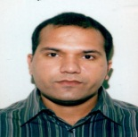
Biography (150 word limit)
Dr. Imran Shahid is an assistant Professor at Umm Al-Qura University, Makkah, Saudi Arabia where his research is focused on the broad areas of host-virus networks in HCV disease progression as well as host-virus genes expression during oxidative stress, hepatic steatosis, fibrosis, and hepatocellular carcinoma. He is also enthusiastically involved in the studies of HCV infection biology, Cell signaling pathways and genome heterogeneity in the Saudi population. He was trained from applied and functional genomics laboratory, National Centre of Excellence in Molecular Biology (NCEMB), University of the Punjab, Lahore, Pakistan where he worked on anti-mRNA based treatment strategies against hepatitis C virus 1a genotype in Pakistani population. Dr. Imran has published many research articles in peer-reviewed international journals and a member of the editorial board of several international journals.
Email: iyshahid@uqu.edu.sa

