Title: Synergistic anti-cancer effects of Nigella sativa seed oil and conventional cytotoxic agent against human breast cancer.

Waheed A. Baig¹, Kholoud Alwosaibai², Khalid M. Al Jubran¹, Tariq M. Chaudhry¹, Nouf Al-Dowish², Fatimah Alsaffar²
¹Department of Clinical Laboratory Science, Prince Sultan Military College of Health Sciences, Dhahran, Saudi Arabia
²Oncology & Immunology Research Center, King Fahd Specialist Hospital, Dammam, Saudi Arabia

Keywords: Breast cancer, Nigella Sativa, Doxorubicin, Synergistic effect, Anti-cancer

- Abstract
Breast cancer is the most commonly diagnosed invasive non-skin malignancy in women worldwide, and it is the leading cause of cancer-related deaths in women. Nigella sativa seed oil has been found to be effective in cancer treatment, as well as having anti-cancer properties in some other types of cancers. The study looked into the synergistic cytotoxic effects of Nigella sativa seed oil and doxorubicin in the treatment of human breast cancer cells (MCF-7).
Nigella sativa seed oil was used to evaluate its effect on human breast cancer cells, either alone or in conjunction with doxorubicin.3-(4,5-dimethylthiazol-2-yl)-2,5-diphenyltetrazolium bromide (MTT) tests were used to examine cell proliferation and cell viability, while phase contrast inverted microscopy was used to examine cellular morphology. Furthermore, the role of Nigella sativa seed oil in decreasing cell tumorgenicity features was highlighted by testing the cancer cell migration using the wound healing assay.
Results showed that higher concentrations (50µg/ml) of Nigella sativa seed oil changed the breast cancer cell morphology and decreased the cell proliferation and viability. Breast cancer cells treated with black seed oil decreased cell movement after 24 hours compared to the untreated cell in the wound healing assay. Whereas, only the higher concentration of doxorubicin (0.5µg/ml-2.5µg/ml) reduced cell proliferation and the cell viability. Moreover, the combination treatment of 50ug/ml of black seed oil with different concentrations of doxorubicin caused a significant cell proliferation reduction and decreased cell viability. The activity was seen optimum at lower concentration (0.1µg /ml) of doxorubicin.
There was decreased cell proliferation and cell viability when Nigella sativa seed oil was used alone or in conjunction with doxorubicin in Breast cancer cells (MCF-7) revealing potential opportunities in the field of cancer treatment.
- Image:

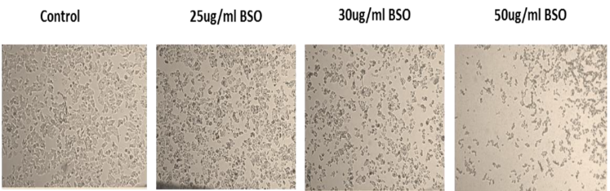
Image 1: Morphological changes in breast cancer cells (MCF-7) after a 24-hour treatment with Black seed oil (BSO).

Image 6: MCF-7 tumor cells were treated for 24 hours with 50 g/ml doses of black seed oil of N. sativa (BSO).
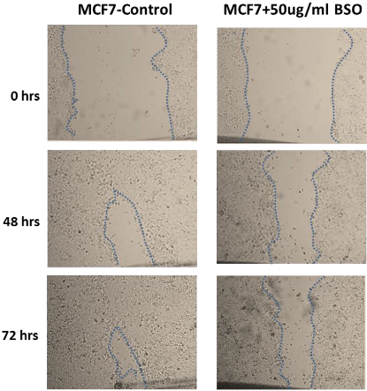
- Reference:
- Tavakkoli A, Mahdian V, Razavi BM, Hosseinzadeh H. Review on clinical trials of black seed (Nigella sativa) and its active constituent, thymoquinone. Journal of pharmacopuncture. 2017 Sep;20(3):179.
- Liu W, Chen W, Zhang X, Zhao P, Fan Z, Bi L, et al. Higher efficacy and reduced adverse reactions in neoadjuvant chemotherapy for breast cancer by using pegylatediposomal doxorubicin compared with pirarubicin. Scientific Reports. 2021 Jan 8;11(1):1-9.
- Biography:
Waheed Ahmad Baig has completed his Master in 2000 from Punjab University and M.Phil. in 2005 from GC University, Lahore, Pakistan. He is presently serving as researcher in Prince Sultan Military College of Health Sciences at Dhahran Saudi Arabia He has vast experience of research and teaching under-graduate and post- graduate students. He has published several papers in reputed journal and supervise student research project. His technical skills include Cell Culture, Flow Cytometry, Immunohistochemistry, PCR, Cancer Biology, Immunofluorescence, Western Blot Analysis and Gel Electrophoresis.

Presenting author details


Full Name: Waheed Ahmad Baig
Contact number: 00966561674007
Twitter account:
Linked In account:
Session name/ number:
Category: Poster presentation
Passport Number: AL3920484

