Structure-based Screening for Protein Phosphatase 1 Interactome Mapping
Julia de Vasconcellos Castro, Ph.D., Diana Murray, Ph.D., Barry Honig, Ph.D.. Columbia University Medical Center, NY, USA

Abstract (300 word limit)
Protein phosphatase-1 (PP1) is a prominent member of the Phosphoprotein Phosphatases family, and it catalyzes the majority of Ser/Thr dephosphorylation reactions. This broad range of functions is tightly regulated by its ability to form hundreds of holoenzymes by swapping a variety of regulatory subunits known as PP1-interacting proteins (PIPs). PIPs are seemingly unrelated in sequence and structure, but share a number of PP1-binding motifs (PP1-BMs). This common trait allows PIPs to combine multiple motifs and bind distinctive sites on PP1 surface to assemble unique holoenzymes. Although the majority of known PP1-BMs are unstructured short linear motifs (SLIMs), some are highly structured. Previous PP1 interactome mapping derives from high-throughput techniques combined with bioinformatics approaches that exploit SLIM PP1-BMs in proteome-wide screens based on sequence homology. Even though the number of known structured PP1-BMs is scarce when compared with the number of established SLIMs, it seems reasonable to expect that structural homology of proteins subunits (domains) could also be applied to expand the PP1 interactome. The present study explores structure-based PrePPI predictions to identify new PP1 interactors. PrePPI combines structural information with different sources of non-structural evidence to predict high-confidence interaction models. PrePPI predicts 17 models that recapitulate known holoenzymes and 127 novel interactions between PP1 and 70 putative PIPs. The analysis suggests that several proteins interact with PP1 via their ankyrin repeat domains, a known structured PP1-BM. Similarly, various proteins were proposed to interact with PP1through their PDZ domains in a manner previously unexplored. Most of the predicted PIPs contain established SLIM PP1-BMs, providing support for their physiological relevance, and additional novel PP1-BMs are proposed based on the analysis of the interaction models. This structural approach facilitates the mapping of a more complete PP1 interactome and provides the basis for novel therapeutic approaches to selectively modulate particular signaling cascades.

Image
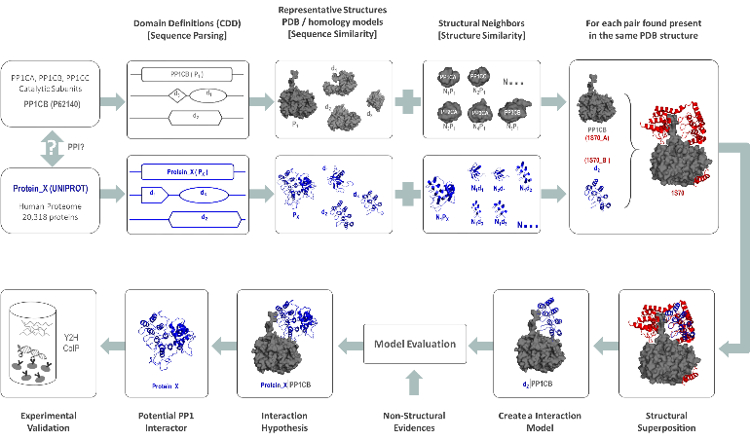
Figure 1 - PrePPI Workflow for predicting PP1 interacting proteins

Recent Publications
- S.S. de Souza, J. de Vasconcellos Castro, L.M. Porto, Modeling the core metabolism of komagataeibacter hansenii ATCC 23769 to evaluate nanocellulose biosynthesis, Brazilian J. Chem. Eng. 35 (2018) 869–886.
- J. V. Castro, E.O. Paull, J.I. Garzon, D. Murray, A. Califano, B. Honig, 285: Uncovering the disorder of breast invasive carcinoma homeostasis proteins, Cancer Res. 78 (2018) 285–285.
- S.S. de Souza, F. V. Berti, K.P. V. de Oliveira, C.Q.P. Pittella, J. V. de Castro, C. Pelissari, C.R. Rambo, L.M. Porto, Nanocellulose biosynthesis by Komagataeibacter hansenii in a defined minimal culture medium, Cellulose. 26 (2019) 1641–1655.

 Biography

Julia de Vasconcellos Castro research interests combine her scientific and chemical reaction engineering training and expertise to solve biological/ biomedical problems. Her work falls in a variety of categories including Metabolomics, Genomics, Proteomics, Microbiology, Biofuels, Tissue Engineering and Systems Biology. Particular efforts have been done in order to understand fundamental aspects of gene structures and organization in bacterial biopolymer synthesis and hydrogen production, the role of transcription factors in regulating protein expression, and how secondary metabolite production may be optimized using metabolic engineering tools. Currently, the focus of Dr. Castro’s research is to understand the molecular basis of the assembly of holoenzymes that turn serine/threonine protein phosphatases into specific enzymes to find novel ways to regulate them and develop new therapeutic approaches

Email: jd3393@cumc.columbia.edu

Notes/Comments:

