Assessing clinical implications and perspectives of the pathophysiological effects of erythrocytes and plasma free hemoglobin in autologous biologics for use in musculoskeletal regenerative medicine therapies.

Peter A. Everts PhD¹, Gerard A. Malanga MD^{2,} Rowan V. Paul MD^{3,} Josh B. Rothenberg MD^{4,} Natalie Stephens PhD^{5,} Kenneth R. Mautner MD^{6.}

¹ Gulf Coast Biologics, Scientific and Research Department, Fort Myers FL, USA.
² New Jersey Regenerative Institute LLC, Cedar Knolls, NJ; Department of Physical Medicine and Rehabilitation, Rutgers University, New Jersey Medical School, Newark, NJ, USA.
³ California Pacific Orthopedics, San Francisco, CA; California Pacific Medical Center, San Fransisco, CA, USA; Darthmouth Geisel School of Medicine, Hanover, NH, USA..
⁴ Boca Raton Regional Hospital, Regenerative Medicine and Orthopedics Biologic Department; BocaCare Orthopedics, Boca Raton, FL, USA.
⁵ Biosciences Research Associates, Cambridge MA, USA.
⁶ Emory University, Department of Physical Medicine & Rehabilitation & Department of Orthopedics, Atlanta, GA 30329, USA.

Abstract
Autologous biologics, defined as platelet-rich plasma (PRP) and bone marrow aspirate stem cell concentrate (BMSC), are cell-based therapy treatment options in regenerative medicine practices, and have been increasingly used in orthopedics, sports medicine, and spinal disorders. These biological products are produced at point-of-care; thereby, avoiding expensive and cumbersome culturing and expansion techniques.
Numerous commercial PRP and BMSC systems are available but reports and knowledge of bio-cellular formulations produced by these systems are limited. This limited information hinders evaluating clinical and research outcomes and thus making conclusions about their biological effectiveness. Some of their important cellular and protein properties have not been characterized, which is critical for understanding the mechanisms of actions involved in tissue regenerative processes. The presence and role of red blood cells (RBCs) in any biologic has not been addressed extensively. Furthermore, some of the pathophysiological effects and phenomena related to RBCs have not been studied. A lack of a complete understanding of all of the biological components and their functional consequences hampers the development of clinical standards for any biological preparation.
This lecture aims to review the clinical implications and pathophysiological effects of RBCs in PRP and BMSC; emphasizes hemolysis, eryptosis, and the release of macrophage inhibitory factor; and explains several effects on the microenvironment, such as inflammation, oxidative stress, vasoconstriction, and impaired cell metabolism.

Image

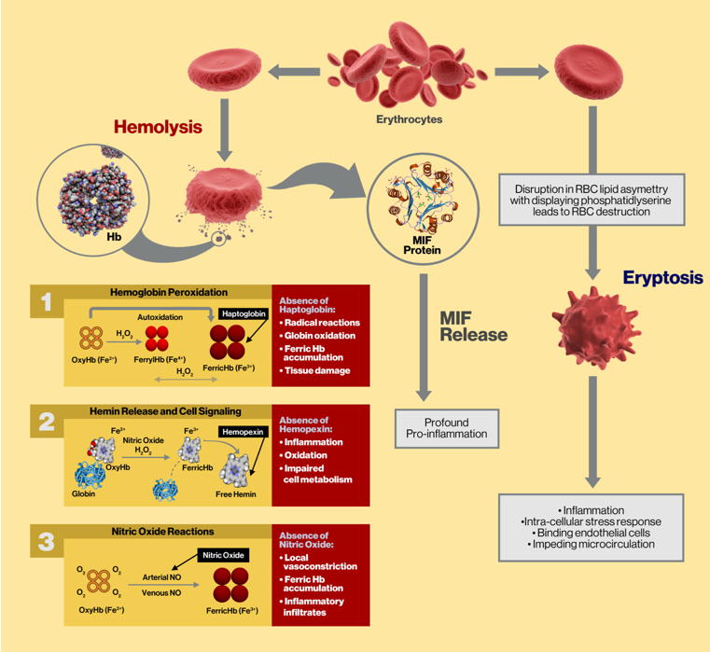

Figure 1. Schematic summary illustration showing the pathophysiological effects and reactions of RBC hemolysis and eryptosis.

Recent Publications (minimum 5)
1. Everts PA, Knape JT, Weibrich G, Schönberger JP, Hoffmann JJ, et al. Platelet rich plasma and platelet gel: a review. J. Extra Corpor. Technol. 2006;38:174-87.
2. Oh M, Nor J. The perivascular niche and self-renewal of stem cells. Front in Physiol. 2015;https://doi:0.3389/fphys.2015.00367.
3. Schaer D, Buehler P,. Alayash A, et al. Hemolysis and free hemoglobin revisited: exploring hemoglobin and hemin scavengers as a novel class of therapeutic proteins. Blood 2013;121:1276-84.
4. Repsold L, Joubert A. Eryptosis: An erythrocyte’s suicidal type of cell death. BioMed Res Internat. 2018;https://doi.org/10.1155/2018/9405617.
5. Karsten E, Hill C, Herbert B. Red blood cells: The primary reservoir of macrophage migration inhibitory factor in

whole blood. Cytokine. 2018;102:34-40.

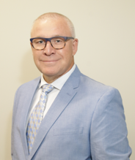
Biography
Dr. Everts has been pioneering in the science and clinical applications of platelet-rich plasma (PRP) technology since 1984 and has been leading research teams in regenerative medicine in using biological therapies. Dr. Everts received his PhD in Medicine from the University of Utrecht in the Netherlands in 2007 on the subject of PRP. At present, he has published and authored more than 50 articles, or book chapters. He has been board member, and chairman of several health care organizations and was member of the sport medicine steering group at the International Olympic Committee. At present he is the Executive Director of Gulf Coast Biologics, a scientific-educational-research-training institute, and Chief Scientific Officer of EmCyte Corporation.
Email: peter@gulfcoastbiologics.com

Notes/Comments:

As agreed, I will present on June 24th, due to other commitments. Email Shean Smith.

