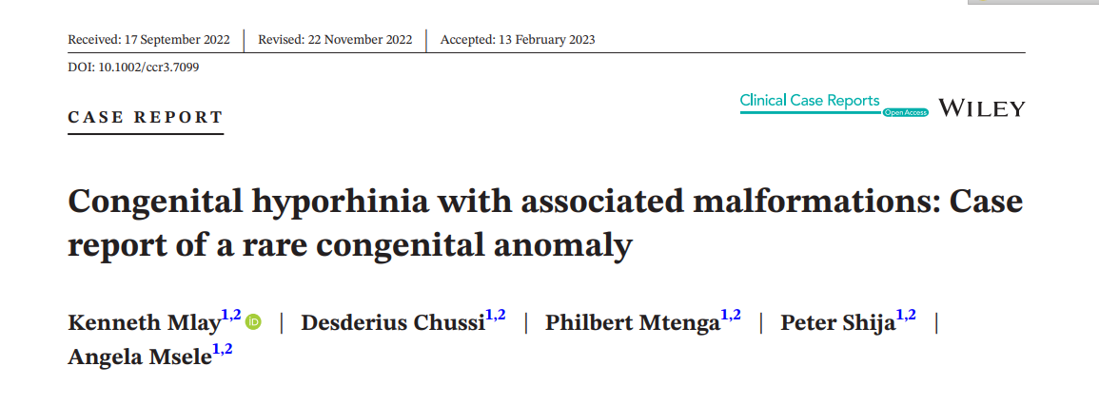
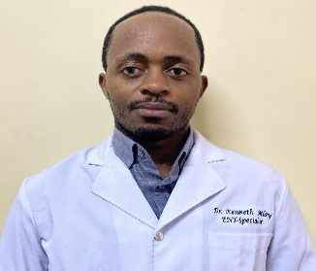
Abstract
Congenital partial arhinia or hyporhinia is very uncommon congenital nasal anomaly. Less than 40 cases of congenital arhinia have been reported in the available literatures, most of them defined as complete arhinia and only four cases were congenital hyporhinia.¹The cause is not clearly known and most cases are sporadic, but there are few familial cases which have been reported.² This pathology is usually found associated with other malformations.³High mortality rate is commonly associated with this congenital malformation. We report an extremely rare case of a congenital absence of the heminose (partial arhinia) in a 3-h-old girl old full-term female neonate born from 17 years prime gravid, presented with nasal malformation, respiratory distress, and bluish coloration. To the best of our knowledge, this is among the few cases of heminose agenesis with associated malformations to be reported in the carefully reviewed literatures. (figure 1)
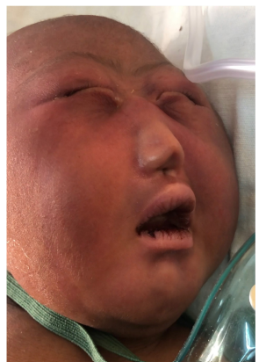figure:1
The patient had holoprosencephaly with cebocephaly, microcephaly, and high arched palate. Orbital anomalies are frequently associated with this condition,⁵ and our index case had hypotelorism. Clinical presentation depends on the severity of nasal hypoplasia, and patient with atretic posterior choanae present with severe respiratory distress at birth.⁴ Our index case had respiratory distress due to the presence of atretic posterior choanae where oral airway and oxygenation was initiated, also there was ongoing discussion with the family about tracheotomy. Prenatal diagnostic advances have greatly improved the possibility of early detection of congenital anomalies. This gives not only an opportunity to plan and improve perinatal care but also offers the option to terminate the pregnancy for cases in which the prognosis is likely to be poor,⁶ but this was not possible in our case. Surgical reconstruction is usually delayed until preschool years around 6 years when facial development is nearly complete but due to associated malformations management controversies regarding timing and surgical techniques.

_{BIOGRAPHY}
Kenneth Mlay is a junior medical specialist in Otorhinolaryngology graduated as overall best student in 2019, also he is a researcher and educator. Energetic and talented medical doctor with 7 solid years of practice experience with a strong focus on listening to and addressing patient concerns. he has excellent organization experience in his role as coordinator of postgraduate education in the otorhinolaryngology department. He has travelled several countries during his career for workshop, conferences and research purposes. He is working at Kilimanjaro Christian medical Centre as a medical specialist and Lecturer, also he has projects in Zanzibar and Kenya. So far, he has several publications with increasing interest on research.

REFERENCES
1. Baruah B, Dubey K, Gupta A, Kumar A. Congenital partial arhinia: a rare malformation of the nose coexisting with intracranial arachnoid cyst. J Clin Neonatol. 2014;3:228.
2. Fakhraee SH, Nariman S, Taghipour R. Congenital arhinia: case report of a rare congenital anomaly. Arch Iran Med. 2011;14:355-356.
3. Ḿendez-Gallart R, Garrido-Valenzuela M, Bautista-Casasnovas A, et al. Congenital partial arhinia with no associated malformations. Int J Pediatr Otorhinolaryngol Extra. 2009;4:162-164.
4. Ngamdu Y, Ibrahim B, Bello M, et al. Congenital hyporhinia with associated malformations. J Case Reports. 2012;2:54-56.
5. Musa S, Abdulkadir I. Congenital hyporhinia in a syndromic Nigerian baby congenital hyporhinia in a syndromic Nigerian baby. Res Gate. 2019;2:30-45.
6. Losee JE, Kirschner RE, Whitaker LA, Bartlett SP. Congenital nasal anomalies: a classification scheme. Plast Reconstr Surg. 2004;113:676-689.
7. Bilkay U, Tokat C, Ozek C, Erdem O, Cagdas A. Reconstruction of congenital absent columella. J Craniofac Surg. 2004;15:60-63

