Abstract

Title: Clear Cell Renal Carcinoma Synchronous with Dedifferentiated Liposarcoma

Juan Esteban Garcia-Robledo M.D^{1,2}, Estefania Beltran M.D¹, Lisa X. Rodríguez-Rojas M.D PhD³, Martin Rengifo M.D⁴, Bladimir Perez M.D⁵, Harry Pachajoa M.D PhD^{3,6} and Angela R. Zambrano M.D².
¹Centro de Investigaciones Clínicas (CIC), Fundación Valle del Lili, Cali, Carrera 98 No. 18-49, Colombia.
²Department of Hematology/Oncology, Fundación Valle del Lili, Cali, Carrera 98 No. 18-49, Colombia.
³Department of Human Genetics, Fundación Valle del Lili, Cali, Carrera 98 No.18-49, Colombia.
⁴Department of Diagnostic Imaging, Fundación Valle del Lili, Cali, Carrera 98 No.18-49, Colombia.
⁵Department of Pathology, Fundación Valle del Lili, Cali, Carrera 98 No. 18-49, Colombia.
⁶Universidad Icesi, Faculty of Health Sciences, Cali, Colombia.

- Abstract Body (up to 250 words)
Background: multiple primary malignant neoplasms are not frequent but are increasing in incidence, some of them are associated with genetic syndromes like Von Hippel-Lindau and Li-Fraumeni. Dedifferentiated liposarcoma is one of the rarest soft tissue tumors and clear cell renal carcinoma is the most frequent kidney cancer. The concomitant presence of these tumors is extremely rare, however, there have been some cases reported, none of them presenting with a liposarcoma of the limbs. This report looks to expose an interesting case of a synchronous multiple primary tumors patient presenting with a very rare liposarcoma associated with a renal cell carcinoma (a very rare association). A review of the literature and a collection of similar cases published previously are also provided.

Case presentation: here we expose the case of a 62-year-old, Hispanic man who presents with a left thigh mass compatible with dedifferentiated liposarcoma which was synchronous with a metastatic clear cell renal carcinoma. Multiple treatment lines were provided with no response, with a further metastatic transformation. Genetic analysis by liquid biopsy showed some mutations that were not susceptible of targeted therapy. At the time of this report the patient is undergoing palliative care as he persists with a non-responsive metastatic disease.

Conclusions: we present the first case reported of a clear cell renal carcinoma synchronous to a dedifferentiated liposarcoma of a limb. The association between renal cell carcinoma and dedifferentiated liposarcoma is unusual and there are few reports in the literature. More research about these tumors along with genetic tests need to be performed looking for a better understanding of the fundamental basis of this rare association.

- Image:

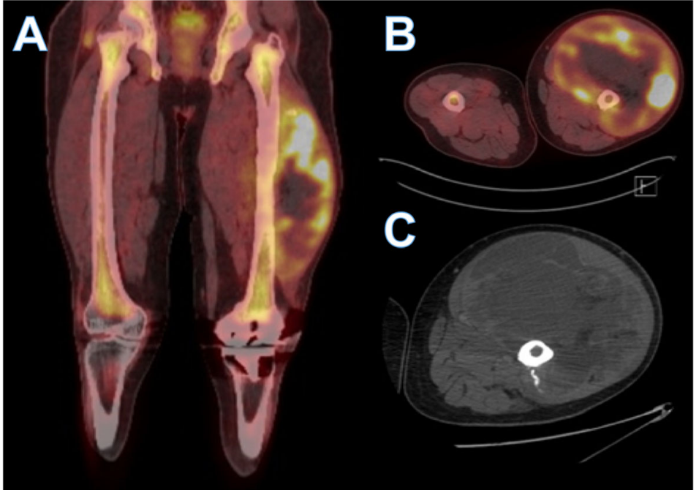

- Biography (Up to 100 words)
Juan Esteban Garcia-Robledo M.D has completed his MD at the age of 22 years from Universidad Icesi as well as a summer research internship at the Harvard Stem Cell Institute in 2017. He serves as research fellow at his home institution Fundación Valle del Lili, performing different tasks related to clinical research in hematology and oncology. He is currently 23 years-old and has published more than 10 research articles in different high impact journals.

- Research interest: hematology and oncology

- Presenting author details


Full Name: Juan Esteban García Robledo
Contact number: +573205528367
Twitter account: @JuanesMD
Linked In account: https://www.linkedin.com/in/juan-esteban-garcia-robledo-m-d-146ab687/
Session name/ number:
Category: (Oral presentation/ Poster presentation)
Passport Number:

