Effect of low-intensity magnetic stimulation on human attention span-Experimental Study
Jalal Qulozadeh Soltani
Hasan Sadeghi

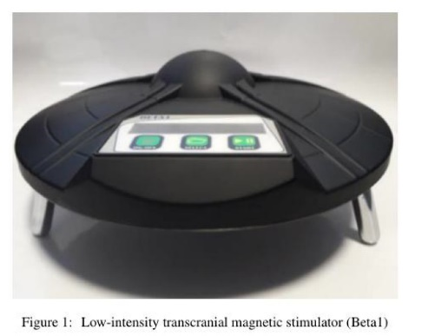

Abstract (300 word limit)

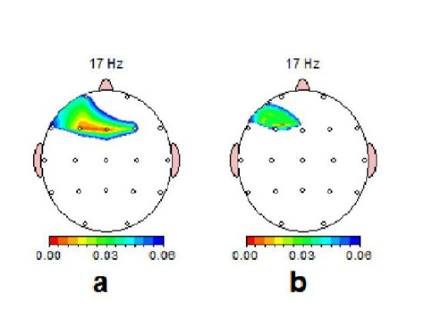
Attention is a cognitive and behavioral process that selectively focuses on the individual aspects of subjective or objective information. It has been shown that transcranial magnetic stimulation of the brain, or rTMS, can affect the networks of attention in the brain of some peoples. In this study we report the effects of our experimental setup(Beta-1 Device) on human brain. Current research shows the influences of our setup on human concentration and attention. Respected to the low number of sessions of this stimulation using the beta1 device and the significant effect of this stimulation, the beta1 system can be helpful in the treatment or improvement of attention deficit disorders. It is suggested that the effectiveness of this machine in increasing attention and focus should be studied by repeating this research and increasing the number of magnetic stimulation sessions of the brain. Due to the results of the previous researches in the stimulation of the DLPFC area and its relevance with the recovery of depression, the effect of stimulation of brain by this device on depression is expected. In the present study, the final scores of attention and visual and auditory focus in the IVA test were considered. It seems that repeating the research and measuring the different components of attention mentioned in this test can illuminate the dark angles of the present study.
Image

Biography (150 word limit)
Email: sadeghi_66@email.com

Notes/Comments:

