A young female presented with features of Gastric Outlet Obstruction
M.M.Shahin-Ul-Islam,FCPS(medicine),MD(Gastroenterology),FMC,Bangladesh
Md. Ismail Hossain, FCPS(medicine),MD(Nephrology),FMC,Bangladesh
Dewan Saifuddin Ahmed,FCPS(medicine),MD(Gastroenterology),BSMMU,Bangladesh
Syeda Nur-E-Jannat, FCPS(medicine),MD(Gastroenterology),DMC,Bangladesh

Abstract (300 word limit)
Peutz-Jeghers syndrome(PJS) is an autosomal dominant syndrome characterized by multiple hamartomatous polyps in the gastrointestinal tract, mucocutaneous pigmentation and an increased risk of gastrointestinal cancer. Polyps are found throughout the gastrointestinaltract but commonly in the small bowel (60-90%), colon (50-64%), stomach (15-30%) and presents with gastrointestinal bleeding, anaemia, abdominal pain due to intussusceptions, obstruction of small intestine or infarction. PJS as a cause of gastric outlet obstruction is rare.A young female of 13 years presented with recurrent attack of abdominal pain, vomiting with significant weight loss for last 4 years. Pain was severe, colicky, in epigastric, periumbilical region aggravated after taking food, relieved with vomiting (spontaneous and induced), vomitous contained 2-3 previous days undigested food. She lost 8 kg weight in last 1 year. She underwent appendicectomy 3 years back. There was no history of fever, jaundice, haematemesis, melaena, alteration of bowel habit. She was moderately anaemic, nonicteric, BMI 15 kg/m²with black pigmentation in lower lip, mucous membrane, at finger tips and sole of foot(figure:1) with an ill-defined lump in epigastric region. Other systemic examination revealed normal. Her haemoglobin was 9 gm/dl, ESR, CRP, LFT, creatinine, CXR were normal with hyponatremia (Na 125), hypokalemia (K 2.5). USG of abdomen suggested gastric mass. After one unit of blood transfusion and correction of electrolyte imbalance, UGI endoscopy revealed multiple gastric & duodenal polyps with largest one was situated at lower body along the lesser curvature with a long pedicle, body of the polyp was impacted into pylorus(figure2). Endoscopic polypectomy(figure2) was done for larger polyps of stomach & duodenum, relieved obstruction with significant symptomatic improvement. Histopathology revealed hamartomatous polyp. Later on colonoscopy also revealed multiple polyps of variable sizes followed by colonoscopic polypectomy, histologically hamartomatous polyps. Our final diagnosis was PJS with gastric outlet obstruction due to gastric polyp with polyposis coli.
Image
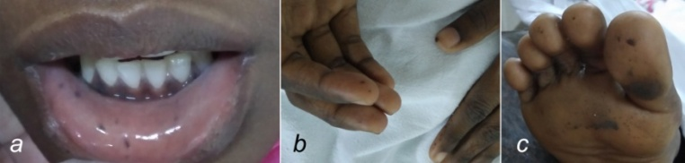
figure 1: increased pigmentation in lower lips, mucus membrane(a),tip of fingers(b), sole of foot(c)

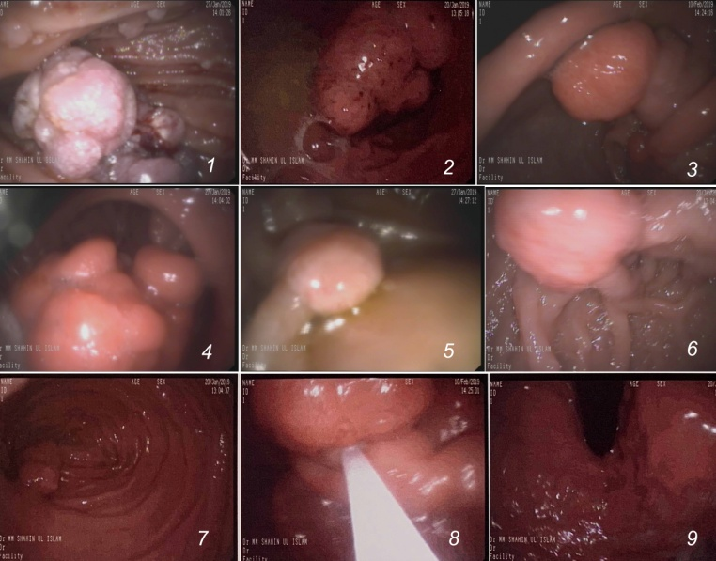
Figure 2:UGI endoscopy revealed multiple large and small polyps in stomach body (1,2), in antrum(3),obstructing pyloric ring(4). Multiple large pedunculated polyps in bulb (5,6),second part of duodenum(7).
Endoscopic Polypectomy is done with polypectomy snare(8). Fundus(9) is normal.
Recent Publications (minimum 5)
- Chang S, Kalarickal J, Joshi V (2009) Peutz-Jeghers syndrome: a rare cause of gastric outlet obstruction. Clin Gastroenterol Hepatol.7(11):A20
- Burgmeier C, Schier F, Staatz G(2012) Gastric outlet obstruction in a neonate because of Peutz-Jeghers syndrome. J Pediatr Surg.47(8):e1-3.
- Duanet al.(2017) Peutz–Jeghers syndrome with intermittent upper intestinal obstruction A case report and review of the literature.Medicine. 96:17
- Chen XD, Yu YY, Yang L, Rui YY, Zhou ZG (2012) Duodenal intussusception due to a giant neuroendocrine carcinoma in a patient with Peutz-Jeghers syndrome: case report and systematic review. Eur J Gastroenterol Hepatol. 24(6):722-6
- Ranjan R, Nath D, Dey S, Arava S (2014) Multifocal Jejuno-ileal carcinoma in a 7-year-old boy with Peutz-Jeghers syndrome: A rare occurrence.Indian J Med Paediatr Oncol. 35:121-2.

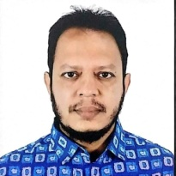 Biography (150 word limit)
M.M.Shahin-Ul-Islam,graduated from Dhaka Medical College, the best medical college in Bangladesh. He started his carrier in medicine and completed fellowship in internal medicine from Bangladesh College of Physicians and Surgeons (BCPS), He worked as consultant of internal medicine in district hospital of Bangladesh. After completing his specialization in Gastroenterology, he started working as assistant professor in Faridpur Medical College Hospital from 2010. Besides teaching undergraduate & post graduate students, he started Gastroenterology department at Faridpur Medical College in 2010. From last year working as associate professor (current charge) at same institute. He is a guide of a number of thesis and dissertations. He has a number of publications in the field of medicine and gastroenterology in national and international journals.
.
Email: shahin52dmc@gmail.com

Notes/Comments:

