A patient presented with pigmentation and generalized weakness
Dewan Saifuddin Ahmed,FCPS,MD,BSMMU,Bangladesh Syeda Nur-E-Jannat,FCPS,MD,DMC,Bangladesh

Abstract (300 word limit)
X-linked adrenoleukodystrophy (X-ALD) is a devastating genetic disease with three main phenotypes (childhood cerebral forms, adrenomyeloneuropathy(AMN) and Addison disease(AD). Tuberculosis is the commonest cause of AD in underdeveloped countries whereas autoimmune destruction accounts for 75-80% cases in developed countries. This is the first case report of X-AMN/ALD in two brothers in Bangladesh confirmed by raised very long chain fatty acid (VLCFA). Our index patient of 19 years presented with anorexia, weakness, vomiting, weight loss for three years with increased pigmentation in perioral skin, lips, tongue, mucus membrane, palmar creases, knuckles, reduced scalp hair(figure-1a-d), postural hypotension, low BMI, was found to have low basal Cortisol (9.00 am), ACTH >1250 pg/ml (normal<46), was diagnosed with AD. After three months he developed progressive spastic paraparesis along with cognitive declination and behavioral abnormality. His only brother was normotensive, clinically asymptomatic at presentation had only increased pigmentation on tongue, palmar crease, scanty scalp hair(figure-1,2a-d) and extensor planter reflexes. He had high ACTH(>1250 pg/ml) with normal basal cortisol (9.00am). Plasma VLCFA analysis revealed significantly high C26:0 with abnormal ratio of C24:0/C22:0 and C26:0/C22:0 in both brothers, with normal level in mother(table-1). MRI (T2 & FLAIR) showed bilateral hyperintense basal ganglia in index patient(Figure2:3a-c). Electrophysiological studies of nerve (SEPs, VEPs, BAEPs, NCS, EMG) were normal in both. Both were given steroid replacement. After three years, index patient became bed bound with slurred speech, urinary urge incontinence and his asymptomatic brother developed spastic paraparesis with cognitive impairment. None had gonadal impairment. Follow up MRI revealed lesion in brainstem in both along with atrophy of thoracic segment of spinal cord in index patient(Figure2:4a-f) and cerebellum, internal capsule involvement in his brother(Figure3:5a-d). Both were of pure AMN variety but due to presence of cognitive impairment and behavioral abnormality they can be categorized as rare cerebral variety of AMN.

Image

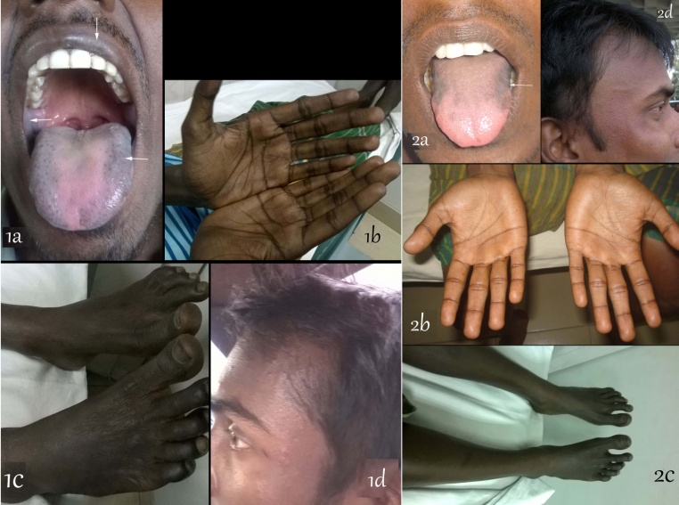
Figure1: Index patient (1a-d),increased pigmentation in tongue, lips, mucus membrane (1a), palmar crease (1b), leg (1c), reduced scalp hair (1d), In brother(2a-d) increased pigmentation in tongue (2a), palmar crease (2b), leg (2c), frontal scalp baldness (2d).

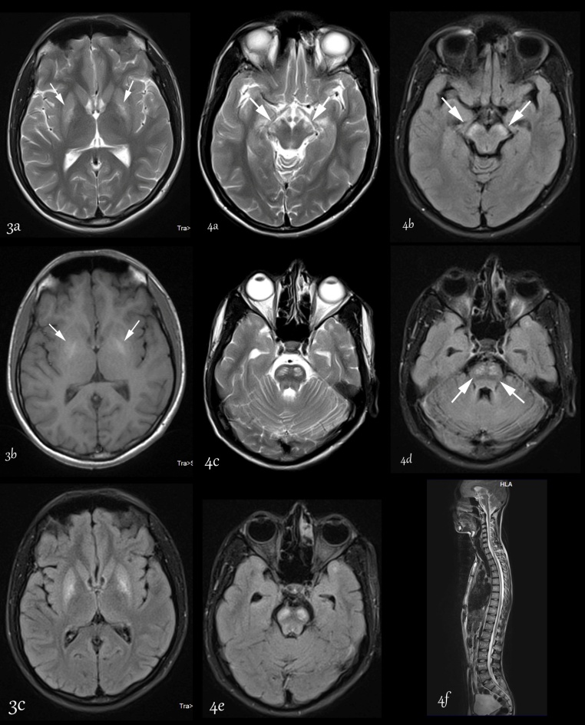
Figure2: Index patient: MRI of brain(3a-c) showing symmetrical increased signal intensity in basal ganglia (globus pallidus) region in T2&Flair. Followup MRI of brain(4a-e) and spinal cord(4f) after three years showing symmetrical signal hyperintensity involving cerebral peduncle of mid brain (4a,4 b), pons (4c,4d,4e) in T2&Flair and atrophy of thoracic segment of spinal cord (4f) in T2 image
Table 1: Plasma VLCFA analysis
Plasma VLCFA | Index patient | Brother | Mother | Reference Range(µmol/L)
DocosanoicAcid (C22) | 34 | 51.7 | 42.2 | 30-112
Tetracosanoic Acid (C24) | 62 | 73.4 | 46.3 | 14-80
Hexacosanoic Acid (C26) | 4.21 H | 3.33 H | 1.08 | 0.33-1.5
C24:C22 ratio | 1.82 H | 1.42 H | 1.01 | 0.44-1.05
C26:C22 ratio | 0.125 H | 0.064 H | 0.026 | 0.005-0.030
Phytanic acid | 0.56 | 3.42 | 4.98 | 0.20-19.30
Pristanic acid | 0.60 | 0.38 | 0.39 | 0.00-2.00
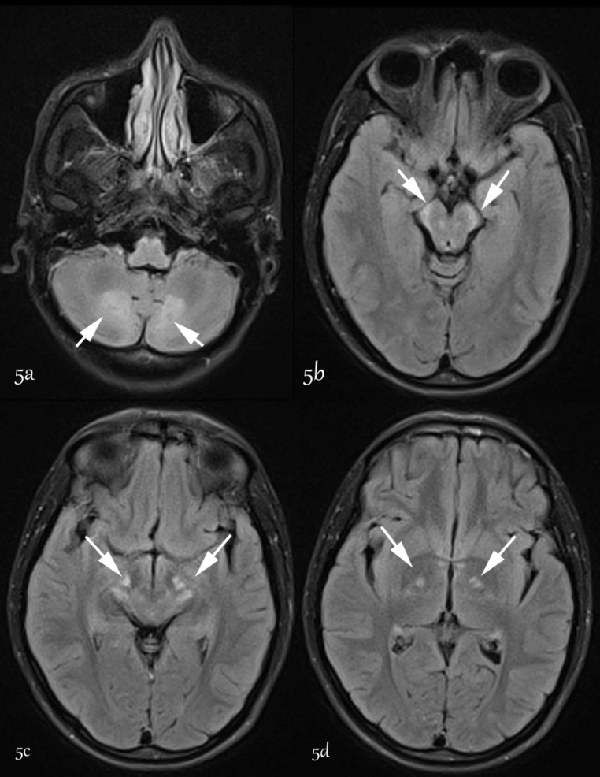
Figure3: Brother: followup MRI of brain after 3 years showing symmetrical signal hyperintensity involving cerebellum hemisphere (5a), cerebral peduncle of mid brain (5b,c), basal ganglia, posterior limb of internal capsule (5d) in Flair images

.

Recent Publications (minimum 5)
- Ofman R, Dijkstra IM, van Roermund CW (2010) The role of ELOVL1 in very long-chain fatty acid homeostasis and X-linked adrenoleukodystrophy. EMBO Mol Med. 2:90–97
- Dobyns WB, Filauro A, Tomson BN (2004) Inheritance of most X-linked traits is not dominant or recessive, just X-linked. Am J Med Genet.129A: 136-143
- Bezman L, Moser AB, Raymond GV (2001) Adrenoleukodystrophy: incidence, new mutation rate, and results of extended family screening. Ann Neurol. 49:512-517
- Moser HW, Loes DJ, Melhem ER (2000) X-Linked adrenoleukodystrophy: overview and prognosis as a function of age and brain magnetic resonance imaging abnormality. A study involving 372 patients. Neuropediatrics 31:227-239.
- Guo YK, Yang ZG, Li Y (2007) Addison’s disease due to adrenal tuberculosis: contrast-enhanced features and clinical duration correlation. Eur J Radiol.62(1): 126-131.

 Biography (150 word limit)
Syeda Nur-E-Jannat graduated from Dhaka Medical College, the best medical college in Bangladesh. She started her carrier in medicine and completed fellowship in internal medicine from Bangladesh College of Physicians and Surgeons (BCPS), worked as medical officer in district health complex, as Junior consultant (Medicine) at Government Employee Hospital, Dhaka, She completed her specialization in gastroenterology from Bangabandhu Sheikh Mujib Medical University (BSMMU) at Dhaka. Now she is working as assistant professor, gastroenterolology at Dhaka Medical College She is involved in teaching of undergraduate and post graduate students at Dhaka Medical College and is working as co-guide of a number of thesis. She has a number of publications in the field of medicine and gastroenterology in national and international journals.
.
Email: jannatgastro@gmail.com

Notes/Comments:

