A child presented with increased frequency of bowel
Dewan Saifuddin Ahmed,FCPS,MD,BSMMU,Bangladesh Syeda Nur-E-Jannat,FCPS,MD,DMC,Bangladesh

Abstract (300 word limit)
Objective: Primary spinal cord tumors are very rare (incidence 0.26/100,000 person/years) in children and adolescents (0-19 years), commonly presents with low back pain, pain radiating to thigh/knee, lower extremity numbness/weakness, urinary dysfunction and abnormal gait. Here we present a case of spinal cord ependymoma in sacral region presented with neurogenic bowel which is very rare in paediatric age group. Methodology: A 5 years old girl from Dhaka presented with increased bowel frequency, 8-12 times/day, semi solid for 2 years without any systemic or neurological complaints. On query, her parents disclosed history of urinary retention 2 years back which improved with intermittent self-catheterization over 3 months with subsequent normal bladder habit for 2 years. General examination, vital parameters were normal. Anal area appeared normal with reduced anal tone. Neurological examination including motor, sensory examination of both lower limbs and other systems revealed normal. Results: CBC, RBS, TSH, creatinine, electrolytes, CXR, USG of whole abdomen, stool R/E, culture, colonoscopy were normal. MRI of lumbo sacral spine (sagittal precontrast T1W1)(Figure1a) revealed a heterogenous, iso-intermediate intense (in comparison to spinal cord) lobulated mass at S2-S5, with mild inhomogenous enhancement on post contrast T1W1(figure1b). It was clearly delineated as mild heterogenous, hyperintense lobulated lesion in Sagittal T2W1(figure1c) suggesting intracanalicular myxopapillary ependymoma/ Schwannoma/ neurofibroma involving S2-S5 spine. Conus medullaris(L1), disk heights were normal without any sign of tethered cord or disc herniation. After laminectomy an extradural tumour (S1-S4) was removed near totally(Figure1de), histopathology revealed cellular ependymoma (WHO grade II). Leukocyte common antigen, CD20, CD3 was negative. It was followed by palliative Radiotherapy (total T.D 4400cGy,22Fr,31days). Conclusion: Patient regained her normal bowel habit within 6 months of surgery. After 8 years she was completely symptoms free without any tumor recurrence which supports long term survival and complete functional recovery of spinal cord ependymoma with specific therapy.

Image
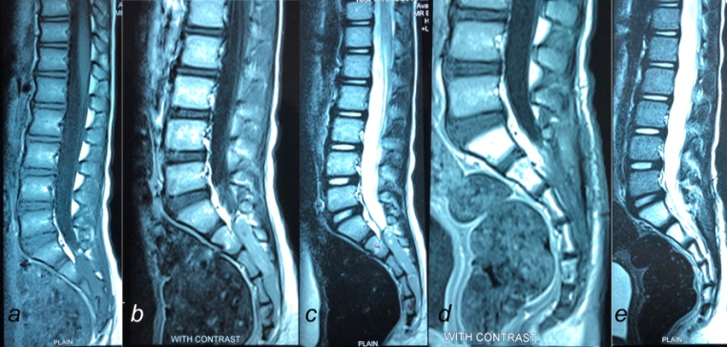
Figure1: MRI of lumbosacral spine: preoperative(a,b,c), postoperative (d,e)
Recent Publications (minimum 5)
- Schellinger KA, Propp JM, Villano JL, McCarthy BJ (2008) Descriptive epidemiology of primary spinal cord tumors. J Neurooncol87:173–179
- McGuire CS, Sainani KL, Fisher PG (2009) Incidence patterns for ependymoma: a Surveillance, Epidemiology, and End Results study. Clinical article. J Neurosurg 110:725–729
- Gomez DR, Missett BT, Wara WM, Lamborn KR, Prados MD (2005) High failure rate in spinal ependymoma swith long-term follow-up. Neuro Oncol 7:254–259
- Merchant TE, Kiehna EN, Thompson SJ, Heideman RL (2000) Pediatric low-grade and ependymal spinal cord tumors. Pediatr Neurosurg 32:30–36
- Volpp PB, Han K, Kagan AR, Tome M (2007) Outcomes in treatmentfor intradural spinal cord ependymomas. Int J Radiat Oncol Biol Phys 69:1199–1204

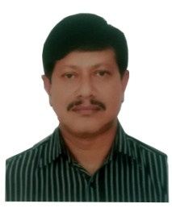Biography (150 word limit)
Dewan Saifuddin Ahmed graduated from Dhaka Medical College, the best medical college in Bangladesh. He started his carrier in medicine and completed fellowship in internal medicine from Bangladesh College of Physicians and Surgeons (BCPS), worked as assistant register in Mymensingh Medical College, as Registrar in Dhaka Medical College, as Junior consultant(Medicine) at Suhrawardy hospital. He completed his specialization in gastroenterology from Institute of Post Graduate Medicine and Research (IPGMR). He worked as assistant professor, gastroenterolology at Dhaka Medical College . He is now working as a professor of medicine and gastroenterology in Bangabandhu Sheikh Mujib Medical University (BSMMU) at Dhaka, Bangladesh. He was involved in teaching of undergraduate students, now post graduate students at BSMMU and is a guide of a number of thesis and dissertations. He has a number of publications in the field of medicine and gastroenterology in national and international journals
Email: saifgastro@gmail.com

Notes/Comments:

