Ultrasound for diaphragmatic dysfunction in postoperative cardiac children
Hussam K. Hamadah, KSA

Abstract (300 word limit)
Abstract Introduction: The use of ultrasound for assessing diaphragmatic dysfunction after paediatric cardiac surgery may be under-utilised. This study aimed to evaluate the role of bedside ultrasound performed by an intensivist to diagnose diaphragmatic dysfunction and the need for plication after paediatric cardiac surgery.
Methods: We carried out a retrospective cohort study on prospectively collected data of postoperative children admitted to the paediatric cardiac ICU during 2013. Diaphragmatic dysfunction was suspected based on difficulties in weaning from positive pressure ventilation or chest X-ray findings. Ultrasound studies were performed by the paediatric cardiac ICU intensivist and confirmed by a qualified radiologist. Results: Out of 344 postoperative patients, 32 needed diaphragm ultrasound for suspected dysfunction. Ultrasound studies confirmed diaphragmatic dysfunction in 17/32 (53%) patients with an average age and weight of 10.8 ± 3.8 months and 6 ± 1 kg, respectively. The incidence rate of diaphragmatic dysfunction was 4.9% in relation to the whole population. Diaphragmatic plication was needed in 9/17 cases (53%), with a rate of 2.6% in postoperative cardiac children. The mean plication time was 15.1 ± 1.3 days after surgery. All patients who underwent plication were under 4 months of age. After plication, they were discharged with mean paediatric cardiac ICU and hospital stay of 19 ± 3.5 and 42 ± 8 days, respectively. Conclusions: Critical-care ultrasound
assessment of diaphragmatic movement is a useful and practical bedside tool that can be performed by a trained paediatric cardiac ICU intensivist. It may help in the early detection and management of diaphragmatic
dysfunction after paediatric cardiac surgery through a decision-making algorithm that may have potential
positive effects on morbidity and outcome.
.

Image
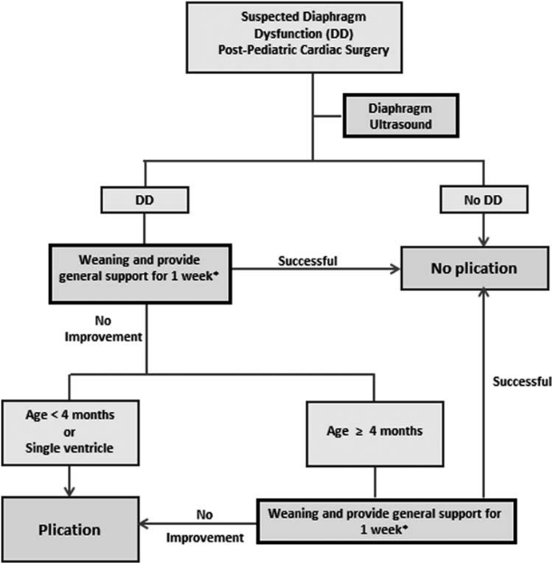
Recent Publications (minimum 5)
1) 5 Years Survival, Performance and Neurodevelopmental Outcome Following Cardiopulmonary Resuscitation after Pediatric Cardiac Surgery, Preliminary Investigation in a Single Center Experience.
Kabbani MS, Alsumih NA, Alsadun SA, Hamadah HK. J Saudi Heart Assoc. 2019;31(4):161-169.
2) Ultrasound for diaphragmatic dysfunction in postoperative cardiac children. Hamadah HK, Kabbani MS, Elbarbary M, Hijazi O, Shaath G, Ismail S, et al. Cardiology in the young. 2017;27(3):452-8.
3) Bedside ultrasonography screening for congenital renal anomalies in children with congenital heart diseases undergoing cardiac repair.
HK Hamadah, O Hijazi, MA Faraji, MS Kabbani. J Saudi Heart Assoc, 2017.09.002
4) Bedside Ultrasound in the Diagnosis and Treatment of Children with Respiratory Difficulty Following Cardiac Surgery.
HK Hamadah, MS Kabbani. J Clin Imaging Sci 2017;7.
5) Management of Life-threatening Refractory Chylothorax and Chylopericardium due to Lymphangiomatosis.
HK Hamadah, MS Kabbani. Am J Sonogr 2018, 1(2) 1-4.

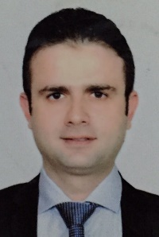Biography (150 word limit)
Mohamad Hussam Hamadah is Associate Consultant Pediatric Cardiac Intensivist in Pediatric Cardiac ICU (PCICU) in King Abdul-Aziz Cardiac Center- National Guard Health Affairs (KSA-Riyadh) since 5-8 2011 till now. Our PCICU is a specialized unit with 15 beds, established since 2002; the unit receives 450 pediatric cardiac admissions. Dr Hamadah has many publications as First Author: 2 Original articles, 1 review article, 2 case reports, and Second Author: 1 Original Article, 3 case report
Our Publications in ultrasound as improved the quality of care in our center and were presented in many international conferences.
Email: hamadahmo@ngha.med.sa

Notes/Comments:
I would like to contribute my research as oral presentation.

