Preoperative and Postoperative Factors affecting 30-Day Mortality of Patients undergoing Mitral Valve Repair or Replacement in Singapore
Jonathan Kia-Sheng Phua¹⁺, Crystal Lim¹⁺, Bowen Li², Siew-Pang Chan^{1,3,4}, Oon-Cheong Ooi^{1,2*}

1 Yong Loo Lin School of Medicine, National University of Singapore, Singapore
2 Department of Cardiac, Thoracic and Vascular Surgery, National University Heart Centre, Singapore
3 Cardiovascular Research Institute, National University Health System, Singapore
4 College of Science, Health & Engineering, La Trobe University, Australia
+Joint first authors
*Corresponding Author
Email: oon_cheong_ooi@nuhs.edu.sg

Abstract (300 word limit)

Aim: To use novel quantitative methods to identify the preoperative and postoperative factors for predicting 30-day mortality for multiracial Asian patients undergoing mitral valve repair or replacement.

Methods: The de-identified data of 197 patients who had undergone mitral valve repair or replacement from 2009 to 2015 were analyzed with generalized structural equation model (gSEM). The Chi-Square Automated Interaction Detector (CHAID) algorithm was applied for variable-selection. Analyzed with Stata MP version 14, all statistical tests were carried out with 95% confidence intervals.

Results: Female gender, BMI>29 kg/m², the need for emergency surgery and prolonged mechanical ventilation were identified as significant predictors of 30-day mortality. Emergency surgery was also significant in explaining other postoperative outcomes such as unplanned reoperation, prolonged mechanical ventilation and prolonged intensive care. Patients who had valve replacement were more likely to suffer from postoperative complications. The final model was deemed to be valid externally (AUC: 0.99; 95% C.I.: 0.98−1.00).

Conclusion: The results were congruent with traditional negative prognosticators for mitral valve surgery. The novel quantitative techniques are able to provide more comprehensive analysis than the conventional methods. With its multiway splitting, the CHAID could identify meaningful cut-offs of the quantitative predictors objectively and jointly. On the other hand, gSEM is able to analyze the multiple outcomes in a single setting that could result in higher precision. A predictor's effect could also be divided into direct and indirect, thus providing more information about its overall effect on the outcomes.

We have validated the use of these new statistical methods for use in future studies on identifying risk factors for medical conditions.

Image

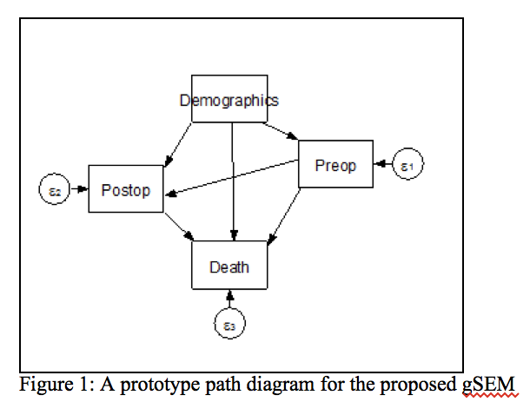

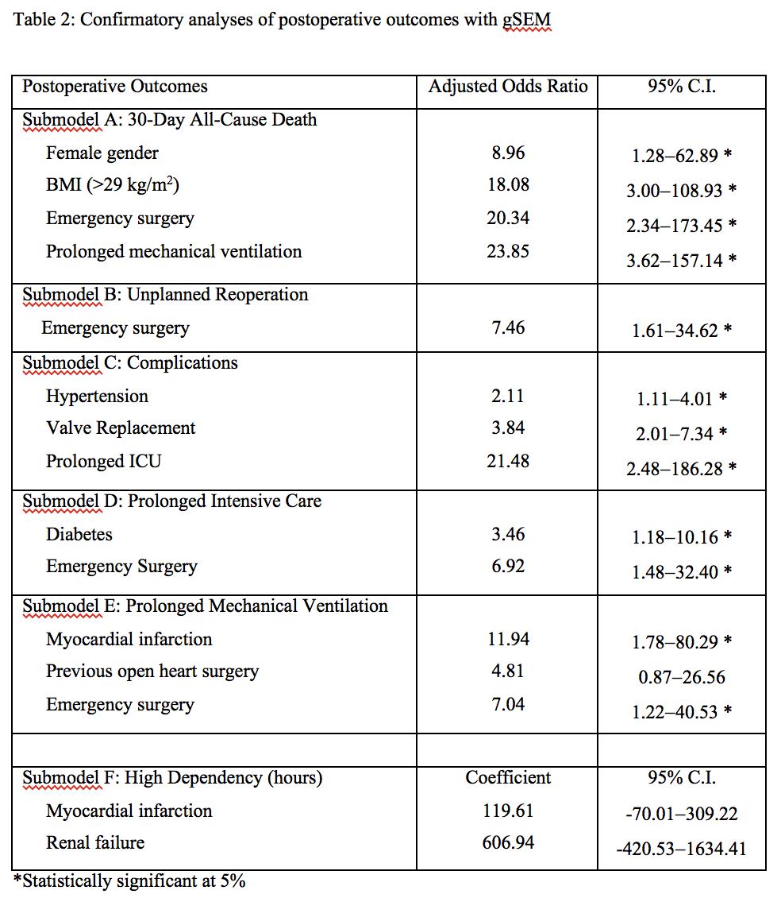

Recent Publications (minimum 5)
1. Manjunath CN, Srinivas P, Ravindranath KS, Dhanalakshmi C. Incidence and patterns of valvular heart disease in a tertiary care high-volume cardiac center: a single center experience. Indian heart Journal. 2014; 66(3): 320-6.
2. Madesis A, Tsakiridis K, Zarogoulidis P, Katsikogiannis N, Machairiotis N, Kougioumtzi I, et al. Review of mitral valve insufficiency: repair or replacement. Journal of thoracic disease. 2014;6 Suppl 1: S39-51.
3. Iung B, Vahanian A. Epidemiology of valvular heart disease in the adult. Nature reviews Cardiology. 2011; 8(3): 162-72.
4. Acker MA, Parides MK, Perrault LP, Moskowitz AJ, Gelijns AC, Voisine P, et al. Mitral-valve repair versus replacement for severe ischemic mitral regurgitation. The New England journal of medicine. 2014; 370(1): 23-32.
5. Silaschi M, Chaubey S, Aldalati O, Khan H, Uzzaman MM, Singh M, et al. Is Mitral Valve Repair Superior to Mitral Valve Replacement in Elderly Patients? Comparison of Short- and Long-Term Outcomes in a Propensity-Matched Cohort. Journal of the American Heart Association. 2016; 5(8).

Biography (150 word limit)
Jonathan Phua and Crystal Lim are current year 4 medical students at Yong Loo Lin School of Medicine, National University of Singapore.
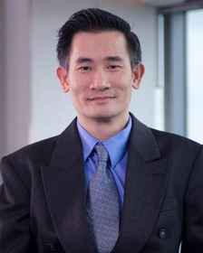
Assistant Professor Ooi Oon Cheong is presently a Consultant Surgeon with the Department of Cardiac, Thoracic and Vascular Surgery at National University Heart Centre, Singapore. He is also a Clinical Tutor in the Department of Surgery, Yong Loo Ling School of Medicine, National University of Singapore. In addition, he serves as a Board Member of the Chapter of Cardiothoracic Surgeons of the Academy of Medicine, Singapore.

