Six-Month Clinical Follow-up of the Self-Apposing Coronary Stent System in Patients with Hemodynamically Significant Stenosis of Unprotected Left Main

SUREV ARTIOM1,2, ABRAS MARCEL1,2, GRIB ANDREI1, 2, POPOVICI ION³
1Department of Interventional Cardiology, Institute of Cardiology, Chisinau, Republic of Moldova
2State University of Medicine and Pharmacy “N. Testemitanu”, Chisinau, Republic of Moldova
3Polivalent Hospital NOVAMED, Chisinau, Republic of Moldova

Keywords: left mail disease, self-apposing stent, angioplasty, coronary angiography.

- Abstract Body
Premises – Left main coronary artery disease is the highest-risk lesion subset of ischemic heart disease, and has traditionally been an indication for coronary artery bypass grafting. In recent years, many interventional techniques have been proposed for the treatment of such lesions. Implantation of self-apposing stents is one of them. These stents have a conical shape and open cells, which allows us to restore the bifurcation of left main and achieve anatomy close to the physiological. Material and methods – Thirty-three patients with left main bifurcation lesions treated with self-apposing coronary, nitinol, sirolimus eluting stent using stent with balloon technique were enrolled in this study. These patients were admitted in hospital during 2016. Primary endpoints were a procedural success, defined as favourable technical and angiographic result in the absence of a major adverse cardiac event (MACE) at hospital discharge and cumulative MACE at six months follow-up. Results –Post-procedural TIMI III flow was reached in both vessels. One recorded stent with balloon technique failure (3,0%) was attributed to impossibility of rewiring due to extremely tortuous circumflex artery, and calcified ostium. There were 2 patients (6,1%) with in-stent thrombosis during hospitalisation and 2 patients (6,1%) with in-stent restenosis during six-month follow-up after intervention. All these events were confirmed angiographically. The cumulative MACE at six-month rate was12,0 % (p<0,05). Conclusions – This study demonstrates that the self-apposing coronary stent can be safely deployed with excellent procedural success of 97% for the treatment of hemodynamically significant stenosis of unprotected left main. It is also feasible for using the stent with balloon technique in most cases. A relatively high cumulative MACE was registered at six months (12,0%). To minimize the rate of MACE, it is probably important to analyse the anatomy of the vessels and the lesions characteristics.

Reference:

1. Boersma H, Doornbos G, Bloemberg BPM, Wood DA, Kromhout D, Simoons ML. Cardiovascular diseases in Europe. European Society of Cardiology, 1999.

2. Stone GW, Sabik JF, Serruys PW, et al. Everolimus-Eluting Stents or Bypass Surgery for Left Main Coronary Artery Disease. N Eng J Med 2016;375:2223-35.

3. Mäkikallio T, Holm NR, Lindsay M, et al. Percutaneous coronary angioplasty versus coronary artery bypass grafting in treatment of unprotected left main stenosis (NOBLE): a prospective, randomised, open-label, non-inferiority trial. Lancet 2016;388:2743-52.

4. Gibson CM, Cannon 4. CP, Daley WL, et al. TIMI frame count: a quantitative method of assessing coronary artery flow. Circulation 1996; 93:879-888

Biography:
Artiom SUREV has completed his general medical study at the age of 23 years in State University of Medicine and Pharmacy Nicolae Testemitanu, Chisinau, Republic of Moldova. At 28 yars he became an interventional cardiologist and starts his doctorate in cardiology in the same university. He is interventional cardiologist in Interventional Cardiology Department of Institute of Cardiology, Chisinau, Republic of Moldova. He has published more than 5 papers in reputed journals in Moldova and outside.

Presenting author details
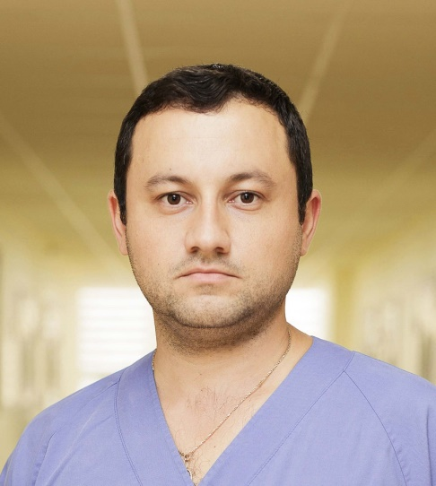
Full Name: Artiom Surev
Contact number: +37369284807
Facebook account: ArtiomSurev

Session name/ number: Cardiac surgery and critical cardiac care

Category: Poster presentation

Passport Number: 383915055

