Complete revascularization with coronary angioplasty in complex atherosclerotic disease. Case presentation

SUREV ARTIOM1,2, ABRAS MARCEL1,2, GRIB ANDREI1, 2,
1Department of Interventional Cardiology, Institute of Cardiology, Chisinau, Republic of Moldova
2State University of Medicine and Pharmacy “N. Testemitanu”, Chisinau, Republic of Moldova

Keywords: complex coronary lesions, angioplasty, intravascular imaging, complete revascularization.

- Abstract Body
In this article, we present a clinical case of interventional treatment of 58 years old patient with complex multivessel atherosclerotic coronary artery disease, SYNTAX score of 37, with preserved global and regional wall motion. According to current guidelines on miocardial revascularization, in this case it is recommended coronary bypass grafting (Class I, level of evidence A). Taking into account patient refusal to heart surgery, the patient was offered an alternative option of revascularization – staged coronary angioplasty. Thus, three percutaneous coronary interventions were performed, which ensured complete myocardial revascularization. The last intervention was guided by intravascular imaging and functional diagnostic methods, such as optical coherence tomography (OCT) and fractional flow reserve (FFR).

Image:

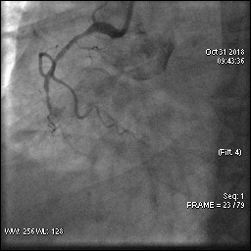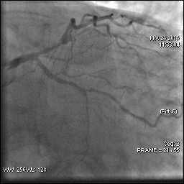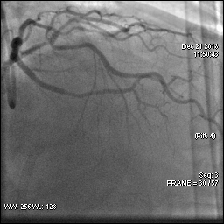

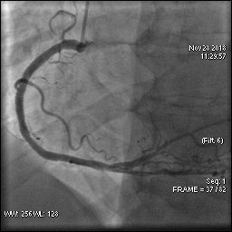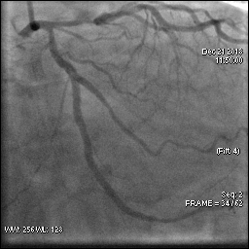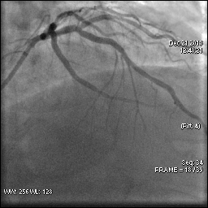

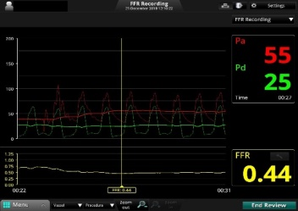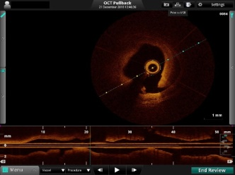
Reference:

- Gaziano T.A., Bitton A., Anand S., AbrahamsGessel S., Murphy A. Growing epidemic of coronary heart disease in low- and middle-income countries. Curr Probl Cardiol. 2010;35(2):72-115.
- Konstantinov I.E. The fi rst coronary artery bypass operation and forgotten pioneers. Ann Thorac Surg. 1997;64(5):1522-1523.
- Stefanini G.G., Holmes D.R. Jr. Drug-eluting coronary-artery stents. N Engl J Med. 2013;368(3):254-265.
- Cohn W.E. Advances in surgical treatment of acute and chronic coronary artery disease. Tex Heart Inst J. 2010;37(3):328-330.
- Polomsky M., Puskas J.D. Off-pump coronary artery bypass grafting: the current state. Circ J. 2012;76(4):784-790.
- Roberts C.S. Postoperative drug therapy to extend survival after coronary artery bypass grafting. Ann Thorac Surg. 2000;69(5):1315-1316.
- Iqbal J., Gunn J., Serruys P.W. Coronary stents: historical development, current status and future directions. Br Med Bull. 2013;106:193-211.
- Morice M.C., Serruys P.W., Kappetein A.P., Feldman T.E., Stahle E., Colombo A. et al. Five-year outcomes in patients with left main disease treated with either percutaneous coronary intervention or coronary artery bypass grafting in the SYNTAX trial. Circulation 2014;129:2388- 94.
- Franz-Josef Neumann, Miguel Sousa-Uva, Anders Ahlsson et al. 2018 ESC/EACTS Guidelines on myocardial revascularization. European Heart Journal (2019) 40, 87–165

Biography:
Artiom SUREV has completed his general medical study at the age of 23 years in State University of Medicine and Pharmacy Nicolae Testemitanu, Chisinau, Republic of Moldova. At 28 yars he became an interventional cardiologist and starts his doctorate in cardiology in the same university. He is interventional cardiologist in Interventional Cardiology Department of Institute of Cardiology, Chisinau, Republic of Moldova. He has published more than 5 papers in reputed journals in Moldova and outside.

Presenting author details
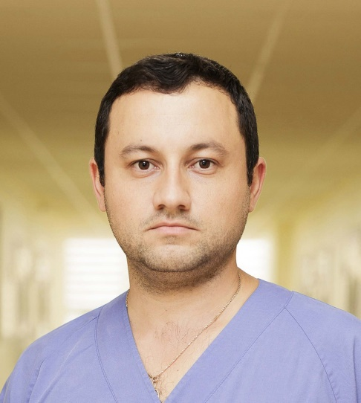
Full Name: Artiom Surev
Contact number: +37369284807

Facebook account: ArtiomSurev

Session name/ number: Cardiac surgery and critical cardiac care

Category: Poster presentation

Passport Number: 383915055

