Title: The Effect of Combination Juice of Cucumber, Star Fruit and Sweet Orange on the Lipid Profile of Hyperlipidemic Rats (Rattus Norvegicus)

RAFIK PRABOWO 1, MIRANTI DEWI PRAMANINGTYAS1
1Department of Crop Improvement, International Rice Research Institute, Manila, Philippines
2Department of Genetics and plant Breeding, National Rice Research institute, Osaka, Japan

Keywords: Rice lines, Salt stress, Microsatellite (SSR) marker, Protein analysis, Gene expression

- Abstract Body (up to 300 words)
The Background: Hyperlipidemia can cause atherosclerosis, the most important cause of hypertension. Previous research has shown that cucumber, star fruit, and sweet orange can decrease blood lipid profile. This research aims to know the effect of combination juice of cucumber, star fruit and sweet orange in hyperlipidemic rat.
Method: This research used 25 rats divided into 5 groups (K+, K-, P1, P2, and P3). Group of K-, P1, P2, P3 were given quail egg yolk for 2 weeks with a dose of 5 ml/ 200 grBW. For the next 2 weeks, K+ and K- groups were only given fed ad libitum. P1 group was given juice 50% cucumber (C), 25% star fruit (SF), 25% sweet orange (SO), P2 group: 25% C, 50% SF, 25% SO, and P3 group: 25% C, 25% SF, 50% SO. The dose of juice was 5 ml/ 200 grBW. All of this intervention were administered to rat with the sonde method. The laboratory test for HDL, LDL, and TC (total cholesterol) was done after 2 weeks and 4 weeks.
Result: Mean of HDL (mg/dl) levels were 81.97 (K+), 24.79 (K-), 40.15 (P1), 55.05 (P2), 71.02 (P3). Mean of LDL (mg/dl) 27,64 (K+), 80,44 (K-), 50,88 (P1), 41,74 (P2), 30,29 (P3). Mean of TC levels (mg/dl) 84.89 (K+), 218.7 (K-), 187.48 (P1), 174.39 (P2), 137.26 (P3). The results showed significant differences in HDL, LDL and TC levels in all groups after given combination juice with p <0.001.
Conclusion: Combination juice significantly increases HDL, decrease LDL and CT levels of hiperlipidemic rats (p <0.001).
Keywords: Hyperlipidemic, Cucumber, Star fruit, Sweet orange, Juice combination

Image:
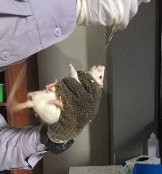
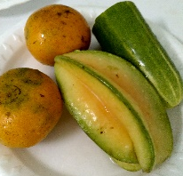
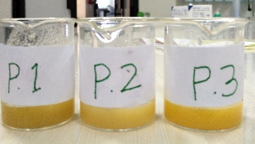

- Reference:

- Murray RK, Bender DA, Bothman KM, Kennelly PJ, Rodwell VW, Weil PA. Harper's Illustrated Biochemistry. 29 edition. New York: McGraw-Hill Companies; 2012. 158-159 p.
- Soltani R, Hashemi M, Farazmand A, Asghari G, Ghahdarijani KH, Kharazmkia A, et al. Evaluation of the
Effects of Cucumis sativus Seed Extract on Serum Lipids in Adult Hyperlipidemic Patients: A Randomized
Double-Blind Placebo-Controlled Clinical Trial. J Food Sci. 2016;
- Vincent R, Briones RR, Cabuhayan, Mendoza CR, Malabanan R. Effect of pectin derived from Averrhoa carambola L . in the lipid profile of Sprague-Dawley rats. Natl Cent Biotechnol Inf. 2010;4(2):21–32.
- Ali Z, Naeem N, Farooq Z, Masood S. Effect on Lipid Profile Parameters by the Addition of Orange Juice in Diet of Hypercholesterolemic Patients. J Nutr Food Sci. 2015;5(6):5–10.

Biography:
Rafik Prabowo is medical student at Faculty of Medicine, Universitas Islam Indonesia. He is a fourth years student and will continue his study to clinical phase in hospital. He is a outstanding student in his campus and his province and be the finalist of outstanding student competition held by Ministry of Reserach, Technology, and Higher Education Indonesia.

Presenting author details



Full Name: Rafik Prabowo
Contact number:+62 85365046829
Twitter account: -
Linked In account: rafikprabowo
Session name/ number: Rafik
Category: (Oral presentation)
Passport Number: 3632842

