In silco analysis of HAND transcription factor modulated during cardiac hypertrophy

Shouhartha Choudhury¹ Prosenjit Paul² and, Supriyo Chakraborty^{3*}
Department of Biotechnology, Assam University, Silchar-788011
School of Life Sciences, Assam University, Silchar-788011

Keywords: HAND1, HAND2, bHLH, Transcription Factor, Gene expression
Abstract
The HAND (Heart and neural crest derivatives) is a basic helix-loop-helix (bHLH) transcription factor essential for normal cardiac and extra-embryonic development. In spite of their high evolutionarily conserved genetic function, expressions of these factors differ subtly across species. Cardiac hypertrophy demonstrated HAND1 downregulated corresponding to cardiomyopathy and HAND2 is expressed in atria. The downregulation expression observed in human cardiomyopathy reflects a permissive role. Cardiomyocytes (cardiac myocytes) reinitiate fetal gene program and initiate adaptive physiological changes, which allow heart to compensate. Therefore, a great deal of research is required for identification of HAND gene and their specific bHLH domain. The genomic complement of bHLH transcription factor is an essential component for identification of the specific gene. Our investigation suggested that the number of HAND gene and their bHLH domain in eukaryotes. The conserved bHLH domain, motifs, phylogeny, chromosome location and expression analysis demonstrated HAND gene is responsible for cardiac development. In this study, we performed bioinformatics and computational techniques together information on HAND transcription factor in mammals.

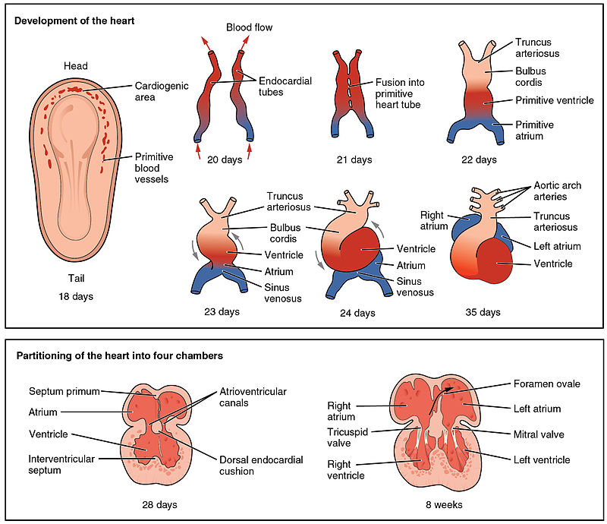
Reference
- Natarajan, A., et al., Human eHAND, but not dHAND, is down-regulated in cardiomyopathies. Journal of molecular and cellular cardiology, 2001. 33(9): p. 1607-1614.
- Srivastava, D., P. Cserjesi, and E.N. Olson, A subclass of bHLH proteins required for cardiac morphogenesis. Science, 1995. 270(5244).
- Thattaliyath, B.D., et al., HAND1 and HAND2 are expressed in the adult-rodent heart and are modulated during cardiac hypertrophy. Biochemical and biophysical research communications, 2002. 297(4): p. 870-875.
Biography
Shouhartha Choudhury completed his B.Tech and M.Tech in Bioinformatics from India and now pursuing integrated pre-Ph.D. research program in School of Life Sciences, Department of Biotechnology, Assam University, Silchar, India-788011. He submitted four research report entitled (a) Genome-wide analysis of AP2/ERF family in plants. (b) Comparative Genomics: Novel BCL-2 family (c) Genome-wide analysis of NeuroD family of bHLH TF and, (d) Genomics of the OLIG family of bHLH transcription factor in Assam University, Silchar for short communication.
Author details


Full Name: Shouhartha Choudhury
Contact number: +91-9954411181
Twitter account: Shouhartha Choudhury
Linked In account: Shouhartha Choudhury
Session name/ number:
Category: (Oral and poster presentation)
Passport Number:

