Low Vs High Fidelity simulation into cardiac training

Sawsan Alyousef, MD, CABP, FCCP
CRESENT, Children specialized hospital, King Fahad medical city
Riyadh Saudi Arabia
Abstract
Crew Resource Simulation was introduced in the aviation industry during NASA workshop in 1979, designed as a training program to improve air safety and reduce the increasing number of fatal accidents attributable to human error. The primary cause of the majority of aviation accidents occurring at that time were due to human error 85% and the leading causes of which were failures of interpersonal communication, leadership, and decision making in the cockpit. David Gaba ,American anaesthetist, trained as a pilot recognized similarities in high stake environment of the operating theatre and cockpit and so developed anaesthesia crises simulation resources management. Medical simulations aim to imitate real patients, anatomic regions, clinical tasks, virtual reality devices and electronic manikins or to mirror real-life situations in which medical services are rendered. Simulation – based learning (SBL) applies these modalities. Benefits of medical simulation includes safe environment, mistake forgiving, trainee focused vs. patient focused, controlled, structured, proactive clinical exposure, reproducible, standardized, debriefing, deliberate and repetitive practice. Medical simulation can assess professional competence as patient care, medical knowledge, practice-based learning & improvement, communication skills, professionalism and systems-based practice. Patient safety priorities are at the forefront of health providers' concerns . Best summarized by “ simulators have the potential to take the early and dangerous part of the learning curve away from patients”. Simulation has rapidly evolved as a learning tool and technology over the past 15 years, and has been shown to be an effective method for teaching. Despite this, the field of cardiovascular medicine is still in the primitive stages of adopting simulation. The reasons cited for this include: the high cost of simulators, a dearth of didactic curricula to accompany the psychomotor skill learned on a simulation, the wide variability and/or lack of consistency that exists among the simulation platforms, and a complete absence of large trials showing that this expensive technology actually improves operators' skill in the angiography suite and presumably enhances patient outcomes. Despite all this, the ACGME now mandates that cardiovascular fellowship training programs must have simulation as part of fellow training. Cardiac simulation training ranges from as simple as training on listening to normal and abnormal heart sounds, differentiating different types of heart murmurs, interpreting ECG findings, utilizing high fidelity manikins for different cardiac scenarios such as heart failure and cardiogenic shock apply team work as crew resource management, practicing transthoracic echocardiogram plus transoesophegeal echo (TEE), cardiac catheterization and central line insertion up to different cardiac interventional procedures.
On June 2017- May 2018, we conducted once per month a one day simulation cardiac course for pediatric residents whom had attended different simulation courses at CRESENT, KFMC. All candidates went through pre course knowledge and clinical skills evaluation followed by the end of the day with post course knowledge and clinical skills evaluation similar to the pre course.125 candidates were involved, 100% of the candidates had significant improvement in their knowledge and skills at post course test compared to pre course and non had declined in their scores beside 100% of them found these courses are enjoyable, safe, not stressful and very useful training methods, 97% enjoyed it mostly because it is repetitive and mistakes are forgiven with zero hazards to patients.100% feels video debriefment following cardiac medical scenarios is very helpful as it clarify areas for improvement much better than conventional training. In conclusion, although cardiac Simulation courses is expensive but it plays important role in patient safety so at the end it is cost effective so would encourage to make it mandatory in the curriculum for cardiac residents and fellows.

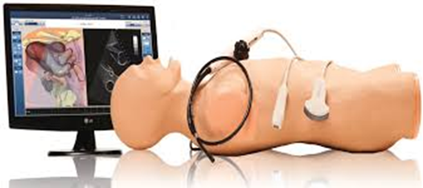
Figure 1 shows TEE simulator

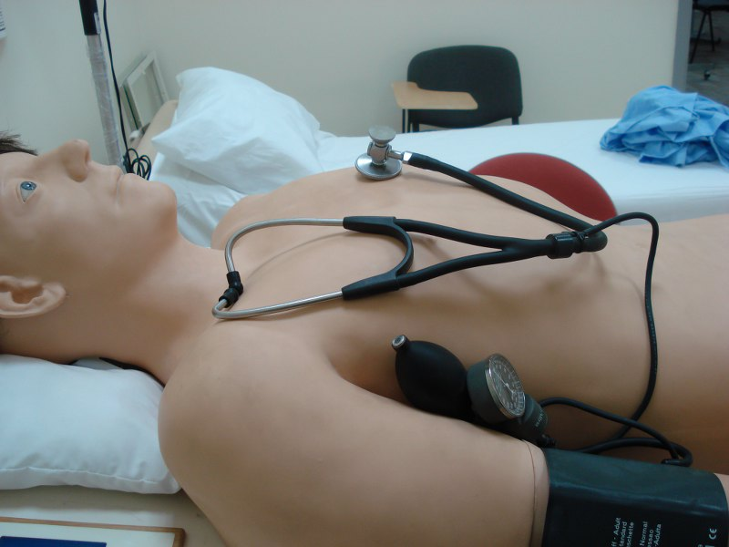
Figure 2: shows Harvey manikin

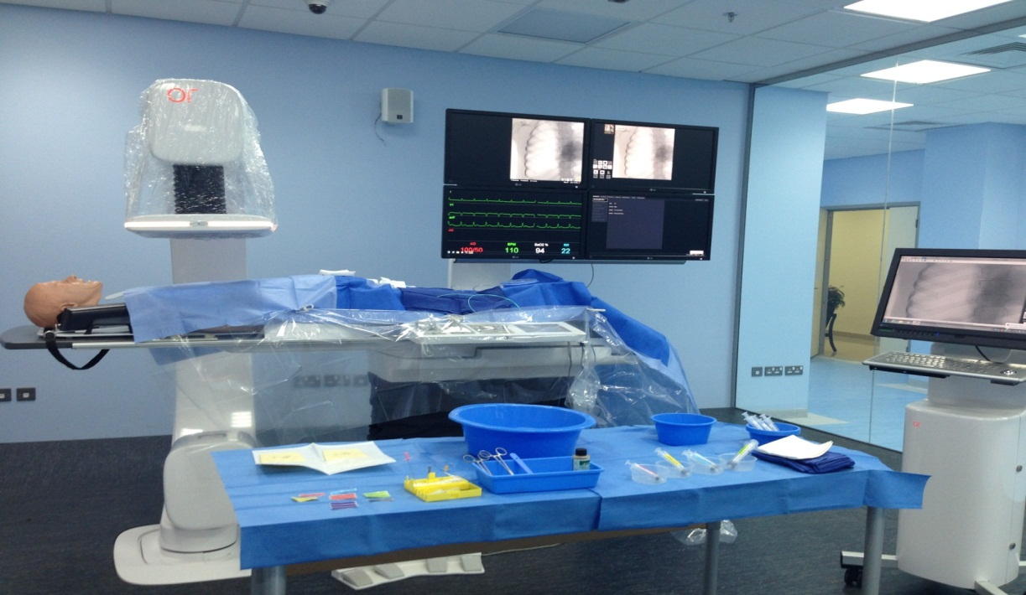
Figure 3 shows Angiocath simulator in cath suite

References:
- Issenberg, SB, Scalese, RJ. Simulation in Healthcare Education. Perspectives in Biology and Medicine. Vol. 51, No. 1: 31-46.
- The current state of medical simulation in interventional cardiology: A clinical document from the Society for Cardiovascular Angiography and Intervention's (SCAI) Simulation Committee. 17 October, 2013, DOI: 10.1002/ccd.25048
- Does Simulation-Based Training Improve Procedural Skills of Beginners in Interventional Cardiology?—A Stratified Randomized Study, Journal of Interventional cardiology, Volume 29, Issue 1, February 2016 Pages 75–82
- Beaubien JM Baker DP . The use of simulation for training teamwork skills in health care: how low can you go?Qual Saf Health Care 2004;13(Suppl. 1):i51–i56.
- Training with simulation versus operative room attendance. Desender LM, Van Herzeele I, Aggarwal R, Vermassen FE, Cheshire NJ. Department of Thoracic and Vascular Surgery,
University Hospital Ghent, Ghent, Belgium. J Cardiovasc Surg (Torino). 2011 Feb;52(1):17-37.
- European Heart Journal, Jivendra Gosai Makani Purva ,Julian Gunn .Volume 36, Issue 13, 1 April 2015, Pages 777–783, https://doi.org/10.1093/eurheartj/ehu527.

Biography:
Sawsan Al Yousef, MD, CABP, FCCP
Assistant Professor king Saud Bin Abdulaziz University and Health Science, Clinical and Research Pediatric Critical Care fellowship from University of Western Ontario, Canada, 2001, Clinical Pediatric Respiratory, University of Toronto, Canada, Arab and Saudi Board of Pediatrics, 1997.Currently Appointed as Consultant Pediatric Intensive Care and Pulmonory at King Fahad Medical City(KFMC) ,Chairperson of Post Graduate Simulation Department at Center for research , Education, Simulation enhance training (CRESENT)KFMC, Director of Saudi Commissioner for Health specialty for PICU Fellowship Examination committee, Saudi Arabia.
e.mail: sawsan_35@hotmail.com
salyousef@kfmc.med.sa
mobile : 00966506407277

